­­

**Partner Flip the Hoop**



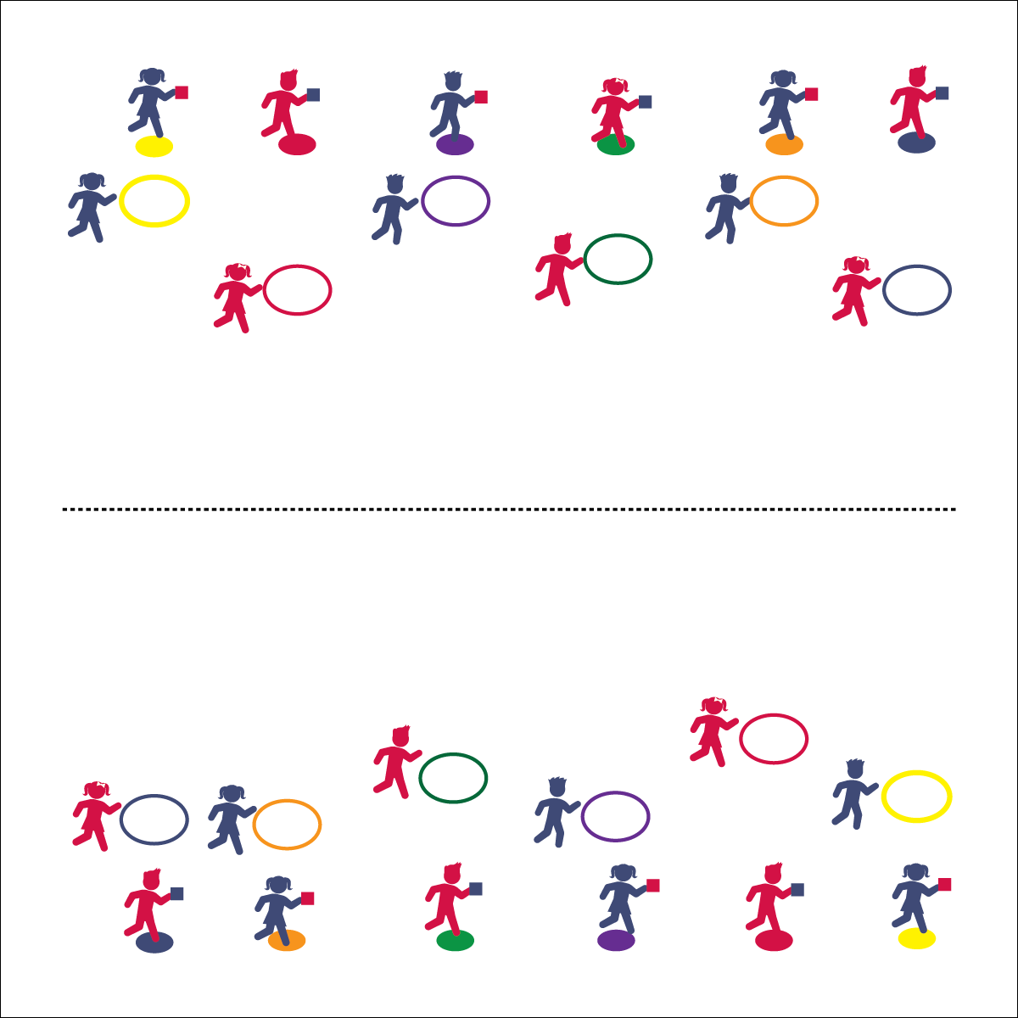

**Activity Procedures:**

1. It’s time for Partner Flip the Hoop. The object of the game is for you and your partner to move your hoop to the center of the activity area. You’ll do that by tossing the bean bag from the spot marker into the hoop. Every successful toss will get your hoop closer to the center.
2. 1 partner begins as the Tosser, and the other is the flipper. On the start signal, the Tosser tosses the bean bag into the hoop. The Flipper flips the hoop toward the center, picks up the bean bag, and changes places with the Tosser. Continue this way until you make it to the center, then reset and being again.
3. If a toss falls outside of the hoop, the flipper will pick up the ban bag without flipping the hoop before changing places with the tagger.

**Grade Level Progression:**

**K–2nd:** Play the game without flipping the hoop (stationary spot and hoop). Pairs toss and switch quickly.

**3rd–5th:** Provide different tossable objects (e.g., critters, foam balls). Allow students to choose a tossable.

Underhand Toss

* Eyes on Target
* Tick-Tock Swing
* Step to Target
* Release and Follow Through



* **DOK 1:** What would you include on a list of positive praise words to use in physical education?
* **DOK 2:** How does praise affect a person’s confidence?
* **DOK 3:** How is praise related to the enjoyment of physical activity with friends?



* **Standard 4 [E4.K-5]** Shares equipment/space with others (K); Works independently with others in a variety of environments (e.g., small and large groups) (1); Works independently with others in partner environments (2); Works cooperatively with others (3a); Praises others for success in movement performance (3b); Praises the movement performance of others both more & less-skilled (4a); Accepts “players” of all skill levels (4b); Accepts, recognizes, and actively involves others with both higher and lower skill abilities into physical activities and group projects (5).

**Equipment:**

* 1 hula hoop per 2 students
* 1 bean bag per 2 students
* 1 spot marker per 2 students

**Set-Up:**

1. Along each sideline, create 2 parallel lines. The outside lines are spot markers and the inside lines are hoops.
2. Put 1 bean bag on each spot marker.
3. Pair students, 1 pair at each hoop.

Personal/Social Responsibility

* **Skill:** I will use an underhand throw to get my bean bag inside the hula hoop.
* **Cognitive:** I will think of ways to praise my partner.
* **Fitness:** I will stay actively engaged during this activity.
* **PSR:** I will work cooperatively with my partner.