­­

**HOOP IT UP**

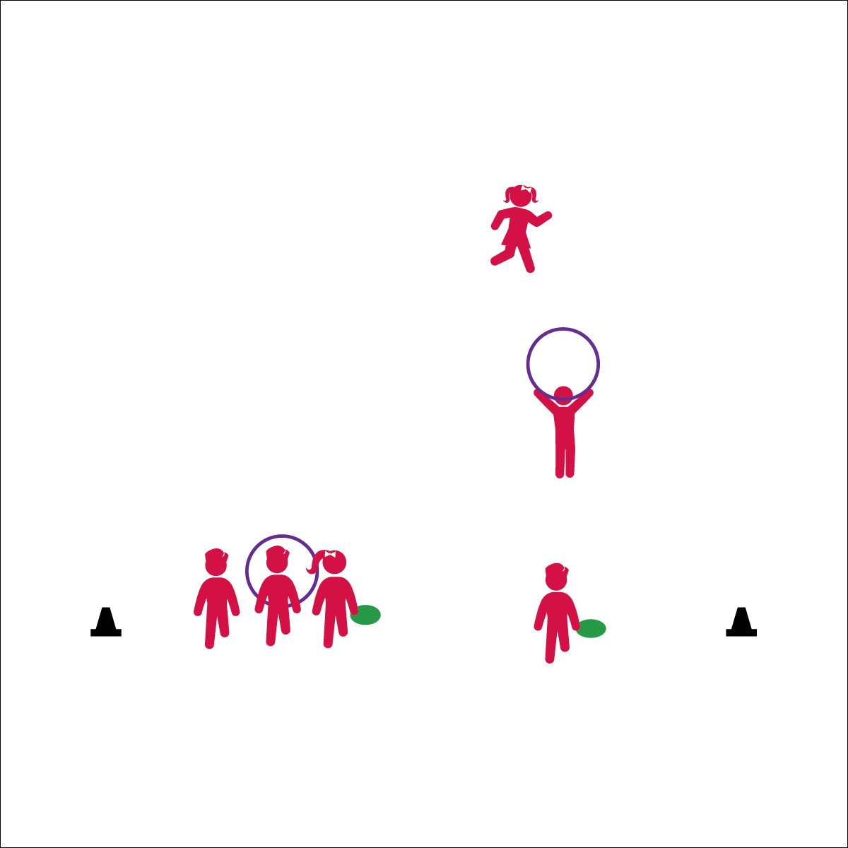

**Activity Procedures:**

1. It’s time for Hoop It Up! The object is for your team to score points by throwing the disc through the hoop and catching it before it hits the ground.
2. All 3 players begin on the start line. Player 1 has the disc, player 2 has the hoop, and player 3 is ready to run. On the start signal, player 2 will run out into open space and hold the hoop up as a target.
3. Player 1 will attempt to throw the disc through the hoop while player 3 runs into open space to the spot where the disc will land.
4. Score 2 points if the disc goes through the hoop and is caught by player 3. Score 1 point if the disc does not go through the hoop but is still caught by player 3. Score 1 point for throws through the hoop but not caught.
5. Rotate after each throw: Thrower to holder; holder to catcher; catcher runs to the start line and becomes the thrower.

**Grade Level Progression:**

* Use a variety of tossable objects (foam balls, football, etc.).

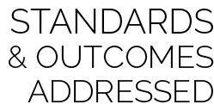

**Standard 1 [M4.6]** Passes and receives with hands in combination with locomotor patterns of running and change of direction and speed with competency in invasion games such as basketball, flag football, speedball, or team handball (6).



* **DOK 1:** What would you include on a list about passing and receiving passes?
* **DOK 2:** How would you summarize your team’s performance during a successful throw and catch?
* **DOK 3:** What facts would you select to support the importance of timing in this cooperative activity?

**Equipment:**

* 1 disc per team of 3 students
* 1 hula hoop per team of 3 students
* 2 cones

**Set-Up:**

1. Group students into teams of 3.
2. Provide each team with 1 hula hoop and 1 flying disc.
3. Number students 1, 2, and 3.  
   1 starts as thrower; 2 as holder; 3 as catcher.
4. Create a long start line using 2 cones. All groups begin on the start line.

* **Skill:** I will throw a flying disc with proper form.
* **Cognitive:** I will discuss the components of passing and receiving in combination with locomotor patterns.
* **Fitness:** I will work to increase my heart rate, running from the start line to catching position.
* **P&S Responsibility:** I will cooperate with my teammates as we work toward a common goal.

Ultimate

* Throwing Shoulder to Target
* Step with Same Foot
* Snap Wrist and Follow Through