­­

**3-Way Tag**



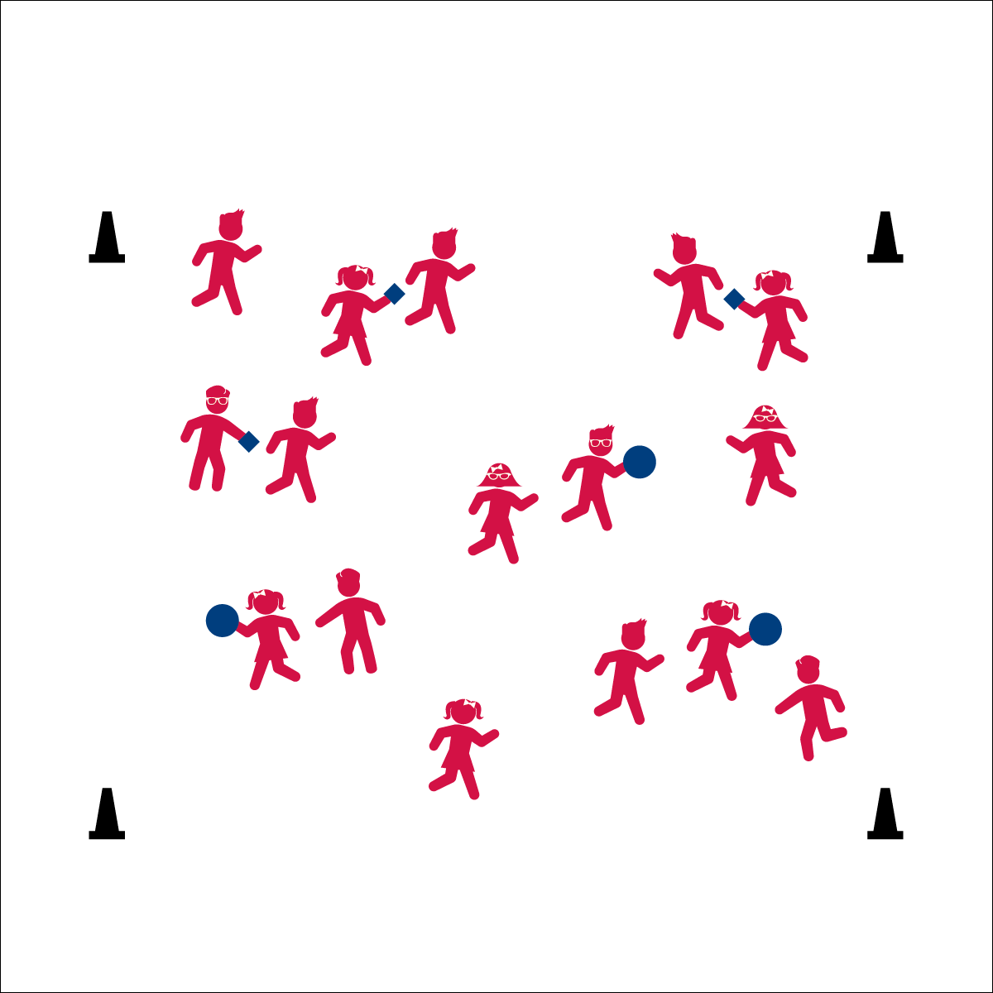



* **DOK 1:** What would you include on a list about chasing during tag games? Fleeing?
* **DOK 2:** How would you apply pathway changes in a game of tag? How might this help you?
* **DOK 3:** How would you change this game to make it more challenging? Less challenging?



* **Standard 1 [E1.K-2]** Performs locomotor skills (hopping, galloping, running, sliding, skipping) while maintaining balance (K); Hops, gallops, jogs, and slides using a mature pattern (1); Skips using a mature pattern (2).
* **Standard 2 [E5.3-5]** Applies simple strategies/tactics in chasing activities (3a); Applies simple strategies in fleeing activities (3b); Applies simple offensive strategies/tactics in chasing and fleeing activities (4a); Applies simple defensive strategies/tactics in chasing and fleeing activities (4b).
* **Skill:** I will move into open space to avoid being tagged.
* **Cognitive:** I will discuss strategies for chasing and fleeing.
* **Fitness:** I will actively engage in order to increase my heart rate.
* **P&S Responsibility:** I will tag safely and follow all instructions.

**Equipment:**

* 1 foam ball per 3 or 4 students
* 1 bean bag per 3 or 4 students
* 4 low-profile cones

**Set-Up:**

1. Create a large activity area using cones as boundaries.
2. Randomly distribute foam balls and bean bags to students.
3. Scatter students in the activity area.

* Bean Bags Tag “Nothing”
* “Nothing” Tag Foam Balls
* Foam Balls are Protected From Bean Bags.

**Activity Procedures:**

1. This is 3-Way Tag. The object is to avoid being tagged. We’ll start at a galloping pace.
2. Players with bean bags can only tag players with nothing. Players with a foam ball are protected from taggers with bean bags.
3. However, players with nothing can tag players with foam balls. Then they take the foam balls in order to gain protection from bean bags. There are no tag-backs allowed.
4. Be sure to tag safely on the upper arm and shoulder with a flat, open hand.

**Grade Level Progression:**

Add dance breaks. When the music starts, the tag game stops and players begin to dance based on what equipment they have. For example, play the song *The Twist*. Players with a ball do Russian twist exercises, players with bean bags do trunk twist exercises, and players with nothing do The Twist. When the music stops, the tag game begins again.

Personal & Social Responsibility