­­

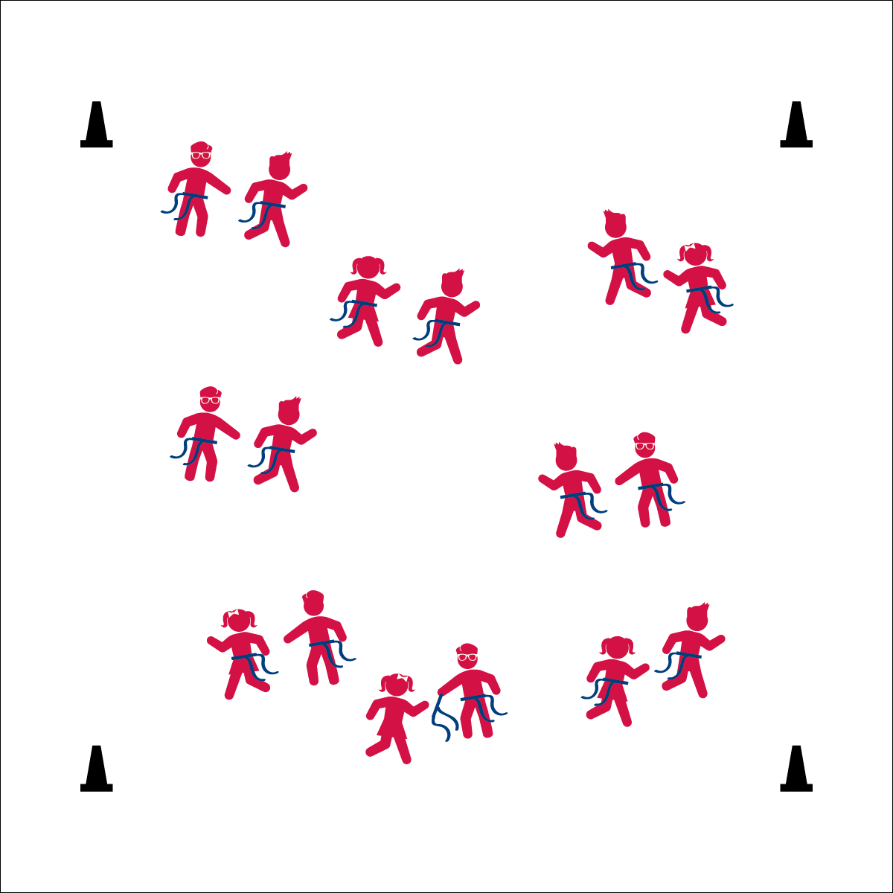

**Equipment:**

* 1 flag belt (or 2 scarves) per student
* 4 cones as boundaries

**Set-Up:**

1. Use 4 cones to create a large activity area.
2. Scatter students in open space, each student wearing a flag belt (or substitute 2 scarves for belts).

* Reach for the Flag
* Pull Down
* Hand It Back

**SLOW-MOTION TAG**

* **Skill:** I will travel safely in general space at different speeds.
* **Cognitive:** I will discuss the difference between *fast* and *slow* during our class discussion.
* **Fitness:** I will actively engage in Slow-Motion Tag.
* **Personal & Social Responsibility:** I will be respectful of other students’ personal space and follow the teacher’s direction.

**Activity Procedures:**

1. We’re going to start learning Flag Tag Games with a fun activity called Slow-Motion Tag. Everyone is it! The object is to pull as many flags as you can without getting your flag pulled.
2. The game starts when I begin to count. Each time I say a number, you can take a step. You can only take a step when you hear me count, but it is okay to reach out and try to pull a flag in between numbers.
3. If you pull a flag, politely hand it back to the person you pulled it from. If your flag is pulled, take the flag back and say, “Thank You,” and then put your flag back in place. You can return to the game as soon as your flag is ready.
4. When I say, “Freeze!” stop and listen for more directions.

**Grade Level Progression:**

**K:** Play the game as described above, but use the alphabet instead of counting numbers.

**1st:** Play the game as described above, skip-counting by 2’s, 3’s, 5’s, and 10’s.

**2nd:** Play the game as described above, calling out heart-healthy foods as a movement prompt.

**SLOW-MOTION TAG**



* **Standard 2 (E3.K-1a)** Travels in general space with different speeds (K); Differentiates between fast and slow speeds (1a).
* **Standard 4 (E1.K-2)** Follows directions in group settings (e.g., safe behaviors, following rules, taking turns) (K); Accepts personal responsibility by using equipment and space appropriately (1); Practices skills with minimal teacher prompting (2).



* Add visual cues when counting.
* Increase or decrease the boundary of the 4 cones.
* Use longer scarves instead of flag belts.



Chase, Dodge, Etiquette, Fast, General Space, Nutrition, Slow



* **DOK 1:** What does *slow* mean? *Fast*?
* **DOK 1:** How would you describe your speed during this game?
* **DOK 2:** How did your speed affect the way that you were able to dodge other students?

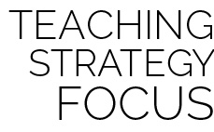

**Identify Critical Content:** Slow-Motion Tag provides both teacher and student with an opportunity to practice and observe safe flag pulls in a slower and more controlled game environment. Mastering this critical content will be essential for safe and active participation in the rest of the module’s activities.