­­

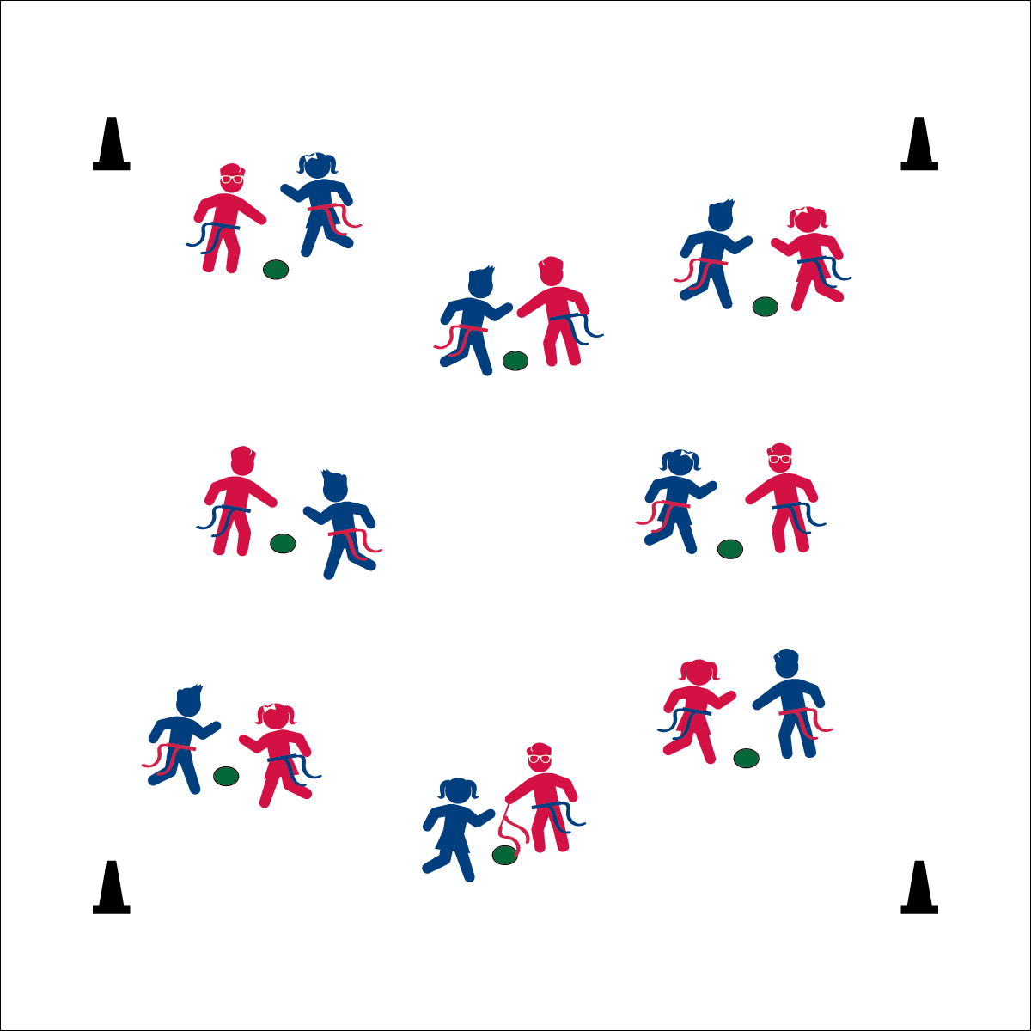

**1 v 1 TAG**

* **Skill:** I will perform side-slides while safely avoiding other students in general space.
* **Cognitive:** I will discuss the difference between *offense* and *defense*.
* **Fitness:** I will stay actively engaged in the activity.
* **Personal & Social Responsibility:** I will keep a safe distance between myself and others playing near me.

**Equipment:**

* 1 flag belt (or 2 scarves) per student
* 1 spot marker per 2 students

**Set-Up:**

1. Scatter spot markers in a large activity area with enough space for safe movement around each spot.
2. Pair students, each student wearing a flag belt (or substitute 2 scarves for belts).
3. Send each pair to a spot marker.

* Reach for the Flag
* Pull Down
* Hand it Back

**Activity Procedures:**

1. This Flag Tag Game is called 1v1 Tag. We’re going to start the game with 1 player on offense and 1 player on defense. The object of the game is for the player on offense to pull the belt of the player on defense.
2. When the game begins, the offense will begin side-sliding around the spot marker and reaching safely for the belt while the defense moves away to avoid being tagged. If the defense moves more than 3 steps away from the spot marker, she/he is automatically tagged.
3. When you’re tagged, reset your belt, change roles (offense to defense), and then start a new game.

**Grade Level Progression:**

**K–1st:** Before starting the activity as described, have students practice safely sliding around their spots. Use a signal to prompt direction changes.

**2nd:** Give the offense a foam football (or other foam ball) to practice proper technique for holding and moving with a football.

**1 v 1 TAG**



1v1, Chase, Defense, Direction, Dodge, Respect, Side-Slide



* **Standard 3 (E1.K-2)** Identifies active play opportunities outside physical education class (K); Discusses the benefits of being active and exercising/playing (1); Describes large-motor and/or manipulative physical activities for participation outside physical education class (e.g., before and after school, at home, at the park, with friends, with the family) (2).
* **Standard 4 (E6.K-2)** Follows teacher directions for safe participation and proper use of equipment with minimal reminders (K); Follows teacher directions for safe participation and proper use of equipment without teacher reminders (1); Works independently and safely in physical education (2a);Works safely with physical education equipment (2b).



* **DOK 1:** Can you remember the cues for side-sliding?
* **DOK 2:** How would you compare and contrast *offense* and *defense*?
* **DOK 2:** What did you notice about general space and being safe?
* **DOK 3:** How is side-sliding related to sports like flag football?



**Help students practice skills and strategies:** 1v1 Tag is designed to provide additional flag pulling practice in a focused environment and with limited movement variables. Students perform the skill, teachers observe the performance, and then they provide feedback. Remember, errors and mistakes are teachable moments.



* Use a lightweight or different size ball that will be easier to hold.
* Use a variety of visual demonstrations before starting the activity.
* Change the distance players can move from their spot marker before becoming automatically tagged.