­­

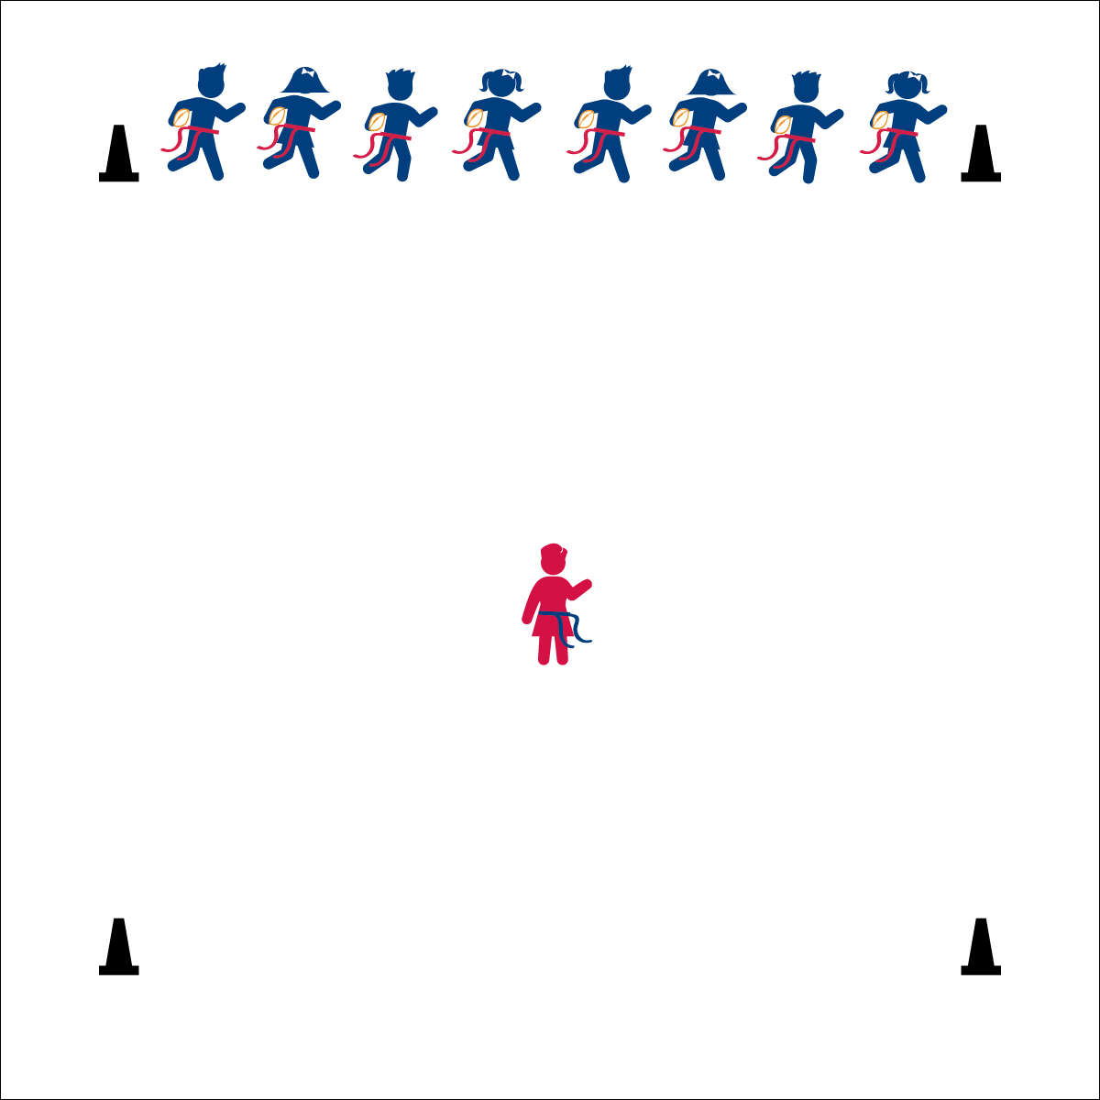

**Activity Procedures:**

1. It’s time for Scoreboard Tag! *(Much like What Time is it Mr. Fox)*
2. The player in the center of the activity area is the scoreboard. The object of the game is for the football players to run into the end zone (on the other side of the area) when time runs out without having their flag pulled by the scoreboard.
3. To start the game, all football players will yell, “How much time is on the clock?!” The scoreboard will reply, “6 minutes!” Each time the players ask, the scoreboard will take time off the clock.
4. When the scoreboard yells, “TIME’S UP!” All football players will gallop (skip, slide, run) to the other side of the area and into the end zone while the scoreboard attempts to pull a flag belt.
5. If a player’s flag is pulled, he/she becomes the new scoreboard.

**Grade Level Progression:**

**K:** Play the game without footballs and with the teacher acting as the scoreboard.

**1st:** Allow students to act as the scoreboard. Add footballs after students have demonstrated safe play.

**2nd:** Play the game as described above.

**Equipment:**

* 1 flag belt (or 2 scarves) per student
* 1 foam football per student
* 6 cones to mark activity area.

**Set-Up:**

1. Create a large, rectangular activity area using 6 cones. (2 cones mark starting line, 2 cones mark mid-field, 2 cones mark end zone.)
2. Each student wearing a flag belt (or substitute 2 scarves for belts).
3. Line students up on the starting line, each holding a football with proper technique.
4. Choose 1 student to be the scoreboard. The scoreboard stands in the center and does not have a football.

Carrying a Football:

* In Your Elbow
* Fingers and Palm
* Hug to Your Chest
* **Skill:** I will perform different locomotor skills.
* **Cognitive:** I will discuss the benefits of exercise for my heart.
* **Fitness:** I will actively engage in the activity and work to increase my heart rate.
* **Personal & Social Responsibility:** I will safely perform locomotor skills while staying inside the playing area.

**SCOREBOARD TAG**

**SCOREBOARD TAG**



Cardiorespiratory Endurance, Gallop, Heart, Heartbeat, Heart Rate, Hop, Locomotor Skills, Muscle, Run, Skip



* **Standard 1 (E1.K-2)** Performs locomotor skills (hopping, galloping, running, sliding, skipping) while maintaining balance (K); Hops, gallops, jogs, and slides using a mature pattern (1); Skips using a mature pattern (2).
* **Standard 3 (E2.K-2)** Actively participates in physical education class (K); Actively engages in physical education class (1); Actively engages in physical education class in response to instruction and practice (2).
* **Standard 3 (E3.K-2)** Recognizes that when you move fast, your heart beats faster and you breathe faster (K); Identifies the heart as a muscle that grows stronger with exercise/play and physical activity (1); Uses own body as resistance (e.g., holds body in plank position, animal walks) for developing strength (2a); Identifies physical activities that contribute to fitness (2b).



* **DOK 1:** What is a locomotor skill?
* **DOK 1:** What are the different locomotor skills that you’ve learned?
* **DOK 2:** What are all of the things that you know about your heart?
* **DOK 2:** What did you notice about your heart when you participated in this activity?



**Organize students to interact with content:** The skill focus of this game is to combine the manipulative skill of properly holding a football with a variety of locomotor skills. With the tagger focused on pulling a single flag, the game takes on a fun and exciting tone while also promoting successful participation for all.



* Adjust the boundaries to make it easier to get to the end zone.
* Focus on a single locomotor skill for each round to avoid confusion.
* Designate 2 scoreboards to work cooperatively.