­­

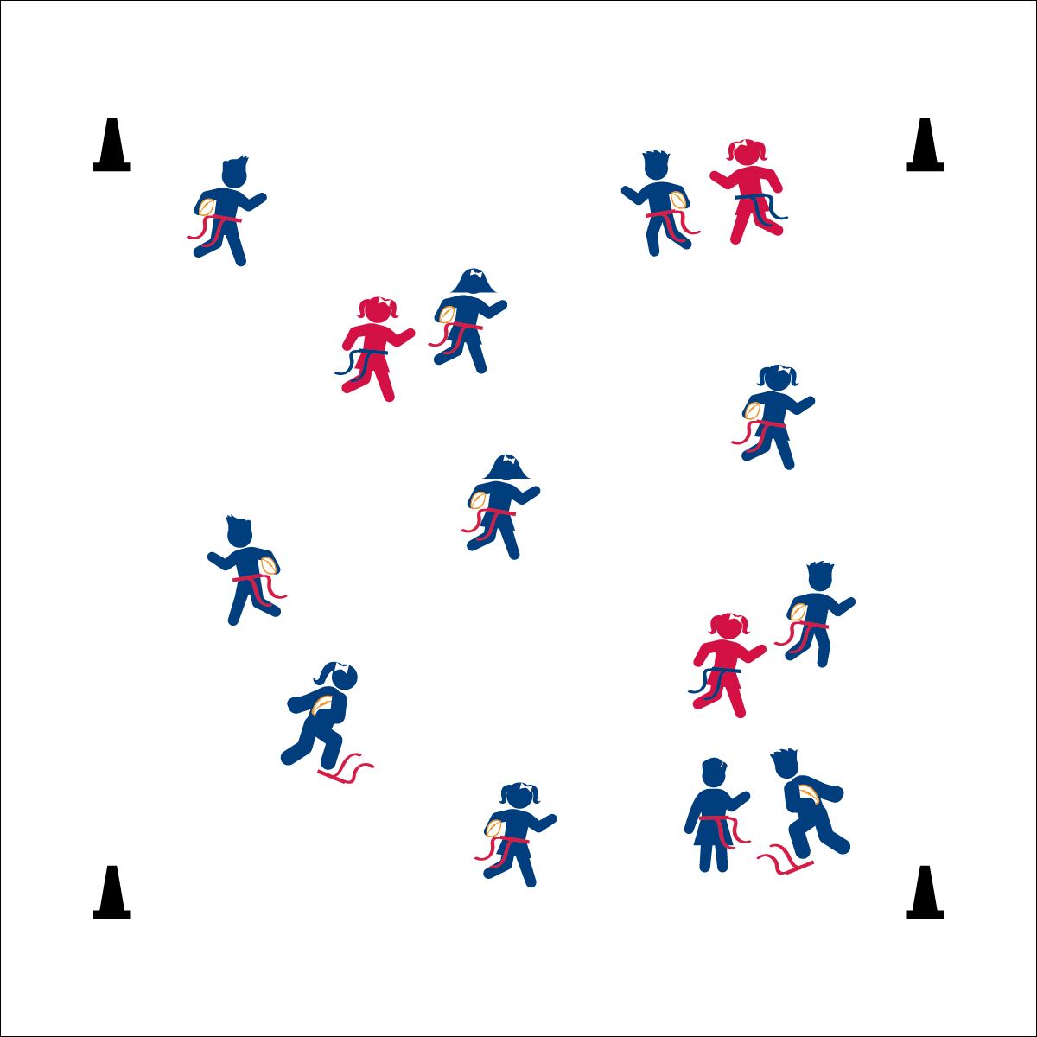

**FOOTBALL FREEZE TAG**

* **Skill:** I will perform a variety of locomotor skills according to the teacher’s cues.
* **Cognitive:** I will discuss the ways that following directions keeps us safe.
* **Fitness:** I will safely perform locomotor skills in order to remain physically active.
* **Personal & Social Responsibility:** I will respect the rules and follow teacher instructions.

Carrying A Football:

* In Your Elbow
* Fingers and Palm
* Hug to Your Chest

**Equipment:**

* 1 flag belt (or 2 scarves) per student
* 1 foam football per student
* 4 cones as boundaries

**Set-Up:**

1. Use 4 cones to create a large activity area.
2. Scatter students in open space, each student wearing a flag belt (or substitute 2 scarves for belts) and carrying a football.
3. Designate 2–4 players as defensive taggers. Taggers do not carry footballs.

**Activity Procedures:**

1. It’s time for Football Freeze Tag. The object of the game is to avoid having your flag belt pulled by a defender. We’ll play at a galloping pace (or other locomotor skill).
2. If your flag is pulled, freeze with your flag at your feet and make a Heisman-Trophy pose (demonstrate). You become unfrozen when another player comes over, hands you your belt and says, “Amazing season, kid!” Then put your belt back on and get back in the game. Defenders cannot tag someone while they are helping a classmate become unfrozen.
3. The Heisman Trophy is awarded to the best player in college football who demonstrates a season of outstanding play along with a high level of integrity. Let’s all work hard to pursue excellence with integrity!

**Grade Level Progression:**

**K:** Start at a speed-walking pace without footballs.

**1st:** Use a variety of locomotor skills. Add footballs after students have demonstrated safe play.

**2nd:** Play the game as described above.

**FOOTBALL FREEZE TAG**



Chase, Dodge, Flee, Locomotor Skills, Safety



* **Standard 1 (E1.K-2)** Performs locomotor skills (hopping, galloping, running, sliding, skipping) while maintaining balance (K); Hops, gallops, jogs, and slides using a mature pattern (1); Skips using a mature pattern (2).
* **Standard 4 (E1.K-2)** Follows directions in group settings (e.g., safe behaviors, following rules, taking turns) (K); Accepts personal responsibility by using equipment and space appropriately (1); Practices skills with minimal teacher prompting (2).



* **DOK 1:** How can you tell that someone if following directions?
* **DOK 2:** How is following directions in Football Freeze Tag related to keeping us safe?
* **DOK 3:** In a football game, who are the people responsible for making sure that players follow the rules and directions?



**Help students practice skills:** Football Freeze Tag provides a dynamic environment for students to practice traveling while properly holding a football. Again, the excitement of the activity keeps the practice session fun and motivating, while also creating ample opportunities for teachers to observe skill performance and provide corrective feedback.



* Focus on a single locomotor skill to avoid confusion.
* Increase the size of the playing area.
* Use a variety of balls, changing size, weight, and texture.