­­

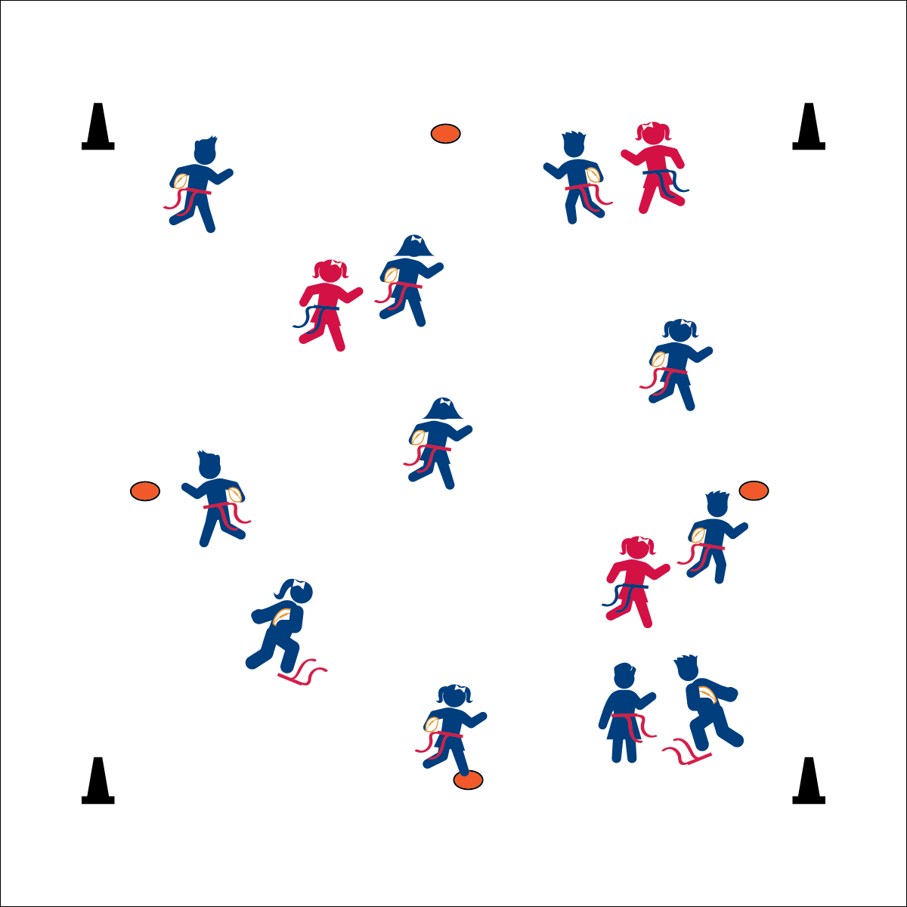

**ISLAND TAG**

* **Skill:** I will perform a variety of locomotor skills.
* **Cognitive:** I will discuss different ways to find and check my heart rate.
* **Fitness:** I will stay active and increase my heart rate.
* **Personal & Social Responsibility:** I will respect other students’ personal space and follow the rules of the activity.
* Safe on a Spot
* 3 Mississippi’s
* Off the Spot

**Equipment:**

* 1 flag belt (or 2 scarves) per student
* 1 foam football per student
* 4 cones as boundaries
* 5 to 7 Spot markers

**Set-Up:**

1. Use 4 cones to create a large activity area. Scatter spot markers throughout the area.
2. Scatter students in open space, each student wearing a flag belt (or substitute 2 scarves for belts) and carrying a football.
3. Designate 2–4 players as defensive taggers. Taggers do not carry footballs.

**Activity Procedures:**

1. This game is called Island Tag. The rules are exactly the same as Football Freeze Tag, but with one big change: the spot markers scattered in the activity area are now safe zones! If you’re standing on a safe zone, you can’t be tagged.
2. You can only stand on a safe zone for a count of 3 Mississippi’s. After that, you need to move off the spot and return to the game.
3. Taggers on defense may not stand and wait for a player to get off a safe zone. If they’re chasing a player who steps on a safe zone, they must immediately leave to find a new player to chase.
4. Be safe and respectful when moving onto a safe zone. If someone is already on a spot, safely change directions and move to an open spot.

**Grade Level Progression:**

**K:** Start at a speed-walking pace without footballs.

**1st:** Use a variety of locomotor skills. Add footballs after students have demonstrated safe play.

**2nd:** Play the game as described above.

**ISLAND TAG**



Breathe, Direction, Heart, Heartbeat, Heart Rate, Locomotor Skills, Nutrition, Oxygen



* **Standard 1 (E1.K-2)** Performs locomotor skills (hopping, galloping, running, sliding, skipping) while maintaining balance (K); Hops, gallops, jogs, and slides using a mature pattern (1); Skips using a mature pattern (2).
* **Standard 3 (E3.K-2)** Recognizes that when you move fast, your heart beats faster and you breathe faster (K); Identifies the heart as a muscle that grows stronger with exercise/play and physical activity (1); Uses own body as resistance (e.g., holds body in plank position, animal walks) for developing strength (2a); Identifies physical activities that contribute to fitness (2b).
* **Standard 5 (E1.K-2)** Recognizes that physical activity is important for good health (K); Identifies physical activity as a component of good health (1); Recognizes the value of “good health balance” (2).



* **DOK 1:** What does *heart rate* mean?
* **DOK 1:** How can you recognize how fast your heart is beating?
* **DOK 1:** How would you describe the way you’re feeling after the activity?
* **DOK 2:** What did you notice about your heart rate when you were on the spot marker?



**Organize students to interact with content:** Island Tag is an instructional layer that extends Football Freeze Tag with one simple modification. This change creates additional complexity in the game, forcing students to perform essential skills in an increasingly intricate activity environment.



* Increase the number of spot markers/safe zones.
* Increase the time students are allowed to stand on each spot marker.
* Provide ongoing verbal cues to remind students of the rules.