­­



**HANDOFF HELPER TAG**

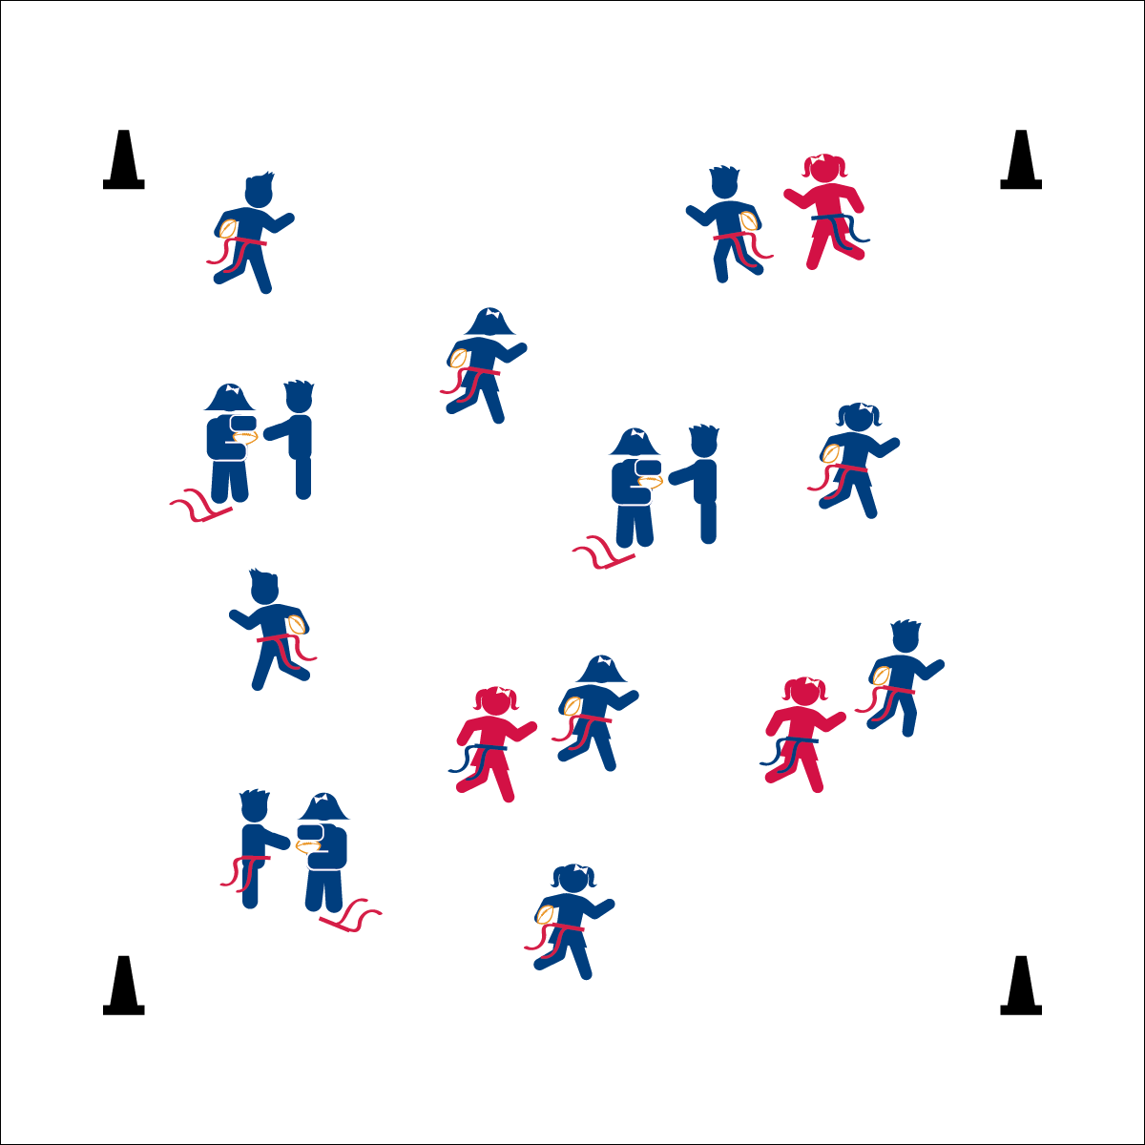

* **Skill:** I will travel safely in general space, keeping my eyes up while changing speeds appropriately.
* **Cognitive:** I will discuss the cues for safe handoffs.
* **Fitness:** I will stay actively engaged in the activity.
* **Personal & Social Responsibility:** I will demonstrate respect for others and follow all of the rules of the activity.
* Arms Ready,  
  Open the Window
* Move Through the Ball
* Ball to the Body,  
  Shut the Window

**Equipment:**

* 1 flag belt (or 2 scarves) per student
* 2–4 beanbags
* 3–5 foam footballs
* 4 cones as boundaries

**Set-Up:**

1. Use 4 cones to create a large activity area.
2. Scatter students in open space, each student wearing a flag belt (or substitute 2 scarves for belts).
3. Designate 2–4 players as defensive taggers. These players carry beanbags to identify them.
4. Designate 3–5 players as Handoff Helpers. These players carry foam footballs.

**Activity Procedures:**

1. Let’s play Handoff Helper Tag! This is another freeze-tag game with a fun twist. We’ll play at a galloping pace.
2. If you are frozen, make a handoff window with your arms. Handoff Helpers will find frozen players and unfreeze them by handing off their football. The unfrozen person becomes a new Handoff Helper, and the former helper joins the game and tries to avoid being tagged.
3. Handoff Helpers cannot be tagged.
4. Both frozen players and Handoff Helpers must focus on good handoff form, using the open side of the handoff window.

**Grade Level Progression:**

**K:** Play the game as described above without reinforcing handoff form. Focus on safe movement and following rules.

**1st–2nd:** Play the game as describe above with a focus on good handoff form.

**HANDOFF HELPER TAG**



* Use specific colors to make it easier to tell taggers apart from Handoff Helpers. For example, make sure all taggers have the same color bean bag, while handoff helpers have footballs that are a single different color.
* Change the size of the boundaries to benefit non-taggers.
* Give visual demonstrations of a proper handoff.



Defense, Etiquette, Fast, Gallop, General Space, Offense, Slow



* **Standard 2 (E3.K-1a)** Travels in general space with different speeds (K); Differentiates between fast and slow speeds (1a).
* **Standard 4 (E6.K-2)** Follows teacher directions for safe participation and proper use of equipment with minimal reminders (K); Follows teacher directions for safe participation and proper use of equipment without teacher reminders (1); Works independently and safely in physical education (2a);Works safely with physical education equipment (2b).



* **DOK 1:** How would you describe a handoff?
* **DOK 2:** How would you use a handoff in a football game?
* **DOK 2:** What did you notice about your handoff when you gave it to the tagged student?
* **DOK 3:** How would you describe the sequence of a handoff?



**Help students process content:** In this activity, a football handoff is used to introduce students to sport-specific skills in a lead-up game environment. Young students will have difficulty following skill cues in a dynamic environment. However, gentle reinforcement with a focus on safe behaviors provides challenge, interest, and fun to this early sport experience.