­­

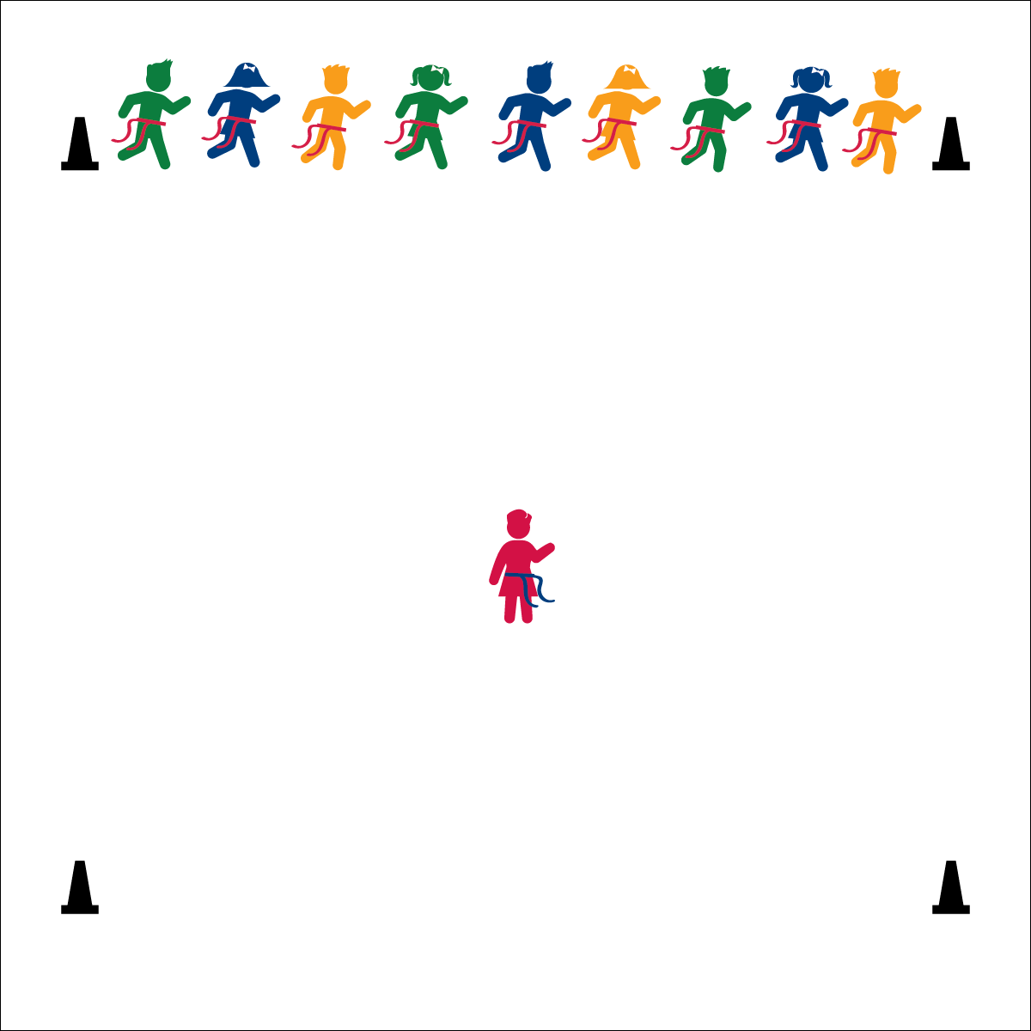

* Eyes Up and Alert
* Keep a Safe Speed
* Find Open Space

**Activity Procedures:**

1. To be a great football athlete, it’s important to have a healthful diet with a lot of vegetables. One of the best ways to eat veggies is in a salad! This game is called Super Salad Bowl Tag! We’re going to begin play at a speed-walking pace.
2. The object of the game is for the veggies to run through the salad bowl to the other side without having their flag pulled by the salad chef.
3. The game starts when the salad chef calls a veggie name. Only those veggies begin to move across the salad bowl. The salad chef tries to pull as many flags as she/he can.
4. If a veggie’s flag is pulled, she/he must freeze in place and help the salad chef catch more veggies. Tagged veggies can use 1 foot to pivot and must hold her/his own flag in 1 hand while using the other to reach out to pull other veggies’ flags.
5. After all veggie names are called, the chef and tagged veggies turn to face the opposite line, where the safe veggies are waiting to begin a new round. When most of the veggies have been tagged, reset the game with a new veggie chef.

**Grade Level Progression:**

**K:** Play with the teacher acting as the veggie chef.

**1st – 2nd:** Perform the activity as described above.

* **Skill:** I will perform a variety of locomotor skills.
* **Cognitive:** I will recognize different types of healthy foods that provide energy.
* **Fitness:** I will stay actively engaged in order to increase my heart rate.
* **Personal & Social Responsibility:** I will demonstrate safe and respectful behaviors.

**Equipment:**

* 1 flag belt (or 2 scarves) per student
* 6 cones to mark the activity area.

**Set-Up:**

1. Create a large, rectangular activity area using 6 cones. (2 cones mark starting line, 2 cones mark mid-field, 2 cones mark end line.)
2. Each student wearing a flag belt (or substitute 2 scarves for belts).
3. Line students up on the starting line. Create 2 or 3 groups of veggies (e.g., lettuce, tomatoes, carrots).
4. Choose 1 student to be the salad chef.

**SUPER SALAD BOWL TAG**

**SUPER SALAD BOWL TAG**



Energy, Etiquette, Locomotor Skills, Nutrition, Respect, Responsibility

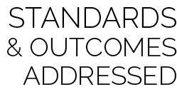

* **Standard 3 (E2.K-2)** Actively participates in physical education class (K); Actively engages in physical education class (1); Actively engages in physical education class in response to instruction and practice (2).
* **Standard 3 (E6.K-2)** Recognizes that food provides energy for physical activity (K); Differentiates between healthy and unhealthy foods (1); Recognizes the “good health balance” of good nutrition with physical activity (2).
* **Standard 4 (E1.K-2)** Follows directions in group settings (e.g., safe behaviors, following rules, taking turns) (K); Accepts personal responsibility by using equipment and space appropriately (1); Practices skills with minimal teacher prompting (2).



* **DOK 1:** What would you include on a list of information about vegetables?
* **DOK 1:** How would you describe the foods you eat?
* **DOK 2:** What do you know about vegetables?
* **DOK 2:** How can you use what you learned about healthy foods today?
* **DOK 2:** How would you summarize your eating habits?

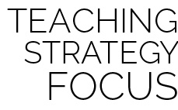

**Identify critical content:** Physical activities and games provide opportunities for teachers to introduce and integrate critical nutrition content in a fun environment. These activities can also help students embrace and retain the information presented.



* Provide visual demonstrations of what students must do when their veggie is called, as well as what to do when they get tagged.
* Use a variety of speeds and locomotor skills.