­­

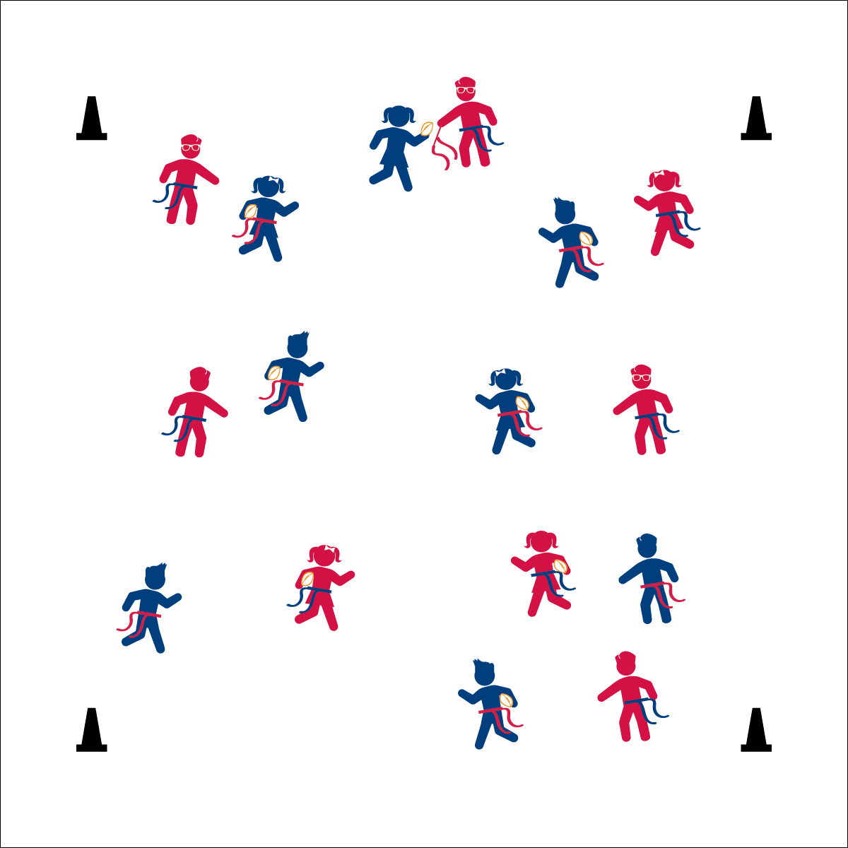

* **Skill:** I will perform a variety of locomotor skills while moving safely in general space.
* **Cognitive:** I will discuss the difference between *offense* and *defense*.
* **Fitness:** I will stay actively engaged.
* **Personal & Social Responsibility:** I will demonstrate respect for the rules and procedures of the activity.

**OFFENSE / DEFENSE TAG**

* Reach for the Flag
* Pull Down
* Hand it Back

**Equipment:**

* 1 flag belt (or 2 scarves) per student
* 1 foam football per 2 students
* 4 cones as boundaries

**Set-Up:**

1. Use 4 cones to create a large activity area.
2. Pair students, each student wearing a flag belt (or substitute 2 scarves for belts).
3. Scatter pairs in the activity area.
4. Designate 1 player from each pair as the defensive player and 1 as the offensive player. Each offensive player with a football.

**Activity Procedures:**

1. Now it’s time for Offense/Defense Tag. The object of the game is for the defensive player to catch and pull the flag of their offensive partner. This is a speed-walking game.
2. When I say “GO,” the defensive player will do 3 jumping jacks while the offensive player moves quickly away. After 3 jumping jacks, the defense may begin to chase the offense.
3. When tagged, the offense will hand the ball to the defense and the players change roles. The new defense will replace the flag belt, do 3 jumping jacks, and then begin to chase the new offense.
4. Players who move outside of the boundaries are automatically tagged, and roles switch.
5. Freeze when you hear the stop signal.

**Grade Level Progression:**

**K:** Keep this game at a speed-walking pace for safety.

**1st:** Use a variety of locomotor activities, increasing the pace of the game as students demonstrate safe movement.

**2nd:** Increase the size of the activity area and, after students demonstrate safe movement, increase the pace to a run.

**OFFENSE / DEFENSE TAG**



1v1, Chase, Defense, Dodge, Flee, General Space, Locomotor Skills, Offense, Respect



* **Standard 1 (E1.K-2)** Performs locomotor skills (hopping, galloping, running, sliding, skipping) while maintaining balance (K); Hops, gallops, jogs, and slides using a mature pattern (1); Skips using a mature pattern (2).
* **Standard 2 (E3.K-1a)** Travels in general space with different speeds (K); Differentiates between fast and slow speeds (1a).
* **Standard 4 (E6.K-2)** Follows teacher directions for safe participation and proper use of equipment with minimal reminders (K); Follows teacher directions for safe participation and proper use of equipment without teacher reminders (1); Works independently and safely in physical education (2a);Works safely with physical education equipment (2b).



* **DOK 1:** How would you describe your role on defense? Offense?
* **DOK 1:** How would you describe your speed on defense? Offense?
* **DOK 2:** How would you use different speeds in a football game?
* **DOK 2:** What did you notice about your speed when you changed directions?



**Help students examine similarities and differences:** The introduction of offense and defense as an important sport concept requires teachers to present information that may seem obvious within a coaching mindset, but will not be intuitive to young students. However, physical education provides many students with their first sport experiences. Take the time to address this new academic language while flushing out the similarities and differences between the concepts.



* Add a 3rd person to a group to give the defensive player a chance to tag another person.
* Change the size of the activity area.
* Allow students to perform arm circles or twists if they have difficulty with jumping jacks.