­­

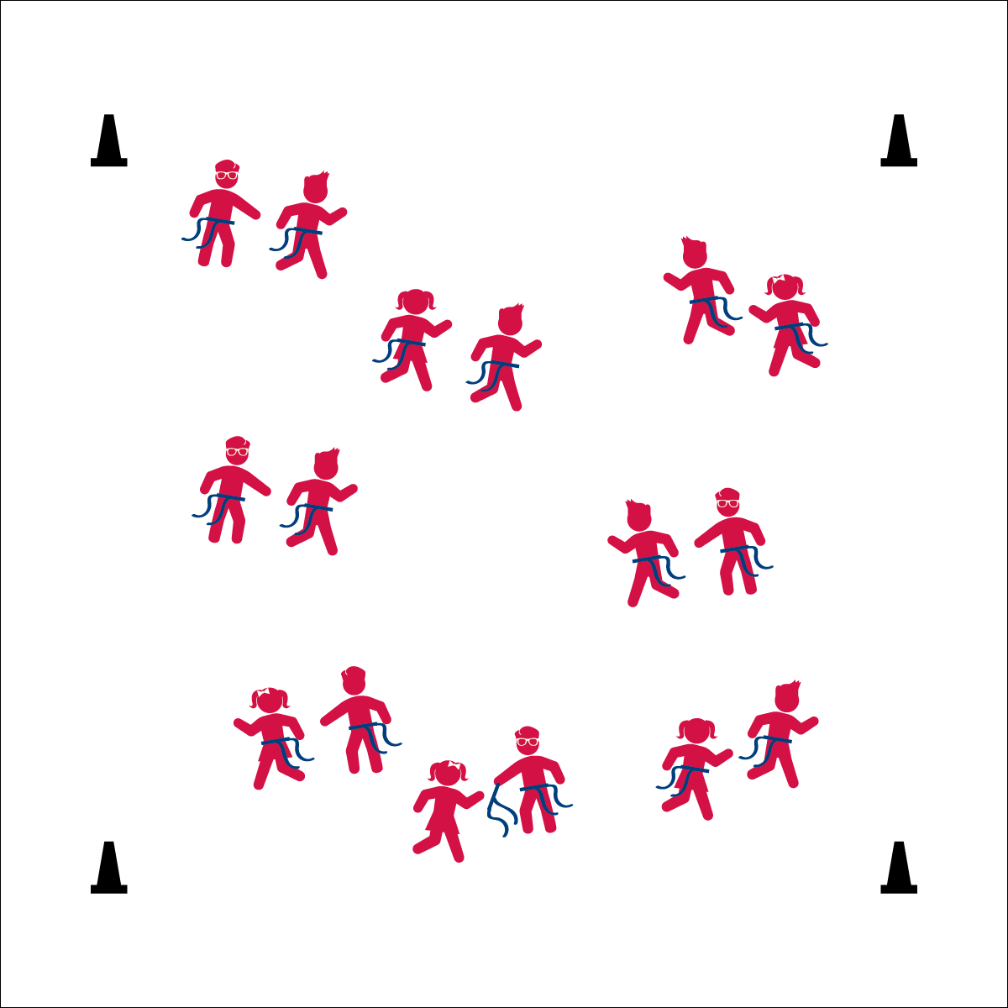

* **Skill:** I will travel safely in general space at different speeds.
* **Cognitive:** I will discuss the difference between *fast* and *slow* during our class discussion.
* **Fitness:** I will actively engage in Slow-Motion Tag.
* **Personal & Social Responsibility:** I will be respectful of other students’ personal space and follow the teacher’s direction.

**Equipment:**

* 1 flag belt (or 2 scarves) per student
* 4 cones as boundaries

**Set-Up:**

1. Use 4 cones to create a large activity area.
2. Scatter students in open space, each student wearing a flag belt (or substitute 2 scarves for belts).

* Reach for the Flag
* Pull Down
* Hand It Back

**SLOW-MOTION TAG**

**Activity Procedures:**

1. We’re going to start learning Flag Tag Games with a fun activity called Slow-Motion Tag. Everyone is it! The object is to pull as many flags as you can without getting your flag pulled.
2. The game starts when I begin to count. Each time I say a number, you can take a step. You can only take a step when you hear me count, but it is okay to reach out and try to pull a flag in between numbers.
3. If you pull a flag, politely hand it back to the person you pulled it from. If your flag is pulled, take the flag back and say, “Thank You,” and then put your flag back in place. You can return to the game as soon as your flag is ready.
4. When I say, “Freeze!” stop and listen for more directions.

**Grade Level Progression:**

**K:** Play the game as described above, but use the alphabet instead of counting numbers.

**1st:** Play the game as described above, skip-counting by 2’s, 3’s, 5’s, and 10’s.

**2nd:** Play the game as described above, calling out heart-healthy foods as a movement prompt.

**SLOW-MOTION TAG**



* **Standard 2 (E3.K-1a)** Travels in general space with different speeds (K); Differentiates between fast and slow speeds (1a).
* **Standard 4 (E1.K-2)** Follows directions in group settings (e.g., safe behaviors, following rules, taking turns) (K); Accepts personal responsibility by using equipment and space appropriately (1); Practices skills with minimal teacher prompting (2).



* Add visual cues when counting.
* Increase or decrease the boundary of the 4 cones.
* Use longer scarves instead of flag belts.



Chase, Dodge, Etiquette, Fast, General Space, Nutrition, Slow



* **DOK 1:** What does *slow* mean? *Fast*?
* **DOK 1:** How would you describe your speed during this game?
* **DOK 2:** How did your speed affect the way that you were able to dodge other students?



**Identify Critical Content:** Slow-Motion Tag provides both teacher and student with an opportunity to practice and observe safe flag pulls in a slower and more controlled game environment. Mastering this critical content will be essential for safe and active participation in the rest of the module’s activities.

**1 v 1 TAG**

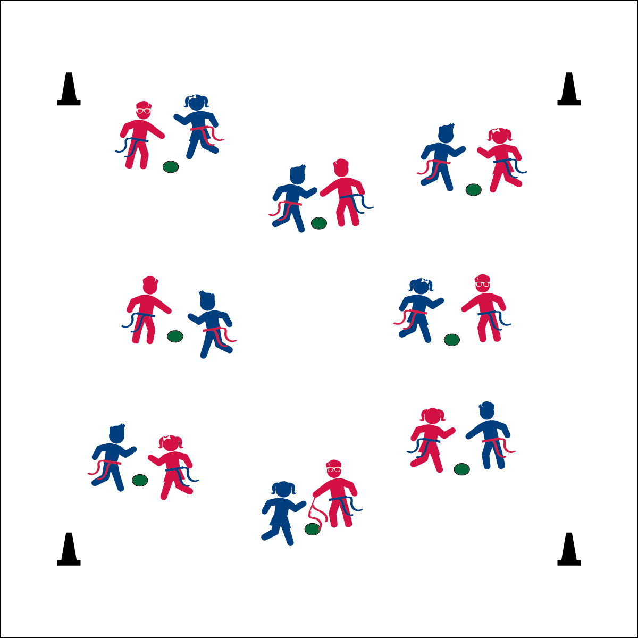

**Equipment:**

* 1 flag belt (or 2 scarves) per student
* 1 spot marker per 2 students

**Set-Up:**

1. Scatter spot markers in a large activity area with enough space for safe movement around each spot.
2. Pair students, each student wearing a flag belt (or substitute 2 scarves for belts).
3. Send each pair to a spot marker.

* Reach for the Flag
* Pull Down
* Hand it Back
* **Skill:** I will perform side-slides while safely avoiding other students in general space.
* **Cognitive:** I will discuss the difference between *offense* and *defense*.
* **Fitness:** I will stay actively engaged in the activity.
* **Personal & Social Responsibility:** I will keep a safe distance between myself and others playing near me.

**Activity Procedures:**

1. This Flag Tag Game is called 1v1 Tag. We’re going to start the game with 1 player on offense and 1 player on defense. The object of the game is for the player on offense to pull the belt of the player on defense.
2. When the game begins, the offense will begin side-sliding around the spot marker and reaching safely for the belt while the defense moves away to avoid being tagged. If the defense moves more than 3 steps away from the spot marker, she/he is automatically tagged.
3. When you’re tagged, reset your belt, change roles (offense to defense), and then start a new game.

**Grade Level Progression:**

**K–1st:** Before starting the activity as described, have students practice safely sliding around their spots. Use a signal to prompt direction changes.

**2nd:** Give the offense a foam football (or other foam ball) to practice proper technique for holding and moving with a football.

**1 v 1 TAG**



* Use a lightweight or different size ball that will be easier to hold.
* Use a variety of visual demonstrations before starting the activity.
* Change the distance players can move from their spot marker before becoming automatically tagged.



1v1, Chase, Defense, Direction, Dodge, Respect, Side-Slide



* **Standard 3 (E1.K-2)** Identifies active play opportunities outside physical education class (K); Discusses the benefits of being active and exercising/playing (1); Describes large-motor and/or manipulative physical activities for participation outside physical education class (e.g., before and after school, at home, at the park, with friends, with the family) (2).
* **Standard 4 (E6.K-2)** Follows teacher directions for safe participation and proper use of equipment with minimal reminders (K); Follows teacher directions for safe participation and proper use of equipment without teacher reminders (1); Works independently and safely in physical education (2a);Works safely with physical education equipment (2b).



* **DOK 1:** Can you remember the cues for side-sliding?
* **DOK 2:** How would you compare and contrast *offense* and *defense*?
* **DOK 2:** What did you notice about general space and being safe?
* **DOK 3:** How is side-sliding related to sports like flag football?



**Help students practice skills and strategies:** 1v1 Tag is designed to provide additional flag pulling practice in a focused environment and with limited movement variables. Students perform the skill, teachers observe the performance, and then they provide feedback. Remember, errors and mistakes are teachable moments.

**SCOREBOARD TAG**

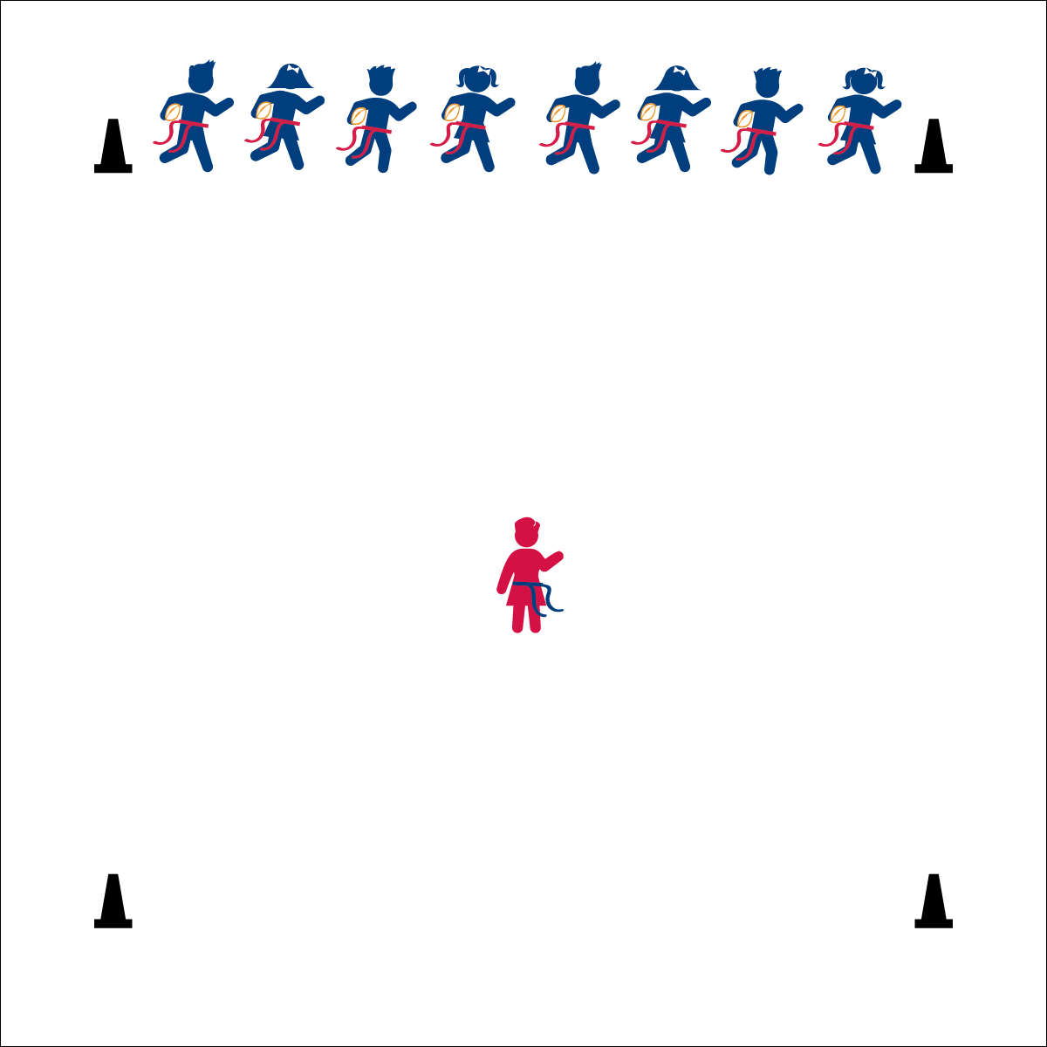

**Equipment:**

* 1 flag belt (or 2 scarves) per student
* 1 foam football per student
* 6 cones to mark activity area.

**Set-Up:**

1. Create a large, rectangular activity area using 6 cones. (2 cones mark starting line, 2 cones mark mid-field, 2 cones mark end zone.)
2. Each student wearing a flag belt (or substitute 2 scarves for belts).
3. Line students up on the starting line, each holding a football with proper technique.
4. Choose 1 student to be the scoreboard. The scoreboard stands in the center and does not have a football.

Carrying a Football:

* In Your Elbow
* Fingers and Palm
* Hug to Your Chest

**Activity Procedures:**

1. It’s time for Scoreboard Tag! *(Much like What Time is it Mr. Fox)*
2. The player in the center of the activity area is the scoreboard. The object of the game is for the football players to run into the end zone (on the other side of the area) when time runs out without having their flag pulled by the scoreboard.
3. To start the game, all football players will yell, “How much time is on the clock?!” The scoreboard will reply, “6 minutes!” Each time the players ask, the scoreboard will take time off the clock.
4. When the scoreboard yells, “TIME’S UP!” All football players will gallop (skip, slide, run) to the other side of the area and into the end zone while the scoreboard attempts to pull a flag belt.
5. If a player’s flag is pulled, he/she becomes the new scoreboard.

**Grade Level Progression:**

**K:** Play the game without footballs and with the teacher acting as the scoreboard.

**1st:** Allow students to act as the scoreboard. Add footballs after students have demonstrated safe play.

**2nd:** Play the game as described above.

* **Skill:** I will perform different locomotor skills.
* **Cognitive:** I will discuss the benefits of exercise for my heart.
* **Fitness:** I will actively engage in the activity and work to increase my heart rate.
* **Personal & Social Responsibility:** I will safely perform locomotor skills while staying inside the playing area.

**SCOREBOARD TAG**



* Adjust the boundaries to make it easier to get to the end zone.
* Focus on a single locomotor skill for each round to avoid confusion.
* Designate 2 scoreboards to work cooperatively.



Cardiorespiratory Endurance, Gallop, Heart, Heartbeat, Heart Rate, Hop, Locomotor Skills, Muscle, Run, Skip



* **Standard 1 (E1.K-2)** Performs locomotor skills (hopping, galloping, running, sliding, skipping) while maintaining balance (K); Hops, gallops, jogs, and slides using a mature pattern (1); Skips using a mature pattern (2).
* **Standard 3 (E2.K-2)** Actively participates in physical education class (K); Actively engages in physical education class (1); Actively engages in physical education class in response to instruction and practice (2).
* **Standard 3 (E3.K-2)** Recognizes that when you move fast, your heart beats faster and you breathe faster (K); Identifies the heart as a muscle that grows stronger with exercise/play and physical activity (1); Uses own body as resistance (e.g., holds body in plank position, animal walks) for developing strength (2a); Identifies physical activities that contribute to fitness (2b).



* **DOK 1:** What is a locomotor skill?
* **DOK 1:** What are the different locomotor skills that you’ve learned?
* **DOK 2:** What are all of the things that you know about your heart?
* **DOK 2:** What did you notice about your heart when you participated in this activity?



**Organize students to interact with content:** The skill focus of this game is to combine the manipulative skill of properly holding a football with a variety of locomotor skills. With the tagger focused on pulling a single flag, the game takes on a fun and exciting tone while also promoting successful participation for all.

**FOOTBALL FREEZE TAG**

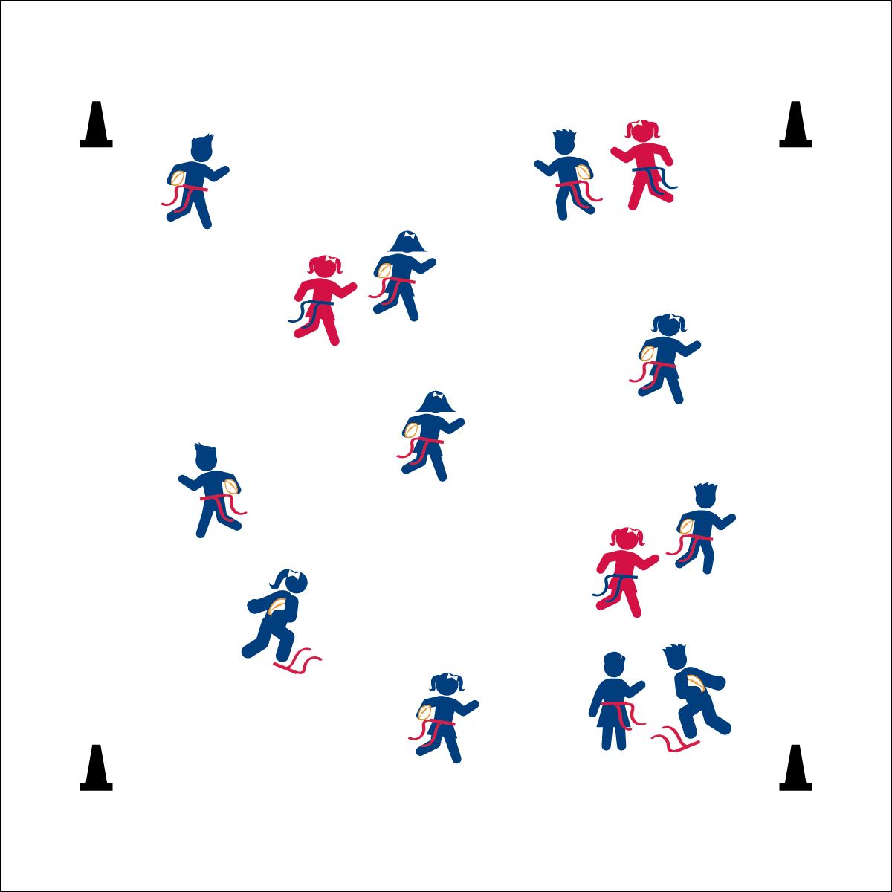

Carrying A Football:

* In Your Elbow
* Fingers and Palm
* Hug to Your Chest
* **Skill:** I will perform a variety of locomotor skills according to the teacher’s cues.
* **Cognitive:** I will discuss the ways that following directions keeps us safe.
* **Fitness:** I will safely perform locomotor skills in order to remain physically active.
* **Personal & Social Responsibility:** I will respect the rules and follow teacher instructions.

**Equipment:**

* 1 flag belt (or 2 scarves) per student
* 1 foam football per student
* 4 cones as boundaries

**Set-Up:**

1. Use 4 cones to create a large activity area.
2. Scatter students in open space, each student wearing a flag belt (or substitute 2 scarves for belts) and carrying a football.
3. Designate 2–4 players as defensive taggers. Taggers do not carry footballs.

**Activity Procedures:**

1. It’s time for Football Freeze Tag. The object of the game is to avoid having your flag belt pulled by a defender. We’ll play at a galloping pace (or other locomotor skill).
2. If your flag is pulled, freeze with your flag at your feet and make a Heisman-Trophy pose (demonstrate). You become unfrozen when another player comes over, hands you your belt and says, “Amazing season, kid!” Then put your belt back on and get back in the game. Defenders cannot tag someone while they are helping a classmate become unfrozen.
3. The Heisman Trophy is awarded to the best player in college football who demonstrates a season of outstanding play along with a high level of integrity. Let’s all work hard to pursue excellence with integrity!

**Grade Level Progression:**

**K:** Start at a speed-walking pace without footballs.

**1st:** Use a variety of locomotor skills. Add footballs after students have demonstrated safe play.

**2nd:** Play the game as described above.

**FOOTBALL FREEZE TAG**



* Focus on a single locomotor skill to avoid confusion.
* Increase the size of the playing area.
* Use a variety of balls, changing size, weight, and texture.



Chase, Dodge, Flee, Locomotor Skills, Safety



* **Standard 1 (E1.K-2)** Performs locomotor skills (hopping, galloping, running, sliding, skipping) while maintaining balance (K); Hops, gallops, jogs, and slides using a mature pattern (1); Skips using a mature pattern (2).
* **Standard 4 (E1.K-2)** Follows directions in group settings (e.g., safe behaviors, following rules, taking turns) (K); Accepts personal responsibility by using equipment and space appropriately (1); Practices skills with minimal teacher prompting (2).



* **DOK 1:** How can you tell that someone if following directions?
* **DOK 2:** How is following directions in Football Freeze Tag related to keeping us safe?
* **DOK 3:** In a football game, who are the people responsible for making sure that players follow the rules and directions?



**Help students practice skills:** Football Freeze Tag provides a dynamic environment for students to practice traveling while properly holding a football. Again, the excitement of the activity keeps the practice session fun and motivating, while also creating ample opportunities for teachers to observe skill performance and provide corrective feedback.

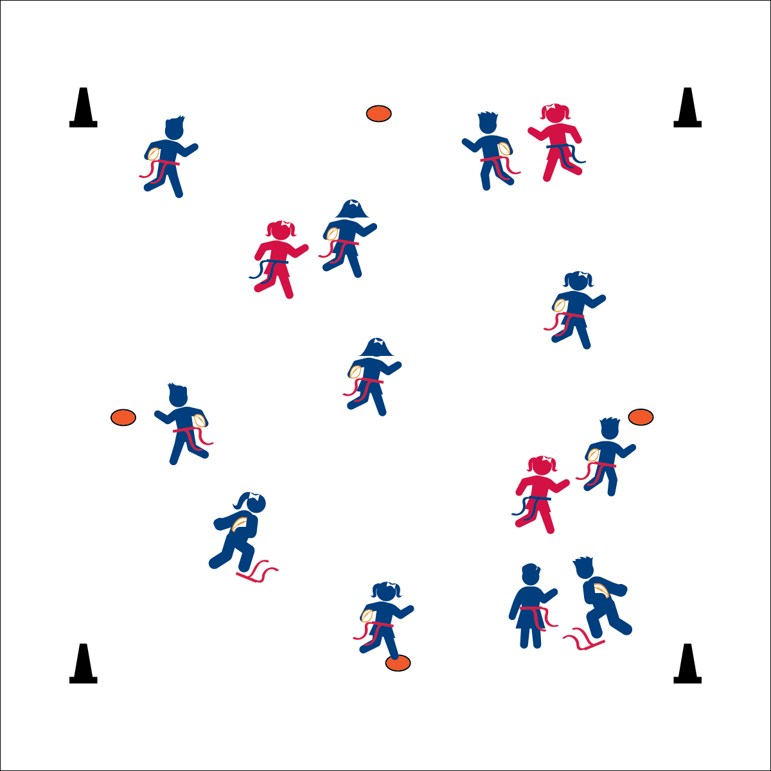

**ISLAND TAG**

* Safe on a Spot
* 3 Mississippi’s
* Off the Spot
* **Skill:** I will perform a variety of locomotor skills.
* **Cognitive:** I will discuss different ways to find and check my heart rate.
* **Fitness:** I will stay active and increase my heart rate.
* **Personal & Social Responsibility:** I will respect other students’ personal space and follow the rules of the activity.

**Equipment:**

* 1 flag belt (or 2 scarves) per student
* 1 foam football per student
* 4 cones as boundaries
* 5 to 7 Spot markers

**Set-Up:**

1. Use 4 cones to create a large activity area. Scatter spot markers throughout the area.
2. Scatter students in open space, each student wearing a flag belt (or substitute 2 scarves for belts) and carrying a football.
3. Designate 2–4 players as defensive taggers. Taggers do not carry footballs.

**Activity Procedures:**

1. This game is called Island Tag. The rules are exactly the same as Football Freeze Tag, but with one big change: the spot markers scattered in the activity area are now safe zones! If you’re standing on a safe zone, you can’t be tagged.
2. You can only stand on a safe zone for a count of 3 Mississippi’s. After that, you need to move off the spot and return to the game.
3. Taggers on defense may not stand and wait for a player to get off a safe zone. If they’re chasing a player who steps on a safe zone, they must immediately leave to find a new player to chase.
4. Be safe and respectful when moving onto a safe zone. If someone is already on a spot, safely change directions and move to an open spot.

**Grade Level Progression:**

**K:** Start at a speed-walking pace without footballs.

**1st:** Use a variety of locomotor skills. Add footballs after students have demonstrated safe play.

**2nd:** Play the game as described above.

**ISLAND TAG**



* Increase the number of spot markers/safe zones.
* Increase the time students are allowed to stand on each spot marker.
* Provide ongoing verbal cues to remind students of the rules.



Breathe, Direction, Heart, Heartbeat, Heart Rate, Locomotor Skills, Nutrition, Oxygen



* **Standard 1 (E1.K-2)** Performs locomotor skills (hopping, galloping, running, sliding, skipping) while maintaining balance (K); Hops, gallops, jogs, and slides using a mature pattern (1); Skips using a mature pattern (2).
* **Standard 3 (E3.K-2)** Recognizes that when you move fast, your heart beats faster and you breathe faster (K); Identifies the heart as a muscle that grows stronger with exercise/play and physical activity (1); Uses own body as resistance (e.g., holds body in plank position, animal walks) for developing strength (2a); Identifies physical activities that contribute to fitness (2b).
* **Standard 5 (E1.K-2)** Recognizes that physical activity is important for good health (K); Identifies physical activity as a component of good health (1); Recognizes the value of “good health balance” (2).



* **DOK 1:** What does *heart rate* mean?
* **DOK 1:** How can you recognize how fast your heart is beating?
* **DOK 1:** How would you describe the way you’re feeling after the activity?
* **DOK 2:** What did you notice about your heart rate when you were on the spot marker?



**Organize students to interact with content:** Island Tag is an instructional layer that extends Football Freeze Tag with one simple modification. This change creates additional complexity in the game, forcing students to perform essential skills in an increasingly intricate activity environment.

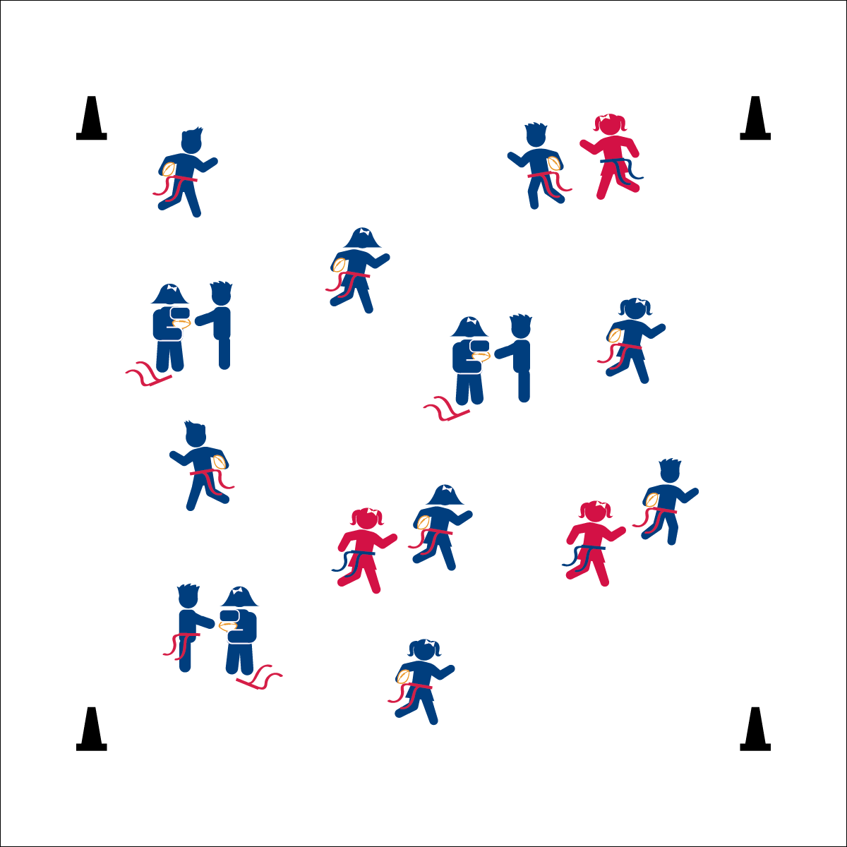

**HANDOFF HELPER TAG**

* Arms Ready,  
  Open the Window
* Move Through the Ball
* Ball to the Body,  
  Shut the Window
* **Skill:** I will travel safely in general space, keeping my eyes up while changing speeds appropriately.
* **Cognitive:** I will discuss the cues for safe handoffs.
* **Fitness:** I will stay actively engaged in the activity.
* **Personal & Social Responsibility:** I will demonstrate respect for others and follow all of the rules of the activity.

**Equipment:**

* 1 flag belt (or 2 scarves) per student
* 2–4 beanbags
* 3–5 foam footballs
* 4 cones as boundaries

**Set-Up:**

1. Use 4 cones to create a large activity area.
2. Scatter students in open space, each student wearing a flag belt (or substitute 2 scarves for belts).
3. Designate 2–4 players as defensive taggers. These players carry beanbags to identify them.
4. Designate 3–5 players as Handoff Helpers. These players carry foam footballs.

**Activity Procedures:**

1. Let’s play Handoff Helper Tag! This is another freeze-tag game with a fun twist. We’ll play at a galloping pace.
2. If you are frozen, make a handoff window with your arms. Handoff Helpers will find frozen players and unfreeze them by handing off their football. The unfrozen person becomes a new Handoff Helper, and the former helper joins the game and tries to avoid being tagged.
3. Handoff Helpers cannot be tagged.
4. Both frozen players and Handoff Helpers must focus on good handoff form, using the open side of the handoff window.

**Grade Level Progression:**

**K:** Play the game as described above without reinforcing handoff form. Focus on safe movement and following rules.

**1st–2nd:** Play the game as describe above with a focus on good handoff form.

**HANDOFF HELPER TAG**



* Use specific colors to make it easier to tell taggers apart from Handoff Helpers. For example, make sure all taggers have the same color bean bag, while handoff helpers have footballs that are a single different color.
* Change the size of the boundaries to benefit non-taggers.
* Give visual demonstrations of a proper handoff.



Defense, Etiquette, Fast, Gallop, General Space, Offense, Slow



* **Standard 2 (E3.K-1a)** Travels in general space with different speeds (K); Differentiates between fast and slow speeds (1a).
* **Standard 4 (E6.K-2)** Follows teacher directions for safe participation and proper use of equipment with minimal reminders (K); Follows teacher directions for safe participation and proper use of equipment without teacher reminders (1); Works independently and safely in physical education (2a);Works safely with physical education equipment (2b).



* **DOK 1:** How would you describe a handoff?
* **DOK 2:** How would you use a handoff in a football game?
* **DOK 2:** What did you notice about your handoff when you gave it to the tagged student?
* **DOK 3:** How would you describe the sequence of a handoff?



**Help students process content:** In this activity, a football handoff is used to introduce students to sport-specific skills in a lead-up game environment. Young students will have difficulty following skill cues in a dynamic environment. However, gentle reinforcement with a focus on safe behaviors provides challenge, interest, and fun to this early sport experience.

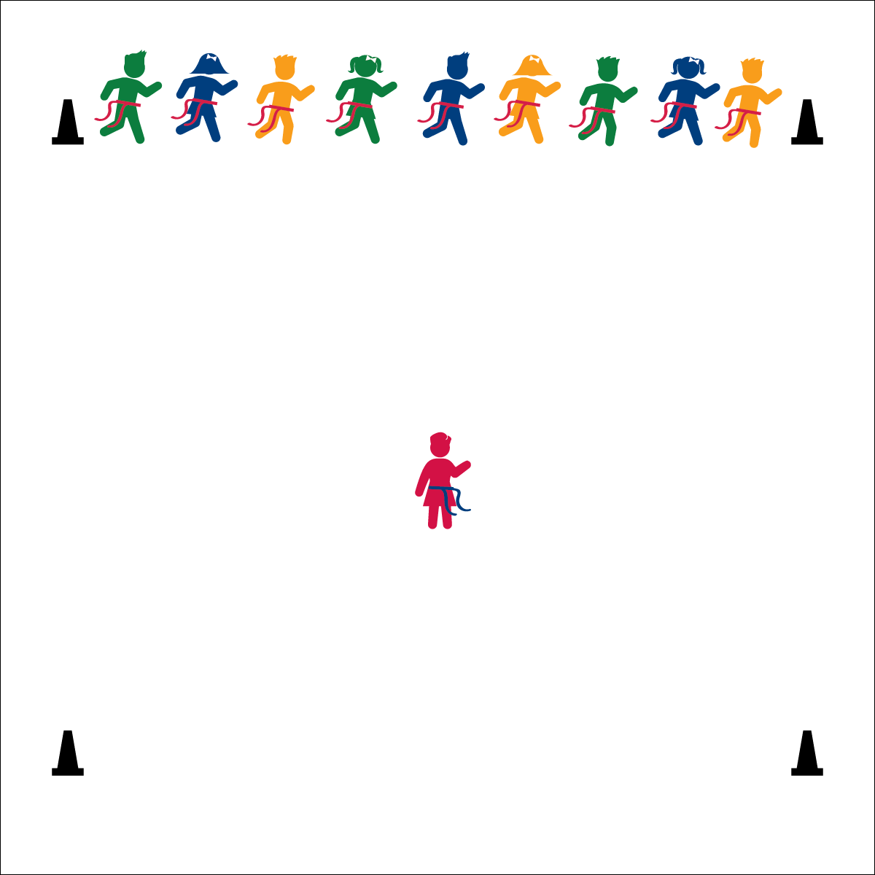

**SUPER SALAD BOWL TAG**

**Activity Procedures:**

1. To be a great football athlete, it’s important to have a healthful diet with a lot of vegetables. One of the best ways to eat veggies is in a salad! This game is called Super Salad Bowl Tag! We’re going to begin play at a speed-walking pace.
2. The object of the game is for the veggies to run through the salad bowl to the other side without having their flag pulled by the salad chef.
3. The game starts when the salad chef calls a veggie name. Only those veggies begin to move across the salad bowl. The salad chef tries to pull as many flags as she/he can.
4. If a veggie’s flag is pulled, she/he must freeze in place and help the salad chef catch more veggies. Tagged veggies can use 1 foot to pivot and must hold her/his own flag in 1 hand while using the other to reach out to pull other veggies’ flags.
5. After all veggie names are called, the chef and tagged veggies turn to face the opposite line, where the safe veggies are waiting to begin a new round. When most of the veggies have been tagged, reset the game with a new veggie chef.

**Grade Level Progression:**

**K:** Play with the teacher acting as the veggie chef.

**1st – 2nd:** Perform the activity as described above.

* Eyes Up and Alert
* Keep a Safe Speed
* Find Open Space
* **Skill:** I will perform a variety of locomotor skills.
* **Cognitive:** I will recognize different types of healthy foods that provide energy.
* **Fitness:** I will stay actively engaged in order to increase my heart rate.
* **Personal & Social Responsibility:** I will demonstrate safe and respectful behaviors.

**Equipment:**

* 1 flag belt (or 2 scarves) per student
* 6 cones to mark the activity area.

**Set-Up:**

1. Create a large, rectangular activity area using 6 cones. (2 cones mark starting line, 2 cones mark mid-field, 2 cones mark end line.)
2. Each student wearing a flag belt (or substitute 2 scarves for belts).
3. Line students up on the starting line. Create 2 or 3 groups of veggies (e.g., lettuce, tomatoes, carrots).
4. Choose 1 student to be the salad chef.

**SUPER SALAD BOWL TAG**



* Provide visual demonstrations of what students must do when their veggie is called, as well as what to do when they get tagged.
* Use a variety of speeds and locomotor skills.



Energy, Etiquette, Locomotor Skills, Nutrition, Respect, Responsibility



* **Standard 3 (E2.K-2)** Actively participates in physical education class (K); Actively engages in physical education class (1); Actively engages in physical education class in response to instruction and practice (2).
* **Standard 3 (E6.K-2)** Recognizes that food provides energy for physical activity (K); Differentiates between healthy and unhealthy foods (1); Recognizes the “good health balance” of good nutrition with physical activity (2).
* **Standard 4 (E1.K-2)** Follows directions in group settings (e.g., safe behaviors, following rules, taking turns) (K); Accepts personal responsibility by using equipment and space appropriately (1); Practices skills with minimal teacher prompting (2).



* **DOK 1:** What would you include on a list of information about vegetables?
* **DOK 1:** How would you describe the foods you eat?
* **DOK 2:** What do you know about vegetables?
* **DOK 2:** How can you use what you learned about healthy foods today?
* **DOK 2:** How would you summarize your eating habits?



**Identify critical content:** Physical activities and games provide opportunities for teachers to introduce and integrate critical nutrition content in a fun environment. These activities can also help students embrace and retain the information presented.

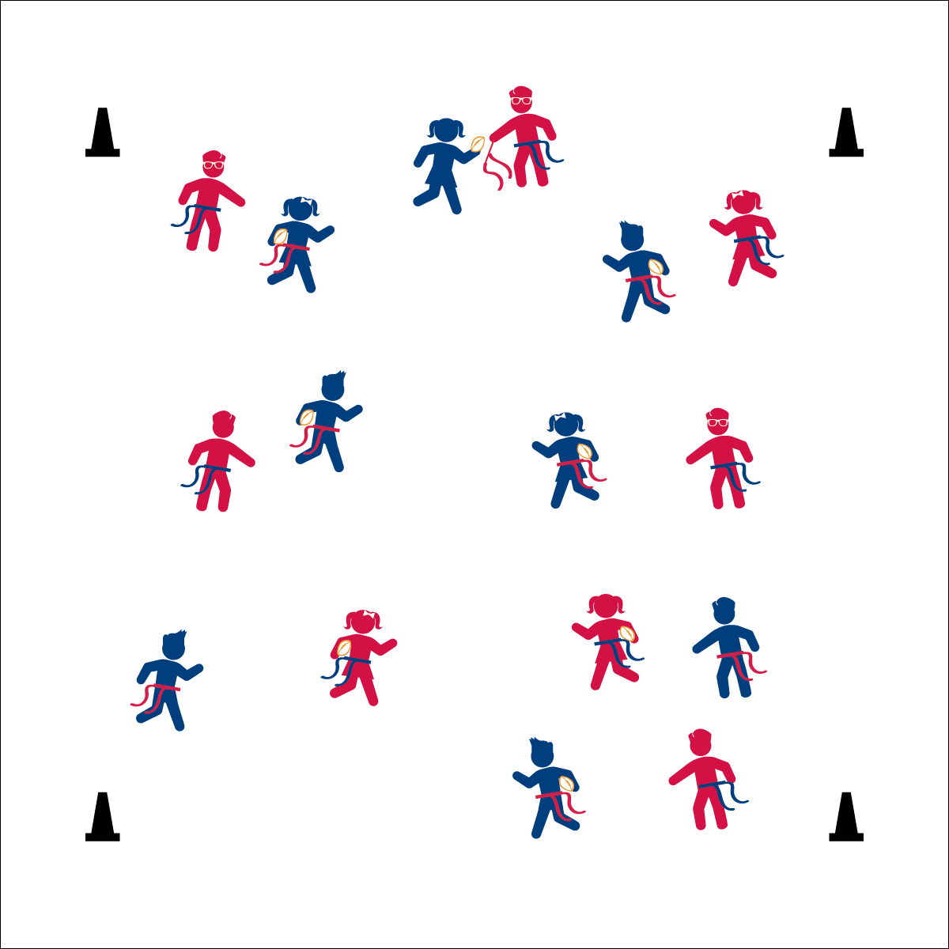

* **Skill:** I will perform a variety of locomotor skills while moving safely in general space.
* **Cognitive:** I will discuss the difference between *offense* and *defense*.
* **Fitness:** I will stay actively engaged.
* **Personal & Social Responsibility:** I will demonstrate respect for the rules and procedures of the activity.

**OFFENSE / DEFENSE TAG**

* Reach for the Flag
* Pull Down
* Hand it Back

**Equipment:**

* 1 flag belt (or 2 scarves) per student
* 1 foam football per 2 students
* 4 cones as boundaries

**Set-Up:**

1. Use 4 cones to create a large activity area.
2. Pair students, each student wearing a flag belt (or substitute 2 scarves for belts).
3. Scatter pairs in the activity area.
4. Designate 1 player from each pair as the defensive player and 1 as the offensive player. Each offensive player with a football.

**Activity Procedures:**

1. Now it’s time for Offense/Defense Tag. The object of the game is for the defensive player to catch and pull the flag of their offensive partner. This is a speed-walking game.
2. When I say “GO,” the defensive player will do 3 jumping jacks while the offensive player moves quickly away. After 3 jumping jacks, the defense may begin to chase the offense.
3. When tagged, the offense will hand the ball to the defense and the players change roles. The new defense will replace the flag belt, do 3 jumping jacks, and then begin to chase the new offense.
4. Players who move outside of the boundaries are automatically tagged, and roles switch.
5. Freeze when you hear the stop signal.

**Grade Level Progression:**

**K:** Keep this game at a speed-walking pace for safety.

**1st:** Use a variety of locomotor activities, increasing the pace of the game as students demonstrate safe movement.

**2nd:** Increase the size of the activity area and, after students demonstrate safe movement, increase the pace to a run.

**OFFENSE / DEFENSE TAG**



* Add a 3rd person to a group to give the defensive player a chance to tag another person.
* Change the size of the activity area.
* Allow students to perform arm circles or twists if they have difficulty with jumping jacks.



1v1, Chase, Defense, Dodge, Flee, General Space, Locomotor Skills, Offense, Respect



* **Standard 1 (E1.K-2)** Performs locomotor skills (hopping, galloping, running, sliding, skipping) while maintaining balance (K); Hops, gallops, jogs, and slides using a mature pattern (1); Skips using a mature pattern (2).
* **Standard 2 (E3.K-1a)** Travels in general space with different speeds (K); Differentiates between fast and slow speeds (1a).
* **Standard 4 (E6.K-2)** Follows teacher directions for safe participation and proper use of equipment with minimal reminders (K); Follows teacher directions for safe participation and proper use of equipment without teacher reminders (1); Works independently and safely in physical education (2a);Works safely with physical education equipment (2b).



* **DOK 1:** How would you describe your role on defense? Offense?
* **DOK 1:** How would you describe your speed on defense? Offense?
* **DOK 2:** How would you use different speeds in a football game?
* **DOK 2:** What did you notice about your speed when you changed directions?



**Help students examine similarities and differences:** The introduction of offense and defense as an important sport concept requires teachers to present information that may seem obvious within a coaching mindset, but will not be intuitive to young students. However, physical education provides many students with their first sport experiences. Take the time to address this new academic language while flushing out the similarities and differences between the concepts.

## 

**FIREWORK TAG**

**Activity Procedures:**

1. This activity is called Firework Tag. Many times, during half-time celebrations, professional football teams will have fireworks.
2. The object of this game is to avoid being tagged while also helping other players who have been tagged before they “explode” as a firework.
3. On the start signal, the defensive tagger will begin to chase and pull the flags of the offensive players. If your flag is pulled you will begin to “melt down” by raising your football high over your head and slowly lowering your body to the ground. Count down from 10-9-8-etc.
4. If another player comes and taps your shoulder before you reach 0, then you re-enter the game. If you count down to 0, then you must complete a firework jump, safely move to a hoop, place your football in the hoop, and then join the game as a new tagger.
5. Play continues until all players have become taggers.

**Grade Level Progression:**

**K:** Simplify by allowing students to re-enter the game after their countdown and firework jump. Change defensive taggers every so often.

**1st–2nd:** Perform the activity as described above.

* Count it Down
* Jump it Up
* Ball in the Hoop
* **Skill:** I will safely travel at different speeds.
* **Cognitive:** I will explain the difference between *fast* and *slow*.
* **Fitness:** I will work to stay actively engaged in the activity at different levels of intensity.
* **Personal & Social Responsibility:** I will be safe and responsible when using equipment.

**Equipment:**

* 1 flag belt (or 2 scarves) per student
* 1 foam football per student
* 4 hoops
* 4 cones as boundaries

**Set-Up:**

1. Use 4 cones to create a large activity area.
2. Place 1 hoops near each cone outside of the activity area.
3. Scatter students in the activity area, each student wearing a flag belt (or substitute 2 scarves for belts) and carrying a football.
4. Designate 1 player as a defensive tagger. Taggers do not carry footballs.

**FIREWORKS TAG**



Defense, Fast, General Space, Intensity, Nutrition, Offense, Slow



* Give visual demonstrations.
* Provide visual or verbal cues to help students count down after being tagged.



* **Standard 2 (E3.K-1a)** Travels in general space with different speeds (K); Differentiates between fast and slow speeds (1a).
* **Standard 3 (E1.K-2)** Identifies active play opportunities outside physical education class (K); Discusses the benefits of being active and exercising/playing (1); Describes large-motor and/or manipulative physical activities for participation outside physical education class (e.g., before and after school, at home, at the park, with friends, with the family) (2).
* **Standard 5 (E1.K-2)** Recognizes that physical activity is important for good health (K); Identifies physical activity as a component of good health (1); Recognizes the value of “good health balance” (2).



* **DOK 1:** How would you describe the speed of the activity?
* **DOK 2:** How did holding the football affect your speed in the activity?
* **DOK 2:** What did you notice about the activity area when there were more taggers?
* **DOK 2:** How can you apply what you learned to develop a strategy to not get tagged?



**Review content:** Take an opportunity to review as many skills and concepts as you can as the module comes to a close. Check for understanding, highlight cumulative progress, and celebrate learning.