­­­

* 1v1
* Chase
* Dodge
* Fast
* General Space
* Slow

­

* **Skill:** I will travel safely in general space at different speeds.
* **Cognitive:** I will discuss the difference between *fast* and *slow* during our class discussion.
* **Fitness:** I will stay actively engaged in the activity.
* **Personal & Social Responsibility:** I will be respectful of other students’ personal space and follow the teacher’s direction.
* **Standard 1 (E1.K-2)** Performs locomotor skills (hopping, galloping, running, sliding, skipping) while maintaining balance (K); Hops, gallops, jogs, and slides using a mature pattern (1); Skips using a mature pattern (2).
* **Standard 2 (E3.K-1a)** Travels in general space with different speeds (K); Differentiates between fast and slow speeds (1a).
* **Standard 4 (E1.K-2)** Follows directions in group settings (e.g., safe behaviors, following rules, taking turns) (K); Accepts personal responsibility by using equipment and space appropriately (1); Practices skills with minimal teacher prompting (2).
* Student Self-Assessment

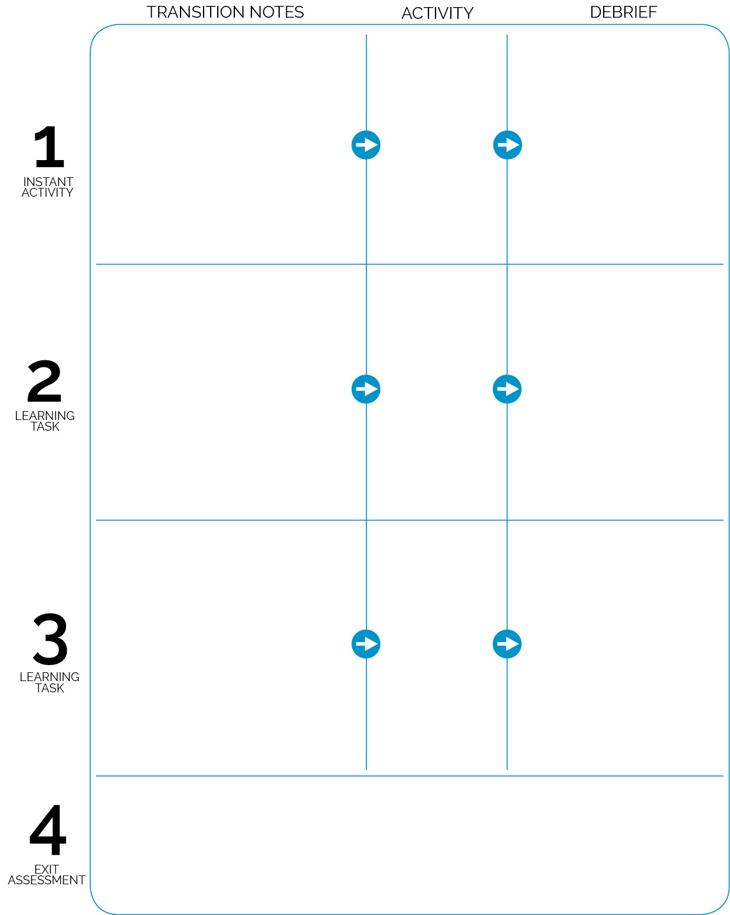

1v1 Tag

Slow-Motion Tag

**DOK 1:** What is *chasing*? What is *fleeing*?

**DOK 2:** What safety rules do you know about that help keep us safe while we’re chasing and fleeing in physical education class?

**DOK 1:** What does *slow* mean? *Fast*?

**DOK 1:** How would you describe your speed during this game?

**DOK 2:** How did your speed affect the way you were able to dodge other students?

Tag of the Month from OPEN’s Instant Activities Module

* **DOK 1:** What does *offense* mean? *Defense*?
* **DOK 2:** How would you compare and contrast *offense* and *defense*?
* **DOK 2:** What did you notice about general space and being safe?

Project the self-assessment onto the wall. As a class, discuss and complete the pre-assessment for safe movement and flag pulling.

Students enter the activity area and prepare for the Tag of the Month. This game is played without flags to review previously taught tag rules and procedures. Flags are introduced after this 1st activity.

Introduce flag belts with instructions for wearing, pulling, and replacing. Pair students and allow them to practice safely pulling their partner’s flag, handing it back to her/him, and then replacing it on their waist. When students can safely perform this skill, scatter in activity area and begin Slow-Motion Tag.

Pair students. Call 1 partner to the equipment area to collect 1 spot. When all pairs have a spot, demonstrate the activity with a pair of students who have shown good safety behaviors.