­­­

* Word
* Word
* Word

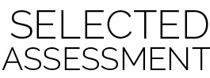­

* **Skill:** I will
* **Cognitive:** I will
* **Fitness:** I will
* **Personal & Social Responsibility:** I will
* **Standard X (EX.K-2)** Standard language here…
* **Standard X (EX.K-2)** Standard language here…
* Assessment Name

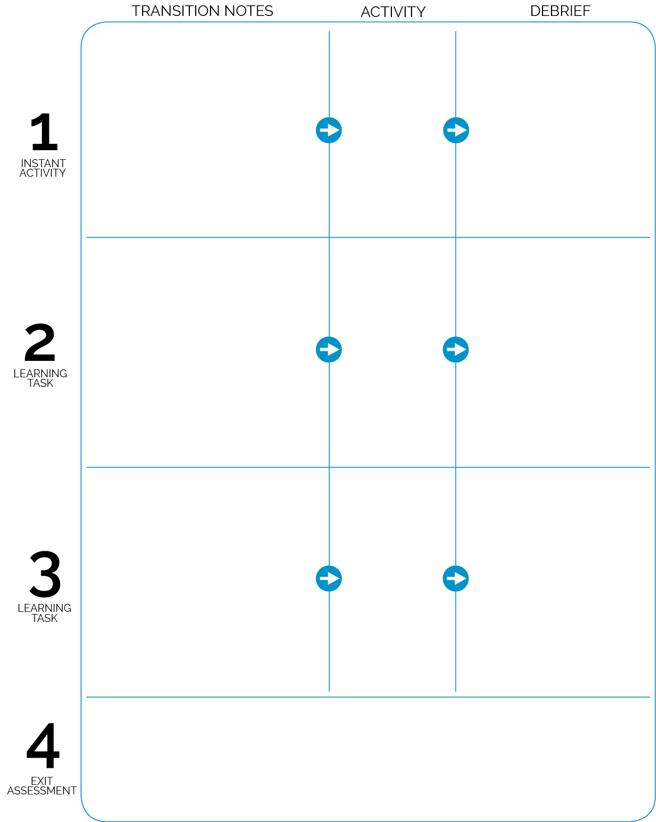

Activity 3

Activity 2

**DOK 1:** Q1

**DOK 2:** Q2

**DOK 3:** Q3

**DOK 1:** Q1

**DOK 2:** Q2

**DOK 3:** Q3

Activity 1

**DOK 1:** Q1

**DOK 2:** Q2

**DOK 3:** Q3

Assessment instructions

Transition 1

Transition 2

Transition 3