­­

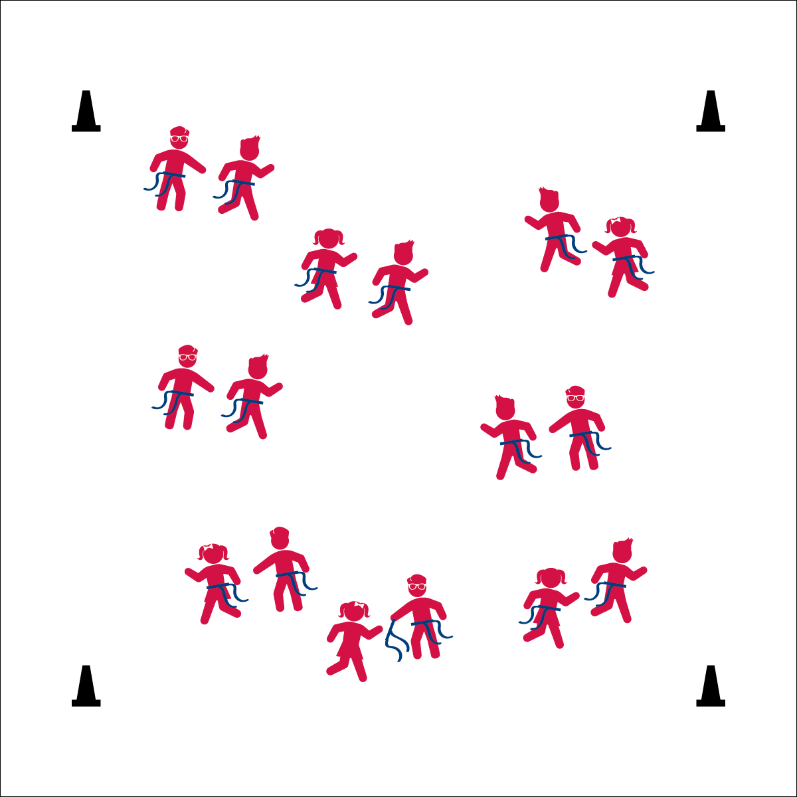

**Equipment:**

* Equip 1
* Equip 2

**Set-Up:**

1. Set up 1
2. Set up 2

* CUE 1
* CUE 2
* CUE 3

**ACTIVITY NAME**

* **Skill:** I will
* **Cognitive:** I will
* **Fitness:** I will
* **Personal & Social Responsibility:** I will

**Activity Procedures:**

1. Today we’re going to… The object is…
2. On the start signal…
3. On the stop signal…

**Grade Level Progression:**

**K:** Progression…

**1st:** Progression…

**2nd:** Progression…

**ACTIVITY NAME**



* **Standard X (EX.K-2)** Standard language here…
* **Standard X (EX.K-2)** Standard language here…



* UDA 1
* UDA 2



Words, Words, Words



* **DOK 1:** Q1
* **DOK 2:** Q2
* **DOK 2:** Q3



**Strategy Here:** Description here….