­­

**SELF-PASSING CHALLENGES**

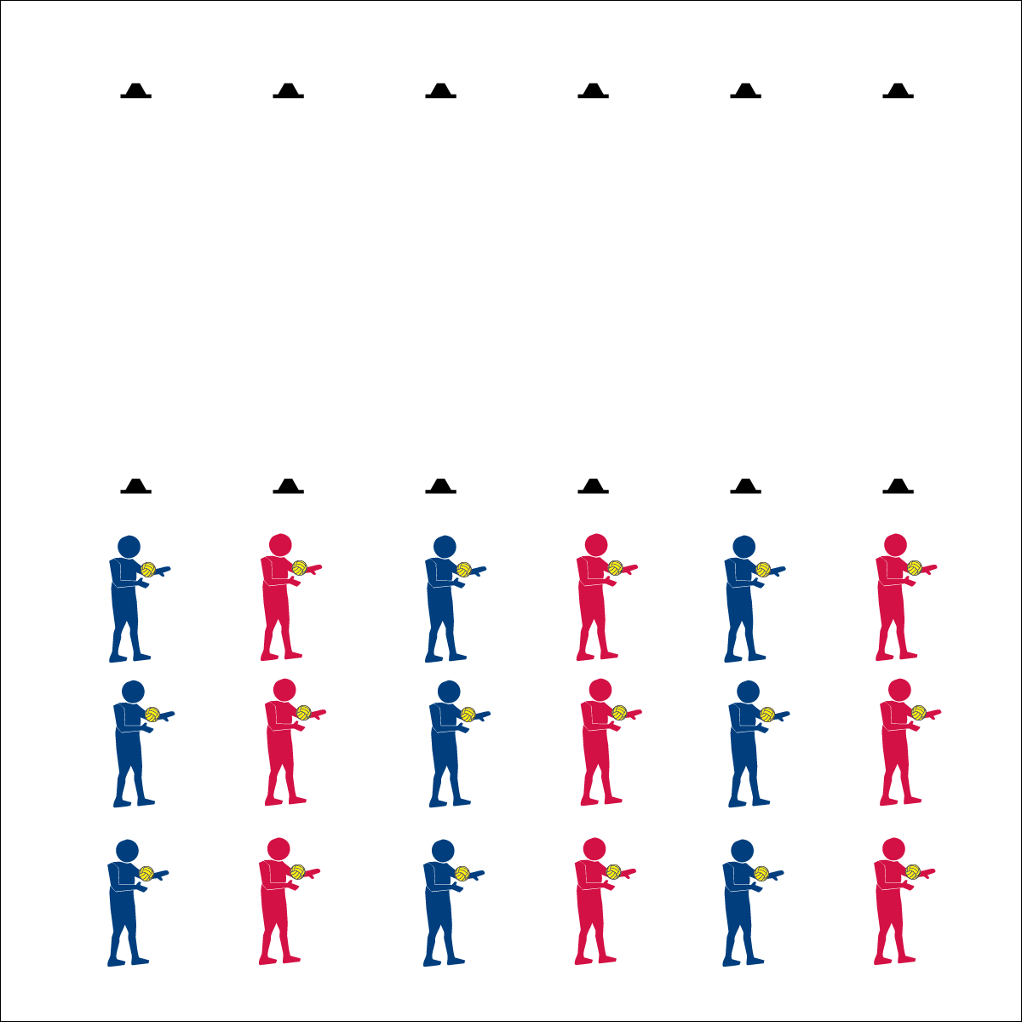

* Athletic Stance (Feet, Knees, Hands, Eyes Ready)
* Hand Placement
* Palm Strike (Palm Flat, Strike Between Heel & Fingers)
* **Skill:** I will demonstrate below-chest and above-chest passes.
* **Cognitive:** I will discuss skill-related fitness.
* **Fitness:** I will work to improve my skill-related fitness.
* **P&S Responsibility:** I will listen to feedback and use suggestions to improve my Roundnet skills.

Roundnet Featuring Spikeball

**Equipment:**

* 2 low-profile cones per group of 2–3 students
* 1 foam ball per group of 2–3 students
* 1 Self-Passing Challenge Card per group of 2–3 students
* 1 Passing Cue Chart per group of 2–3 students

*(Use Spikeballs® if they are available)*

**Set-Up:**

1. Create 6 or more lines using low-profile cones.
2. Divide students into groups of 2 or 3, each group with a foam ball.
3. Line up each group behind a cone. Provide students with enough personal space for moderate activity.

**Activity Procedures:**

1. Today we’re going to start our Roundnet training by completing a series of self-passing challenges. There are two types of passes used in Roundnet: 1) Below-Chest; 2) Above-Chest.
2. Both passes require you to be ready in an athletic stance, use proper hand placement, and use a Palm Strike to hit the ball (demonstrate and practice critical elements).
3. Below-chest passing requires hand placement at waist level, palms out, fingers away from the body.
4. Above-chest passing requires hands at shoulder level, palms out, fingers pointing up toward the head.
5. On the start signal, work to complete the self-passing challenges found on the Challenge Card. Reach JV level with 10 successful self-passes. Reach Varsity level with 20 successful self-passes.
6. Freeze and be ready to listen when you hear the stop signal.

**Grade Level Progression:**

* Appropriately communicates suggestions for improvement and assistance to partners.
* Works with a partner to develop a plan of action for improving challenge performance.



* **DOK 1:** What are the components of skill-related fitness?
* **DOK 2:** Which components affect Roundnet performance? Why? Provide evidence.
* **DOK 3:** How would you adapt one (or several) of the self-passing challenges to work on specific components of skill-related fitness (e.g., coordination)?



* **Standard 3 [M7.6-8]:** Identifies the components of skill-related fitness (6); Distinguishes between health-related and skill-related fitness (7); Compares and contrasts health-related fitness components (8).