­­

**Partner-PASSING**



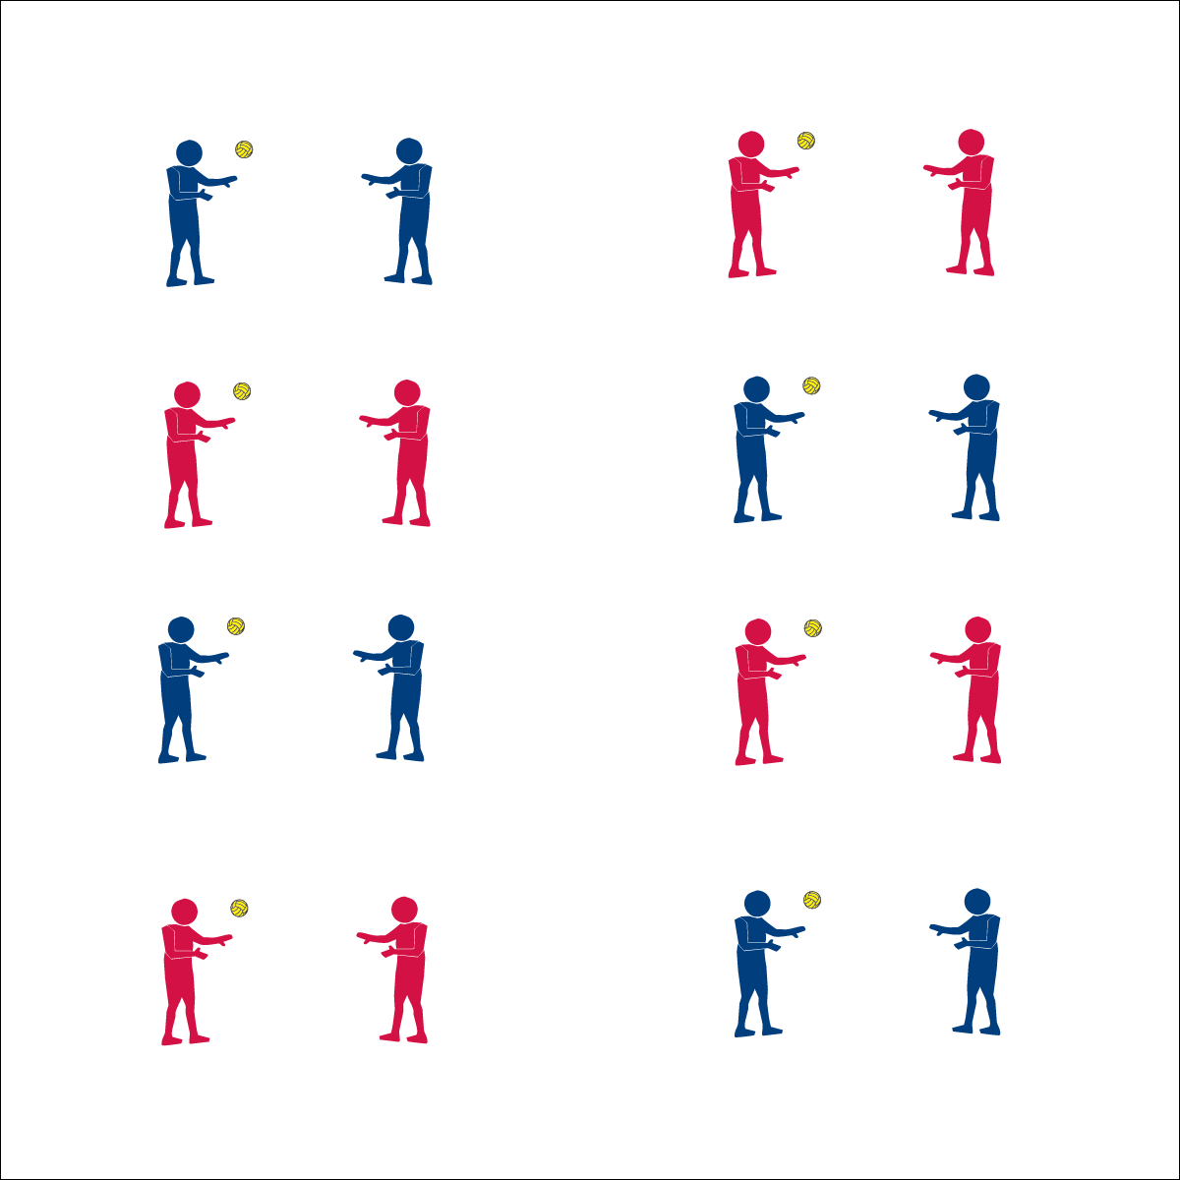



* **DOK 1:** What is health-related fitness?
* **DOK 2:** How would you compare/contrast health-related with skill-related fitness?
* **DOK 3:** How do you think skill-related fitness relates to health-related fitness? How do each of these relate to Roundnet?



* **Standard 4 [M4.6-8]:** Accepts differences among classmates in physical development, maturation, and varying skill levels by providing encouragement and positive feedback (6); Demonstrates cooperation skills by establishing rules and guidelines for resolving conflicts (7); Responds appropriately to participants’ ethical and unethical behavior during physical activity by using rules and guidelines for resolving conflicts (8).

**Activity Procedures:**

1. We’re going to continue our Roundnet passing drills by completing a series of partner passing challenges. This will give us more advanced practice with the below- and above-chest passes.
2. Remember, both passes require you to be ready in an athletic stance, use proper hand placement, and use a Palm Strike to hit the ball.
3. On the start signal, begin working to complete the partner passing challenges found on the Challenge Card. Reach JV level with 10 successful partner passes. Reach Varsity level with 20 successful partner passes.
4. Freeze and be ready to listen when you hear the stop signal.

**Grade Level Progression:**

* Discuss how Roundnet practice can affect health- and skill-related fitness.
* Discuss how health- and skill-related fitness components relate to Roundnet. More specifically, discuss how each component can impact an individual’s performance**.**

**Equipment:**

* 1 foam ball per 2 students
* 4-8 Partner Passing Challenge Cards

*(Use Spikeballs® if they are available)*

**Set-Up:**

1. Pair students, each pair with a ball.
2. Post several Partner Passing Challenge Cards throughout the activity area for students to see and reference.

* Accurate Passes
* Maintain Balance
* Offer Encouragement
* **Skill:** I will make accurate passes to my partner.
* **Cognitive:** I will compare health- and skill-related fitness.
* **Fitness:** I will work to improve my skill-related fitness.
* **P&S Responsibility:** I will encourage my classmates by offering positive feedback on their performance.

Roundnet Featuring Spikeball