­­

**SELFIE SPIKES**



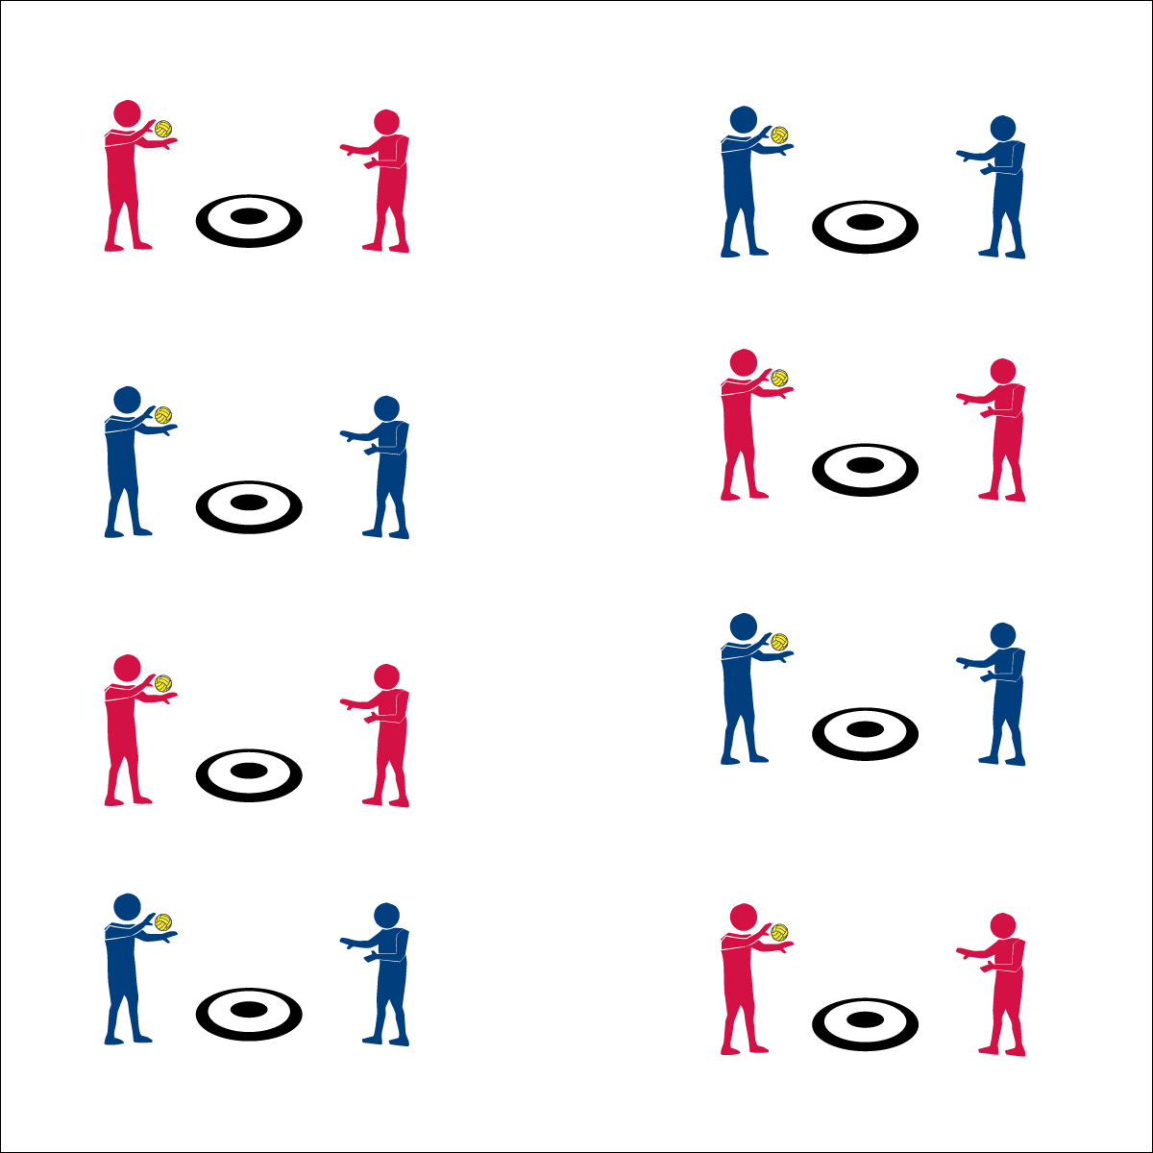

**Equipment:**

* 1 hoop per 2 students
* 1 spot marker per 2 students
* 1 ball per 2 students

*(Use Spikeball® sets if they are available)*

**Set-Up:**

1. In a large activity area, place 1 spot marker and 1 ball in the center of each hoop.
2. Pair students, each pair at a hoop.



* **Standard 1 [M13.6-8]:** Strikes with a mature overarm pattern in a non-dynamic environment for net/wall games such as volleyball, handball, badminton, or tennis (6); Strikes with a mature overarm pattern in a dynamic environment for net/wall games such as volleyball, handball, badminton, or tennis (7); Strikes with a mature overarm pattern in a modified game for net/wall games such as volleyball, handball, badminton, or tennis (8).

**Activity Procedures:**

1. This activity is called Selfie Spikes. The object is to land your spikes inside the hoop.
2. On the start signal, your partner will toss you the ball just above waist level. Self-pass the ball and then spike it into the hoop.
3. Complete 5 attempted spikes and then change roles.
4. When you believe you’ve mastered the hoop at level 1, move to level 2 and attempt to hit the spot marker with each spike.
5. When you hear the stop signal, hold the ball and be ready to listen.

**Grade Level Progression:**

* Works with partner to develop a plan of action for improving personal performance.
* **Skill:** I will spike the ball with a mature striking pattern.
* **Cognitive:** I will develop a plan for improving spiking skills.
* **Fitness:** I will discuss how coordination relates to Roundnet.
* **P&S Responsibility:** I will promote a positive activity environment for all.



* **DOK 1:** What are the cues for a mature spike?
* **DOK 2:** How did you apply these cues in the Selfie Spike activity?
* **DOK 3:** How are the cues related to successful spiking?
* Partner Toss
* Self-Pass
* Accurate Spike

Roundnet Featuring Spikeball