­­

**RALLY TIME**



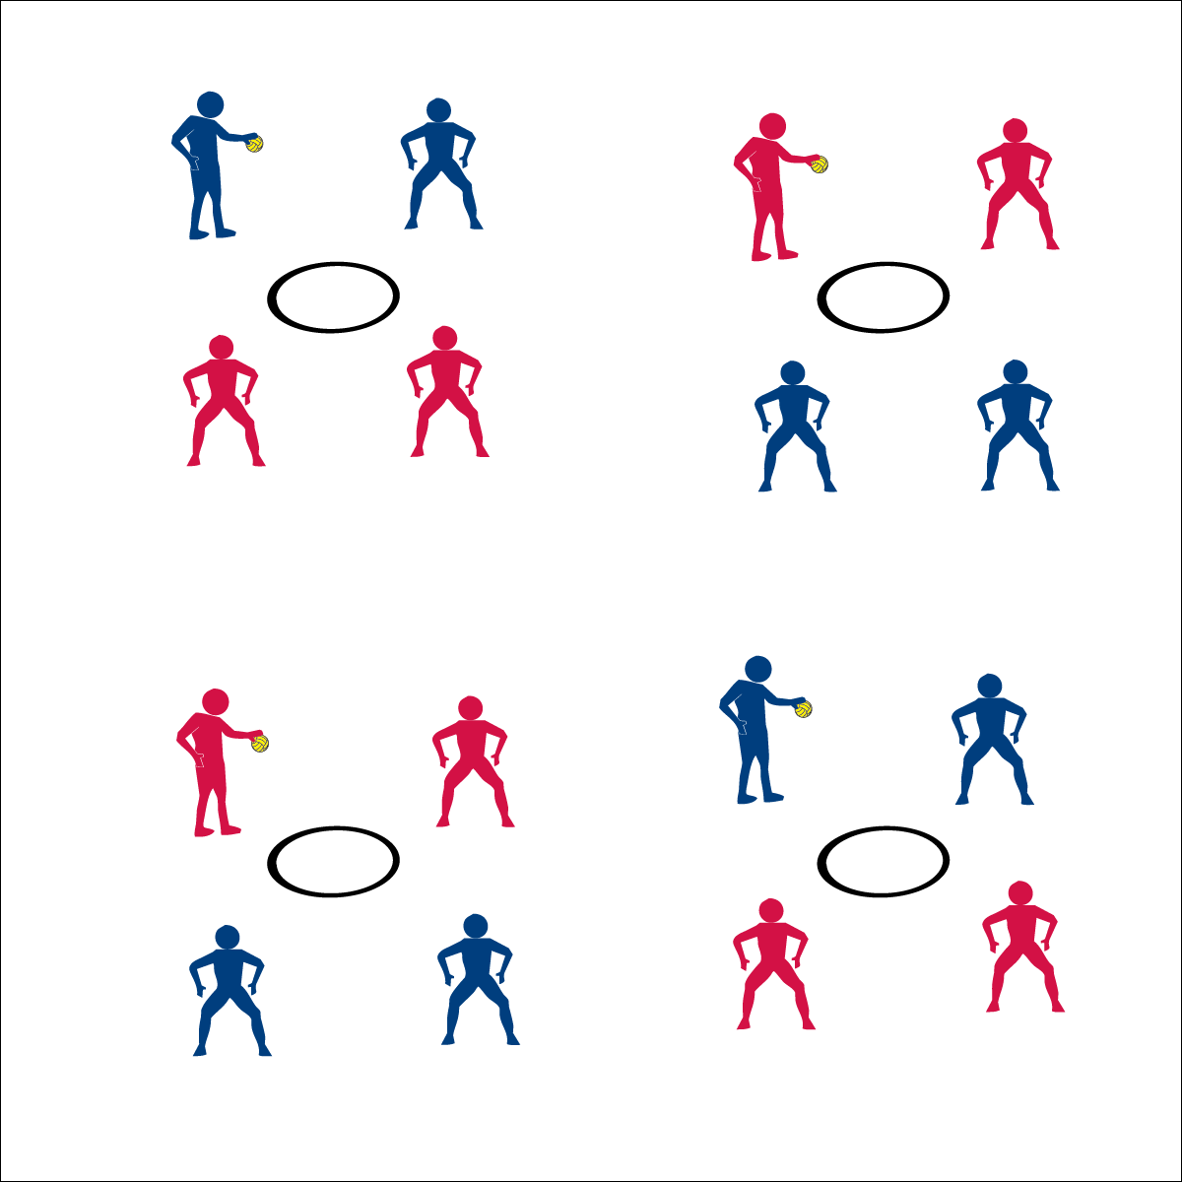

* **Skill:** I will spike and pass using all skill cues.
* **Cognitive:** I will discuss the importance of cooperation in this activity.
* **Fitness:** I will stay actively engaged in Rally Time.
* **P&S Responsibility:** I will demonstrate respect by providing encouraging feedback to my teammates.

**Equipment:**

* 1 hoop per group of 4 students
* 1 ball per group of 4 students

*(Use Spikeball® sets if they are available)*

**Set-Up:**

1. In a large activity area, place 1 spot marker and 1 ball in the center of each hoop.
2. Pair students and send 2 pairs to each hoop.



* **Standard 1 [H1.L1-L2]:** Demonstrates competency and/or refines activity-specific movement skills in two or more lifetime activities (outdoor pursuits, individual-performance activities, aquatics, net/wall games or target games) (L1); Refines activity-specific movement skills in one or more lifetime activities (outdoor pursuits, individual-performance activities, aquatics, net/wall games or target games) (L2).

**Activity Procedures:**

1. Today’s activity is a cooperative game called Rally Time.
2. The object of the activity is to build a rally with consecutive Roundnet passes and spikes.
3. Begin each rally with a tossed serve to a member of the opposite team. Teams have a maximum of 3 hits (2 passes and 1 spike) to send the ball down to the net for a change of possession.
4. Each change of possession scores a rally point. Score 10 consecutive possession changes to achieve JV status. Score 20 to achieve Varsity status
5. Hold the ball and be ready to listen when you hear the stop signal.

**Grade Level Progression:**

* Provide students with time to choose and implement a practice task based on skills they’ve identified as needing improvement.



* **DOK 1:** What is a rally?
* **DOK 2:** How would you apply purposeful practice concepts in Rally Time?
* **DOK 3:** How would you adapt Rally Time to make it easier? More challenging?
* Toss Serve
* Control a Pass
* Accurate Spike

Roundnet Featuring Spikeball