­­

**Disc TAg**



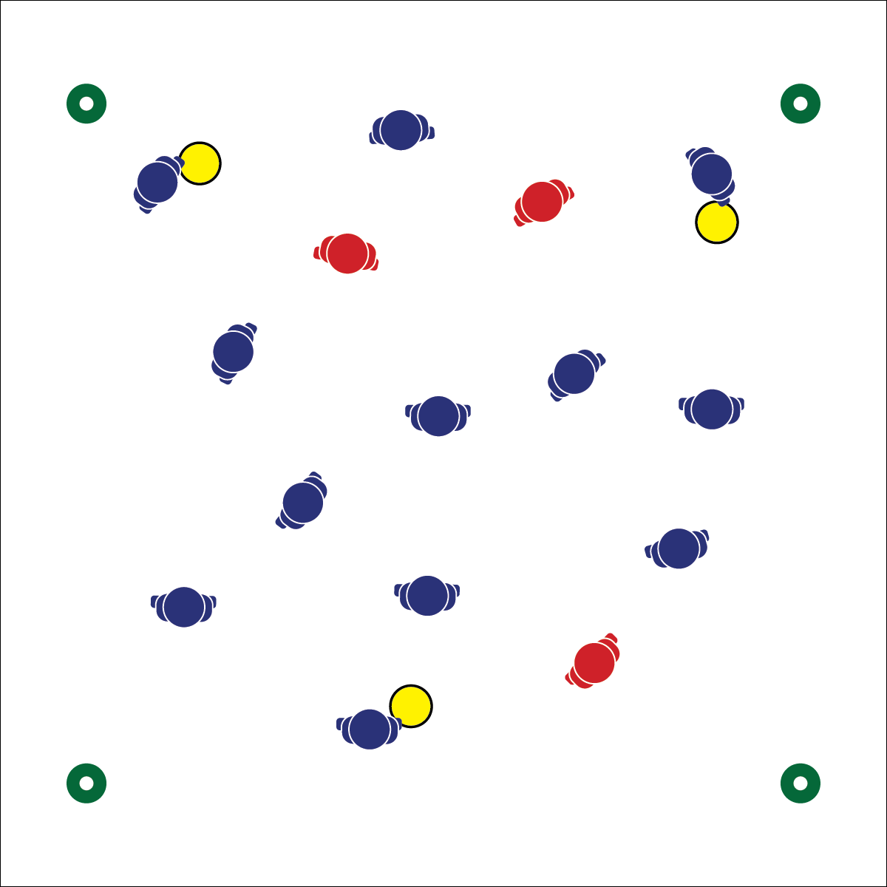

**Activity Procedures:**

1. Today’s activity is called Disc Tag. The object is for the taggers to tag all students, and for the rest of the class to avoid getting tagged. Focus your skill practice on how to throw and catch a disc.
2. Players wearing pinnies are the taggers, and players holding discs are Savers. Savers will free those who have been tagged. Players with discs cannot be tagged.
3. If you are tagged, you must perform jumping jacks (or another exercise) until a disc is tossed to you by a Saver. Throw the disc back to the same Saver after you catch it. Throws must be made from at least 10 feet away.
4. Play several rounds, switching Savers and Taggers.

**Grade Level Progression:**

* Add a give-and-go to each throw. Saver makes a toss and then cuts to open space for the return toss.
* Allow Taggers to knock down tosses. If a toss is knocked down, Savers find a new player to save.



* **DOK 1:** What are examples of lifetime recreational sports?
* **DOK 2:** What have you learned in physical education that applies to 1 or more recreational sport?
* **DOK 3:** What facts would you select to support the importance of recreational sport participation in college? Can you elaborate on why you chose those facts?

**Equipment:**

* 3 pinnies
* 3 foam discs
* 4 low-profile cones

**Set-Up:**

1. Use low-profile cones to create a large activity area. Scatter students in the area.
2. Give pinnies to 3 students and foam discs to 3 different students.



* **Standard 1 [M4.6]** Passes and receives with hands in combination with locomotor patterns of running and change of direction and speed with competency in invasion games such as ultimate (6).
* **Standard 1 [H1.L1]** Demonstrates competency and/or refines activity-specific movement skills in two or more lifetime activities (target games) (L1).

Ultimate

* **Skill:** I will demonstrate a pancake catch using skill cues.
* **Cognitive:** I will discuss the importance of improving skills.
* **Fitness:** I will identify lifetime recreational sports and discuss the importance of participation.
* **P&S Responsibility:** I will use language that promotes positive team dynamics.
* 2 Hands Out in Front
* Palms Facing Each Other
* Snap Together