­­

**Over There**



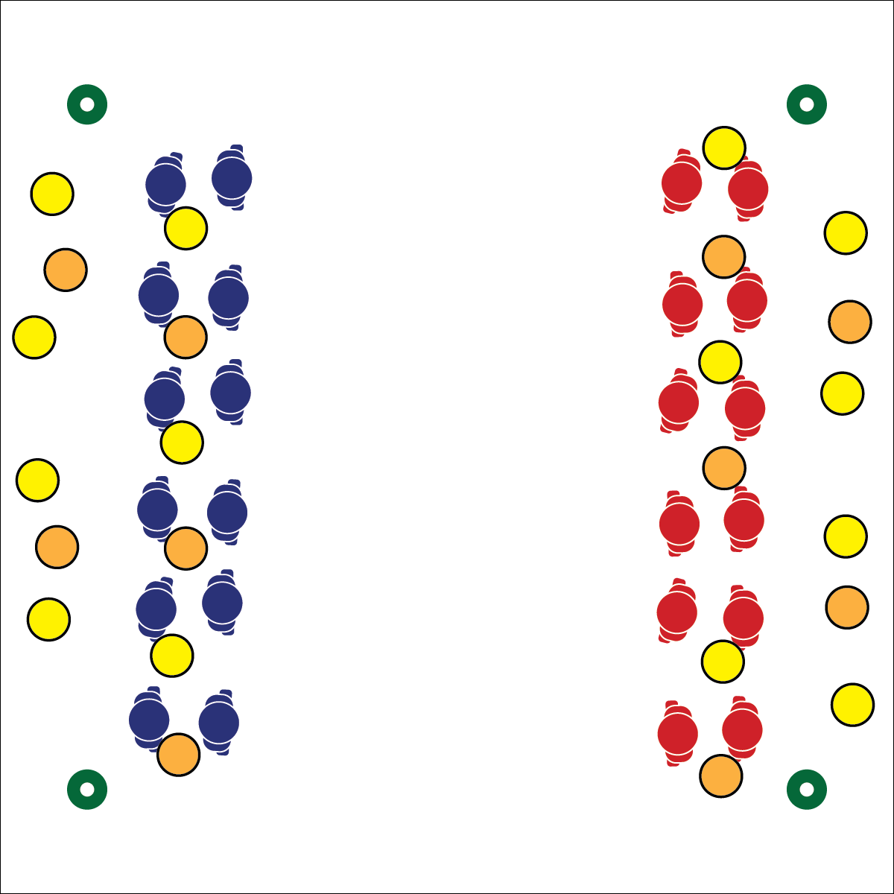

**Equipment:**

* 12 foam discs
* 12 foam balls
* 4 cones per team
* Pinnies for half of all the students

**Set-Up:**

1. Use cones to create end zones at each end of a large activity area.
2. Divide and scatter foam discs and balls inside each team’s end zone.
3. Create 2 equal teams, and pair students within their teams. Students start inside their end zones with their partner.



* **Standard 4 [M4.6-8]** Accepts differences among classmates in physical development, maturation, and varying skill levels by providing encouragement and positive feedback (6); Demonstrates cooperation skills by establishing rules and guidelines for resolving conflicts (7); Responds appropriately to participants’ ethical and unethical behavior during physical activity by using rules and guidelines for resolving conflicts (8).
* **Standard 4 [H3.L1-2]** Uses communication skills and strategies that promote team/group dynamics (L1); Assumes a leadership role (e.g., task or group leader, referee, coach) in a physical activity setting (L2).

**Activity Procedures:**

1. Today’s activity is called Over There. Your team’s goal is to get all your foam discs and balls past the other team’s end line to score a point. You will work with a partner who is the same team as you to pass and catch objects, moving them into the opposite end zone.
2. Students holding a foam disc/ball cannot travel with the object, they can only pivot in place. Forward progress is made with a pass to your partner. The ball must advance into the end zone with a pass.
3. After a score is made, players return to their end zone, pick up a new disc/ball and begin again.

**Grade Level Progression:**

* Combine pairs into groups of 4. Every player in a group must receive a catch before a score is made.
* Designate 1–3 defensive players on each team. They can intercept passes and jog to the end zone.

Ultimate

* **Skill:** I will demonstrate cooperation skills with my partner.
* **Cognitive:** I will discuss various cooperation skills.
* **Fitness:** I will actively engage in Over There.
* **P&S Responsibility:** I will accept differences among my teammates in varying skill levels.
* Listen
* Share Thoughts and Ideas
* Keep an Open Mind
* Use Positive Language



* **DOK 1:** What would you include on a list about cooperation skills?
* **DOK 2:** What do you know about each of these skills?
* **DOK 3:** What is your interpretation of how well your team used cooperation skills? Provide examples.