­­

**Capture the corner**



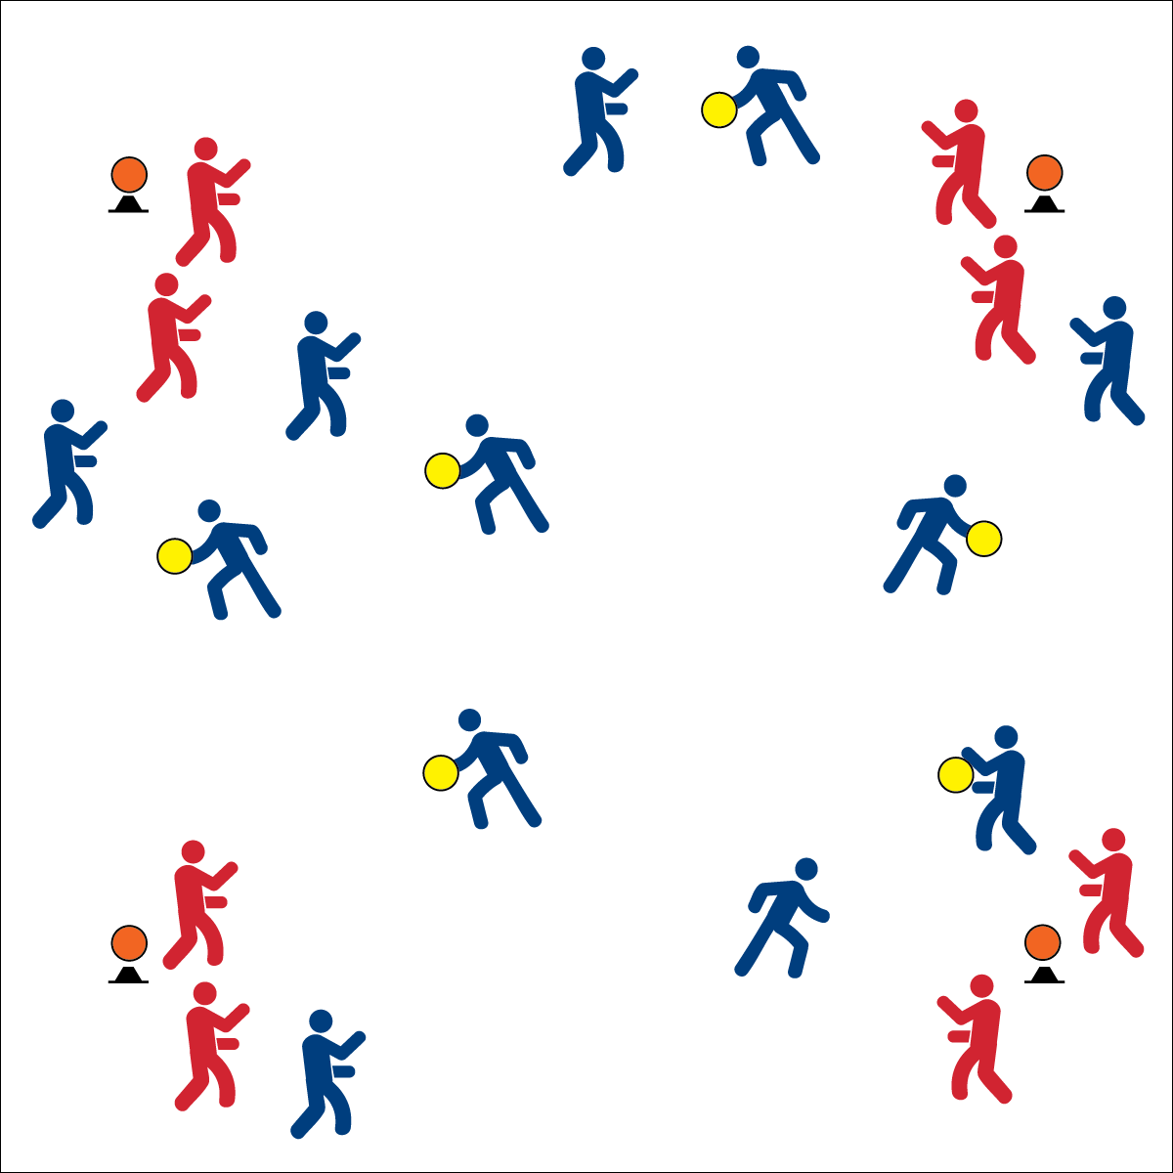

* **Skill:** I will create open space by staying spread out on offense.
* **Cognitive:** I will discuss force, speed, and accuracy as it relates to passing and receiving.
* **Fitness:** I will stay actively engaged on offense and defense.
* **PSR:** I will work cooperatively with my partner.



* **DOK 1:** How can you recognize open space?
* **DOK 2:** How would you apply cutting, fakes, and passing to create open space?
* **DOK 3:** How well did you apply these strategies? Support your answer with examples.

**Activity Procedures:**

1. It’s time to play Capture the Corner.
2. The object of the game is for offensive teams to “capture” the corners by throwing their foam discs and knocking a foam ball off its cone. Defensive teams work to block offensive shots on their cone.
3. If a corner is “captured,” the team who captured it scores a point and changes roles with that cone’s defense.
4. When you’re holding your disc, you cannot take any steps—you can only pivot. Players “off the disc” can move throughout the activity area using quick cuts and fakes in order to move into spaces with open passing lanes.
5. Defensive players must stay within 4 feet of their assigned cone and cannot touch the cone or the foam ball with any part of their body. Begin on the start signal. Freeze on the stop signal.

**Grade Level Progression:**

* Play with teams of 3 to 4 students.
* Add pairs of field defenders that move throughout the activity area. If a disc is intercepted, teams switch roles.



* **Standard 2 [M3.6-8]** Creates open space by using the width and length of the field/court on offense (6); Creates open space by staying spread on offense, and cutting and passing quickly (7); Creates open space by staying spread on offense, cutting, and passing quickly, and using fakes off the ball (8).
* **Standard 2 [H2.L1-2]** Uses movement concepts and principles (e.g., force, motion, rotation) to analyze and improve performance of self and/or others in a selected skill (L1); Describes the speed/accuracy trade-off in throwing and striking skills (L2).

**Equipment:**

* 4 cones
* 4 foam balls
* 4 hoops
* 1 disc per 2 students (or group of 3 students)

**Set-Up:**

1. Create a large activity area with 1 cone in each corner and a ball balanced on top of each cone. (Use 6 cones/balls for larger class sizes and activity spaces.)
2. Students work in pairs. Send 1 pair to each cone to play defense (they do not need a disc). Other pairs begin scattered in general space, each pair with a disc.

Ultimate

* Pass and Then Move
* Catch, Turn, Look for Open Space
* Talk to Your Teammate