­­

**Switch**



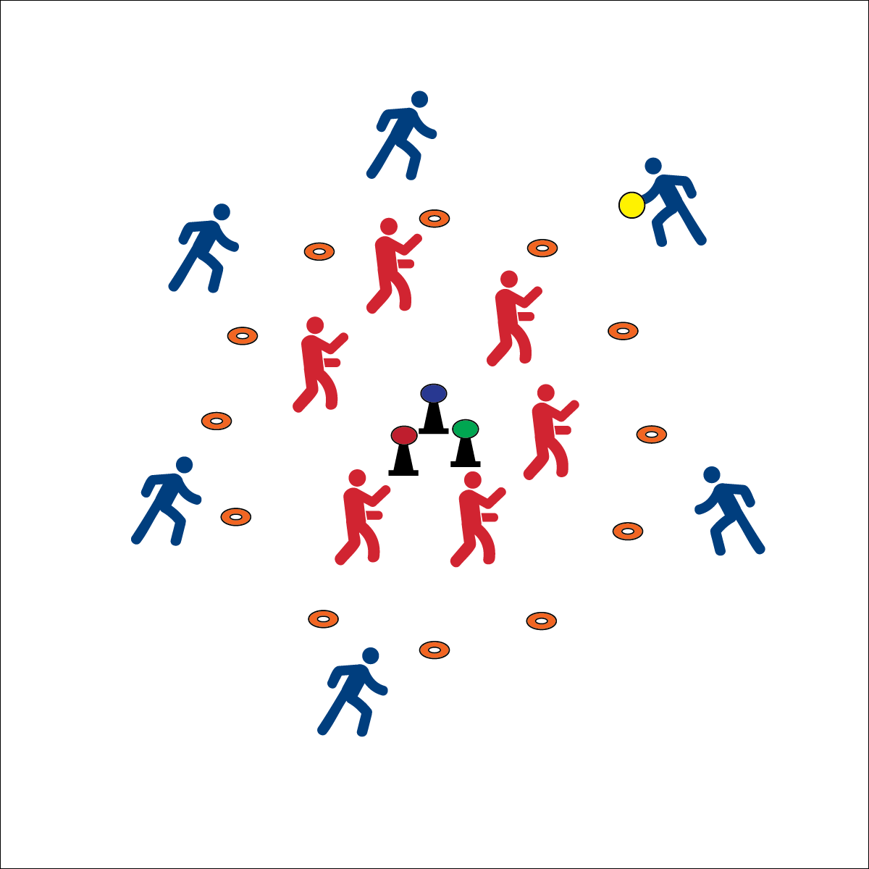

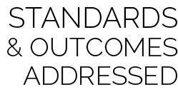

* **Standard 2 [M2.6-8]** Executes at least 1 the following offensive tactics to create open space: moves to open space without the ball; uses a variety of passes; uses pivot, fake, or give & go (6); Executes at least 2 of the following offensive tactics to create open space: give & go; a variety of passes; fakes, pivot) (7); Executes at least 3 of the following offensive tactics to create open space: moves to create open space on and off the ball; uses a variety of passes, fakes, and pathways; give & go (8).



* **DOK1:** What does it mean to have an offensive advantage?
* **DOK 2:** What skills and strategies help you gain an offensive advantage?
* **DOK 3:** How is the movement of players without the fly disc related to offensive advantage?

**Activity Procedures:**

1. Today’s activity is called Switch. The object of the game is for the offense to score a goal. Three passes must be made before a shot is taken.
2. When a goal is scored or an interception is made (defense gains possession), players yell, “SWITCH!” On this signal, teams switch; offense becomes defense and defense becomes offense.
3. The new offensive team must complete 3 passes before a shot is taken.
4. Defensive teams stay inside the cones but may move throughout the defensive area. Offense must stay outside cones but may move throughout the offensive area. Continue play until you hear the stop signal.

**Grade Level Progression:**

* Add a second flying disc to the activity.

**Equipment:**

* 3 cones per 12 students
* 3 foam balls per 12 students
* 1 flying disc per 12 students
* 12 low profile cones per 12 students
* 1 pinnie per 2 students.
* **Set-Up:**

1. Create Create 1 activity area per 12 students with 3 cones in the center of each area. Foam balls on the cones.
2. Create 8 to 10 paces from the cones using 12 low profile cones. This creates a defensive area inside and an offensive area outside.
3. Create teams of 6 students with 1 team inside the circle area (defense) and 1 team outside the circle area (offense). The team starting on offense wears pinnies.

* **Skill:** I will demonstrate throwing cues for accurate passing.
* **Cognitive:** I will identify and discuss basic skills and strategies need to gain an offensive advantage.
* **Fitness:** I will remain actively engaged.
* **PSR:** I will work safely while staying active.

Ultimate

* Offense: Space, Movement, Pass, Shoot
* Defense: Ball/Opponent, Angles, Space, Force Outside