­­

**Ghosts in the graveyard**



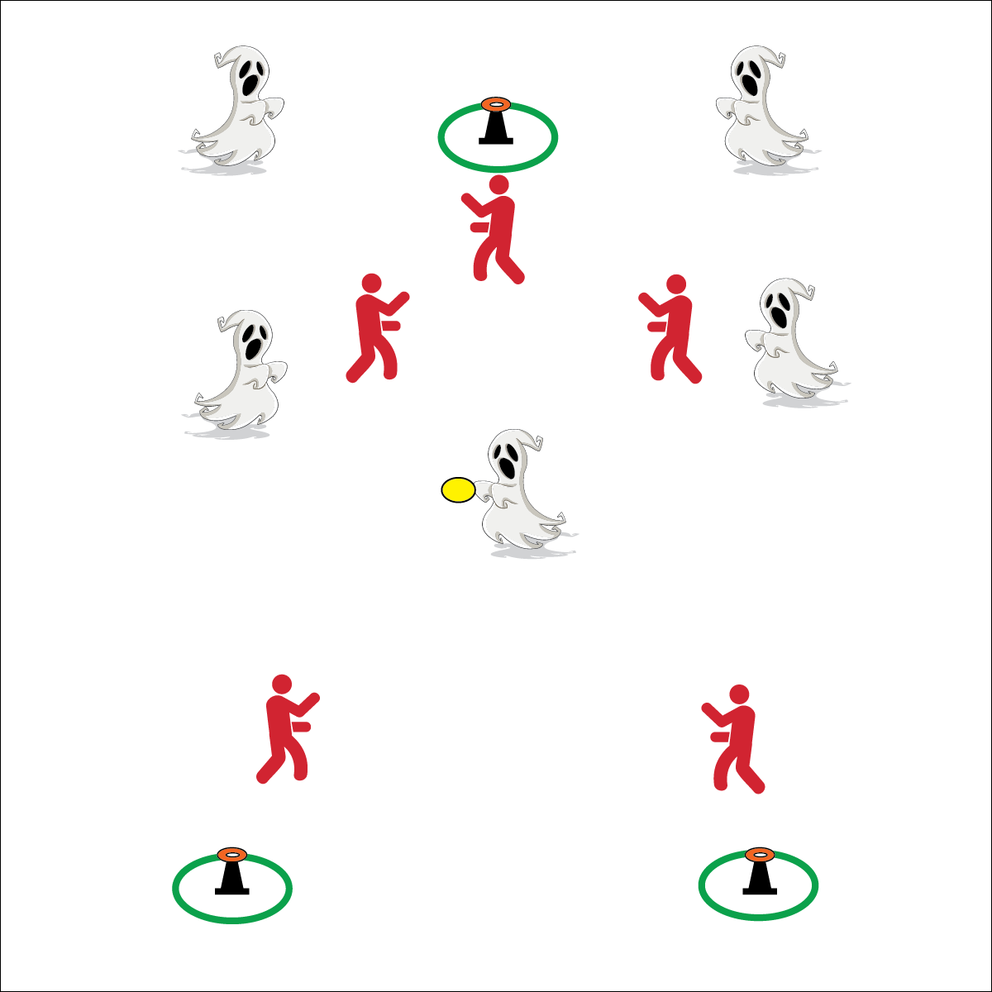

**Activity Procedures:**

1. It’s time to play Ghost in the Graveyard. The object of the game is for the “Ghosts” (offense) to tip over the tombstones by throwing the disc (or ball) and knocking the small cone off of the large cone. The “Ghostbusters” (defense) will work to intercept or knock the disc out of the air.
2. The game is played in 1- to 2-minute rounds. During each round, the offensive team stays on offense. Interceptions and knock downs are points for the defense, tipped tombstones are points for the offense. At the end of each round teams switch roles.
3. Rules for Defense: no contact is allowed, defense cannot touch a held disc (knock it out of hands), players cannot move inside of a hoop.
4. Rules for Offense: Players with the disc cannot move (only pivot), the disc is advanced with passing, if a disc is intercepted or hits the floor the closest offensive player picks it up and continues play.

**Grade Level Progression:**

* Start by playing 5v4 with 1 defender acting as a referee. This provides an advantage to the offense.



* **Standard 2 [M3.6-8]** Creates open space by using the width and length of the field/court on offense (6); Creates open space by staying spread on offense, and cutting and passing quickly (7); Creates open space by staying spread on offense, cutting, and passing quickly, and using fakes off the ball (8).
* **Standard 2 [H2.L1-2]** Uses movement concepts and principles (e.g., force, motion, rotation) to analyze and improve performance of self and/or others in a selected skill (L1); Describes the speed/accuracy trade-off in throwing and striking skills (L2).



* **DOK 1:** How can you recognize open space?
* **DOK 2:** How would you apply cutting, fakes, and passing to create open space?
* **DOK 3:** How well did you apply these strategies? Support your answer with examples.

**Equipment:**

* 3 cones
* 3 low profile cones
* 1 foam disc or ball
* 3 hoops
* 1 pinnie or armband per 2 students

**Set-Up:**

1. Create a large activity area with 3 cones spaced inside the area (like giant triangle). Place low profile cone on the top of each cone.
2. Create teams of 4 to 6 players; 2 teams per activity area.

* **Skill:** I will create open space by staying spread out on offense.
* **Cognitive:** I will discuss force, speed, and accuracy as it relates to passing and receiving.
* **Fitness:** I will stay actively engaged on offense and defense.
* **PSR:** I will demonstrate the Spirit of the Game.

Ultimate

* Pass and Then Move
* Catch, Turn, Look for Open Space
* Talk to Your Teammates