­­

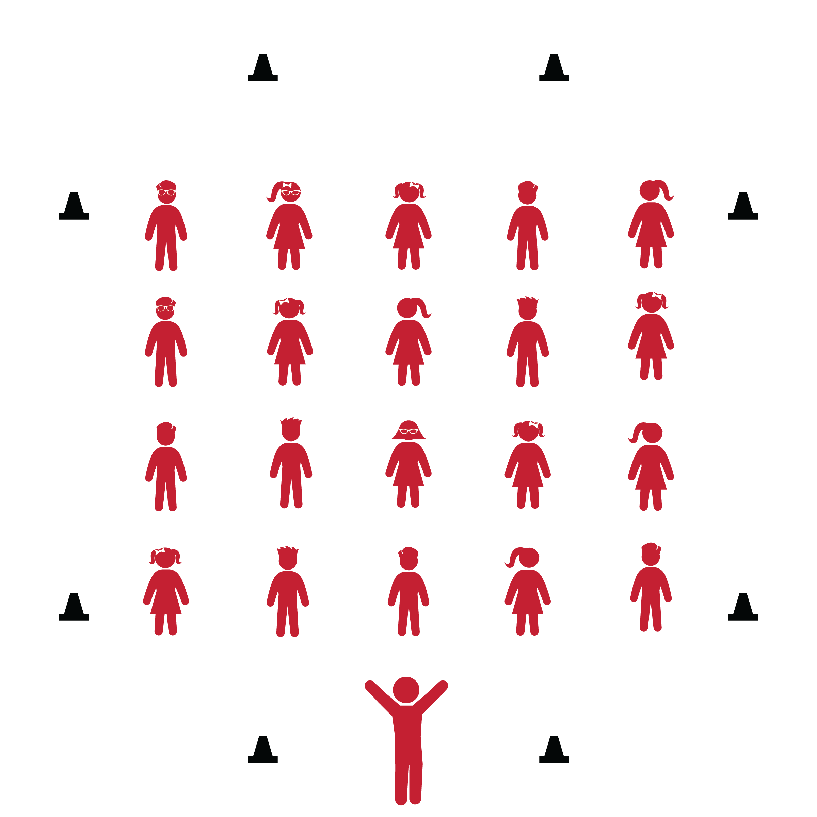

**CHA CHA SLIDE**



* **Skill:** I will perform the correct movements with the beat of the music.
* **Cognitive:** I will remember and the names of dance steps and perform the correct movements when they are called.
* **Fitness:** I will actively engage during the activity.
* **Personal & Social Responsibility:** I will move safely and respectfully in self-space.
* Follow Lyric Cues: To the Left, Take it Back, One Hop, Stomp, Cha Cha, Charlie Brown, Criss Cross.

**Equipment:**

* Music player
* *The Cha Cha Slide* by Mr. C (available on [iTunes](https://itunes.apple.com/ie/album/cha-cha-slide-ep/id1190695934) and [YouTube](https://www.youtube.com/watch?v=gIdLRftdrH8))
* 6–8 cones

**Set-Up:**

1. Set cones across from one other on each side of the activity area.
2. Arrange students in lines between the cones. Be sure students have enough space to dance safely.

**Activity Procedures:**

1. Today’s dance is called *The Cha Cha Slide*. It is a 4-wall dance created by Chicago DJ and performer Mr. C, which is short for Casper. During 4-wall dances, you turn to face each wall of the gymnasium as you perform the dance.
2. The purpose of the dance is to exercise and have fun while following the lyrical cues and rhythm of the song.
3. Throughout the song, listen closely to the lyrics. They will guide you through the dance’s movements as you face each of the 4 walls multiple times throughout the song.

**Grade Level Progression:**

**3rd:** Perform the dance in its original form, following the cues of the song.

**4th:** Students add bigger movements and their own style to the original steps.

**5th:** Students create their own choreography for each lyrical cue throughout the song.

**CHA CHA SLIDE**



Beat, Choreography, Crouch, Cues, Dance, Diagonally, Four-Wall Dance, Freeze, Grapevine, Hop, Jump, Lyric, Movement, Quarter-Turn, Rock, Rhythm, Side Step, Stomp

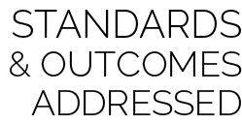

* **Standard 1 [E5.3-5]** Performs teacher-selected and developmentally appropriate dance steps and movement patterns (3); Combines locomotor movement patterns and dance steps to create and perform an original dance (4); Combines locomotor skills in cultural as well as creative dances (self and group) with correct rhythm and pattern (5).
* **Standard 2 [E2.3-5]** Recognizes locomotor skills specific to a wide variety of physical activities (3); Combines movement concepts with skills in small-sided practice tasks, gymnastics, and dance environments (4); Combines movement concepts with skills in small-sided practice tasks in game environments, gymnastics, and dance with self-direction (5).
* **Standard 3 [E3.3-5]** Engages in the activities of physical education class without teacher prompting (3); Actively engages in the activities of physical education class, both teacher-directed and independent (4); Actively engages in all the activities of physical education (5).
* **Standard 4 [E1.3-5]** Exhibits personal responsibility in teacher-directed activities (3); Exhibits responsible behavior in independent group situations (4); Engages in physical activity with responsible interpersonal behavior (e.g., peer to peer, student to teacher, student to referee) (5).

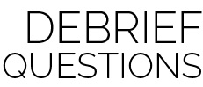

* **DOK 1:** What dance movements did we use to perform this dance?
* **DOK 2:** What locomotor skill did we perform differently in this dance than we normally would perform it?
* **DOK 2:** What were the different levels and directions we used to perform this dance?
* **DOK 3:** How would a dance like this help people come together in a social setting?

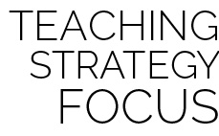

**Dance Strategy Focus:** Use this dance to highlight how dances can include different levels, pathways, and directions. Have students think of their own interpretations of the musical cues and, as always, encourage them to be creative in their movements.



* Teach and demonstrate each lyrical cue before adding music.
* List or draw the movements and cues on chart paper so students can follow along.
* Provide alternative movements for students who have movement disabilities.



* Perform the dance while dribbling a basketball.
* Pick a student leader to serve as group leader for each of the 4 wall directions.
* Have student leaders add a special flare to the choreography for the class to follow.