­­

**CUPID SHUFFLE**

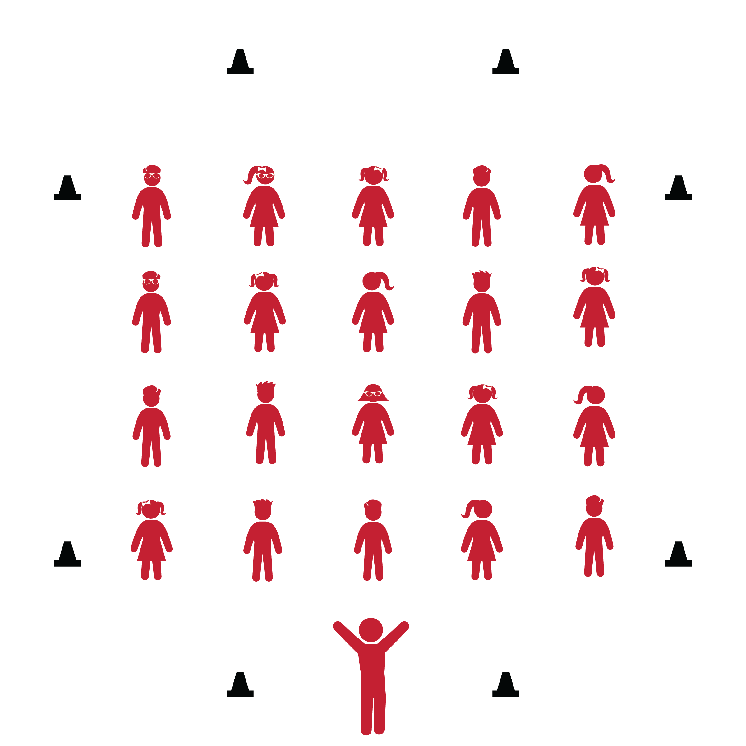

* **Skill:** I will perform the correct movements with the beat of the music.
* **Cognitive:** I will remember the names of dance steps and perform the correct movements when they are called.
* **Fitness:** I will actively engage during the activity.
* **Personal & Social Responsibility:** I will move safely and respectfully in self-space.
* Follow Lyric Cues: To the Right, To the Left, Now Kick, Now Walk it by Yourself

**Equipment:**

* Music player
* *Cupid Shuffle* by DJ Cupid (available on [iTunes](https://itunes.apple.com/us/album/cupid-shuffle-ep/id260167050) and [YouTube](https://www.youtube.com/watch?v=fAhXfcm_v40))
* 6–8 cones

**Set-Up:**

1. Set cones across from one other on each side of the activity area.
2. Arrange students in lines between the cones. Be sure students have enough space to dance safely.

**Activity Procedures:**

1. Today’s dance is called the *Cupid Shuffle*. It is a 4-wall dance created by DJ Cupid.
2. The purpose of the dance is to exercise while following the lyrical cues and rhythm of the song.
3. Listen closely to the lyrics at the beginning of the song. They will teach you the movements that you’ll repeat over and over throughout this dance. They’ll also repeat multiple times, so don’t worry if you can’t remember them the first time. You’ll face each of the 4 walls multiple times throughout the song.

**Grade Level Progression:**

**3rd:** Perform the dance in its original form, following the cues of the song.

**4th:** Students add bigger movements and their own style to the original steps.

**5th:** Students create their own choreography for each lyrical cue throughout the song.

**CUPID SHUFFLE**



Beat, Choreography, Count, Cues, Four-Wall Dance, Heel Touch, Lyric, Movement, Quarter-Turn, Rhythm



* Teach and demonstrate each lyrical cue before adding music.
* List or draw the movements and cues on chart paper so students can follow along.
* Provide alternative movements for students who have movement disabilities.



* Perform the dance with fitness movements such as running in place, jumping jacks or high-leg kicks (see activity card).
* Pick a student leader to serve as group leader for each of the 4 wall directions.
* Have student leaders add a special flare to the choreography for the class to follow.



* **Standard 1 [E5.3-5]** Performs teacher-selected and developmentally appropriate dance steps and movement patterns (3); Combines locomotor movement patterns and dance steps to create and perform an original dance (4); Combines locomotor skills in cultural as well as creative dances (self and group) with correct rhythm and pattern (5).
* **Standard 2 [E2.3-5]** Recognizes locomotor skills specific to a wide variety of physical activities (3); Combines movement concepts with skills in small-sided practice tasks, gymnastics, and dance environments (4); Combines movement concepts with skills in small-sided practice tasks in game environments, gymnastics, and dance with self-direction (5).
* **Standard 3 [E3.3-5]** Engages in the activities of physical education class without teacher prompting (3); Actively engages in the activities of physical education class, both teacher-directed and independent (4); Actively engages in all the activities of physical education (5).
* **Standard 4 [E1.3-5]** Exhibits personal responsibility in teacher-directed activities (3); Exhibits responsible behavior in independent group situations (4); Engages in physical activity with responsible interpersonal behavior (e.g., peer to peer, student to teacher, student to referee) (5).



* **DOK 1:** What dance movements did we use to perform this dance?
* **DOK 2:** What did you notice about how the dance was organized?
* **DOK 3:** Did the way the dance was organized help make it easier for a lot of people to perform this dance at once?
* **DOK 3:** How is this dance similair to the Cupid Shuffle? How is it different?

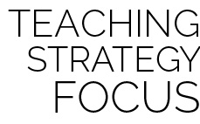

**Dance Strategy Focus:** The Cupid Shuffle is a popular 4-wall dance in which many people participate during social events where dancing is involved. This dance is not very complicated, so use this opportunity to help students feel successful and celebrate that feeling individually and as a group. You can also use the fitness challenges included on the activity card to begin to help your students think about how music guides choreography, as well as how fitness and exercise can be a part of both dance and positive social interaction.