­­

**SPACE JAM**

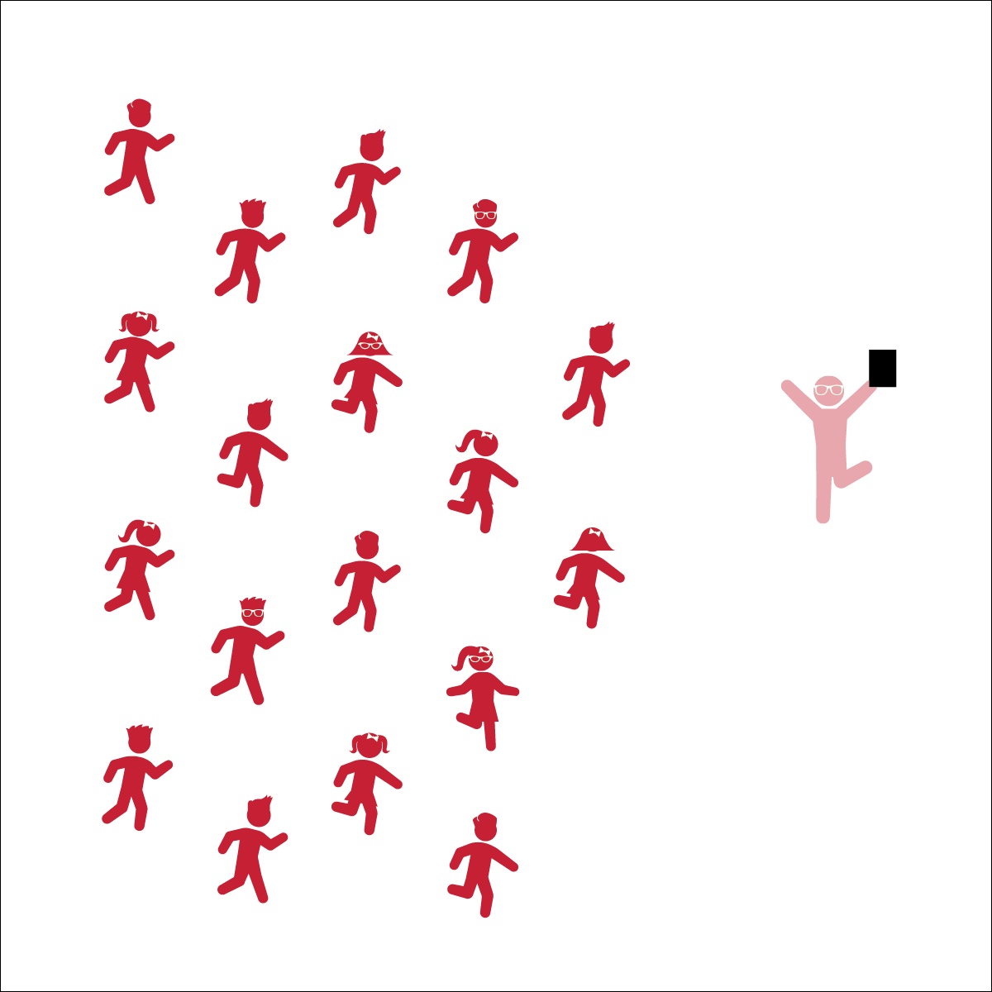

* **Skill:** I will perform movements with the beat and tempo of the music
* **Cognitive:** I will remember and perform the dance’s movements
* **Fitness:** I will perform this dance with my best effort to warm up all the parts of my body.
* **Personal & Social Responsibility:** I will encourage my classmates as we learn the movements and have fun.
* Follow Teacher’s Cues
* Find and Follow the Beat of the Music

**Equipment:**

* Music Player
* *Space Jam* by Quad City DJ’s (available on [iTunes](https://itunes.apple.com/us/album/space-jam/id1170755018?i=1170755174) and [YouTube](https://www.youtube.com/watch?v=J9FImc2LOr8)

**Set-Up:**

1. Scatter students in self-space throughout the activity area.
2. Be sure students have enough space to dance safely.

**Activity Procedures:**

1. Today’s dance is to the song *Space Jam* by Quad City DJ’s. It was designed to provide a fun movement experience to get the whole body moving.
2. Follow along with my movements (and/or movements being projected on the screen). Find and stay with beat of the song, and try to start to remember the sequence of the dance movements.
3. Teachers: use Space Jam Activity Card to teach the choreography of this dance.

**Grade Level Progression:**

**3rd:** Teach the choreography in parts, helping students learn each section both with and without music. Add them all together with music only when students have each section mastered.

**4th:** Have students follow along with music and attempt to learn the steps, going back to teach sections where they need extra practice. Once they know the steps, have them perform them with their own style.

**5th:** Once students have mastered this dance, have them create and perform their own “supercharged” movements.

**SPACE JAM**



8-Count, Beat, Bounce, Choreography, Count, Grapevine, Jump, Locomotor Skills, Movement, Non-Locomotor Skills, Respect, Responsibility, Sequence

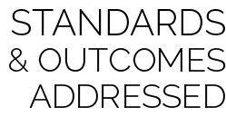

* **Standard 2 [E2.3-5]** Recognizes locomotor skills specific to a wide variety of physical activities (3); Combines movement concepts with skills in small-sided practice tasks, gymnastics, and dance environments (4); Combines movement concepts with skills in small-sided practice tasks in game environments, gymnastics, and dance with self-direction (5).
* **Standard 3 [E4.3-5]** Recognizes the importance of warm-up and cool-down relative to vigorous physical activity (3); Demonstrates warm-up and cool-down relative to the cardio-respiratory fitness assessment (4); Identifies the need for warm-up and cool-down relative to various physical activities (5).
* **Standard 5 [E4.3-5]** Describes the positive social interactions that come when engaged with others in physical activity (3); Describes and compares the positive social interactions when engaged in partner, small-group, and large-group physical activities (.4); Describes the social benefits gained from participating in physical activity (e.g., recess, youth sport) (5).



* **DOK 1:** What dance movements did we use to perform this dance?
* **DOK 2:** Can you explain how the different movements affected different parts of your body?
* **DOK 3:** If we changed the music, would you have to perform the dance differently? If yes, how?

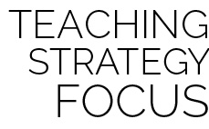

**Dance Strategy Focus:** Dance is like any other activity category in that skills require practice and concepts require explanation and processing. It’s the teacher’s job to help students process their experiences in ways that are student-centered and allow them to connect physical education lessons to their physical and emotional feelings. Take time for dance debrief sessions, and encourage deep discussion through tiered questioning techniques.



* Spend extra time teaching and demonstrating each section before adding music.
* List or draw the movements and cues on chart paper so students can follow along.
* Provide alternative movements for students who have movement disabilities.



* Perform the dance without following the teacher’s movements.
* Designate one or more students as leaders to serve as a guide at the front of the class.