­­

**FJASKERN**

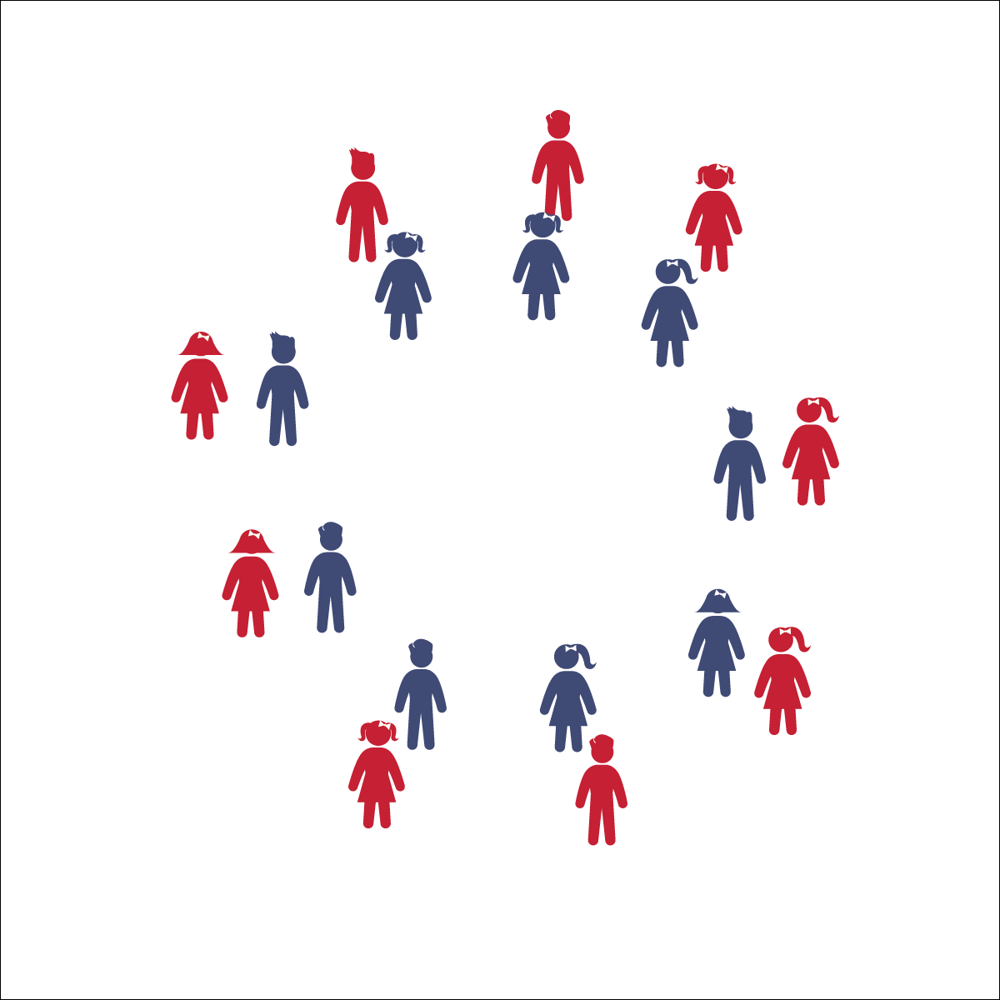

* **Skill:** I will perform movements with the beat and tempo of the music.
* **Cognitive:** I will remember and perform the dance’s movements.
* **Fitness:** I will actively engage during the activity.
* **Personal & Social Responsibility:** I will move safely and respectfully in self-space and with a partner.
* Follow Teacher’s Cues
* Find and Follow the Beat of the Music
* Dance Faster as the Tempo Increases

**Equipment:**

* Music player
* *Fjaskern* song (available on [iTunes](https://itunes.apple.com/us/album/dance-music-for-children-level-1/id459845807) and [YouTube](https://www.youtube.com/watch?v=_ZVCQ7YUg58&list=UUP7A9GpTe-XHmcGf6BBNWwQ&index=27))

**Set-Up:**

1. Divide the class evenly and arrange students into two circles: an outer circle and an inner circle.
2. Students who are standing across from one another in the circles are partners.
3. All students face the counter-clockwise direction.
4. Be sure students have enough space to dance safely.

**Activity Procedures:**

1. Today we’re going to perform a Swedish dance named Fjaskern (pronounced ‘FYEHS-kern’). In English, “fjaskern” means “hurry-scurry.” The dance starts slow but gets faster and faster.
2. We will learn the movements of this dance first without music and then perform the dance with music together.
3. Teachers, use the Fjaskern Activity Card to teach the movements.
4. Make sure to listen to the music closely, especially when the tempo—the speed of the song—increases. You will have to dance faster to keep up with the music.

**Grade Level Progression:**

**3rd:** Focus on learning the steps and movement patterns. Take ample time to teach students the dance without music before adding music and increasing the tempo.

**4th:** Once students have mastered the traditional steps, allow them to insert their own movements.

**5th:** Try the dance with 2 sets of outer and inner circles, all inside one another (4 concentric circles). Provide additional information about Sweden to deepen the cultural aspects of the lesson.

**FJASKERN**



8-Count, Beat, Clockwise, Count, Counter-Clockwise, Line Dance, Movement, Partner, Tempo



* **Standard 1 [E5.3-5]** Performs teacher-selected and developmentally appropriate dance steps and movement patterns (3); Combines locomotor movement patterns and dance steps to create and perform an original dance (4); Combines locomotor skills in cultural as well as creative dances (self and group) with correct rhythm and pattern (5).
* **Standard 2 [E2.3-5]** Recognizes locomotor skills specific to a wide variety of physical activities (3); Combines movement concepts with skills in small-sided practice tasks, gymnastics, and dance environments (4); Combines movement concepts with skills in small-sided practice tasks in game environments, gymnastics, and dance with self-direction (5).
* **Standard 4 [E4.3-5]** Works cooperatively with others (3a); Praises others for their success in movement performance (3b); Praises the movement performance of others, both more and less-skilled (4a); Accepts players of all skill levels into the physical activity (4b); Accepts, recognizes, and actively involves others with both higher and lower skill abilities into physical activities and group projects (5).



* **DOK 1:** What dance movements did we use to perform this dance?
* **DOK 1:** What does the word ‘fjaskern’ mean in English?
* **DOK 2:** What did you have to do to make sure you stayed with your partner? What was it like to dance with a partner?
* **DOK 3:** Did the activity get harder as the tempo got faster and faster? Why do you think that was?
* **DOK 4:** Does this dance tell a story? Share with us a story you created around the movements of this dance and explain how that story gives it more meaning.

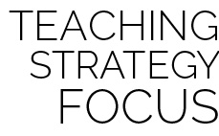

**Dance Strategy Focus:** Fjaskern is a dance that provides many teachable moments. It is a cultural dance that can start conversation about ackowledging similarities and celebrating differences. It also provides an opportunity for students to practice handling the challenges of working with a partner and keeping on beat with the increasing tempo. Like all dances, teach the choreography slowly at first and then move faster, finally incorporating the music once the students understand the movements. Remember to make dance fun by commiting yourself fully, not fearing mistakes, and laughing often.



* Instead of using circles, have pairs perform the movements around hula hoops (1 hoop per pair).
* List or draw the movements on chart paper so students can follow along.
* Provide a teacher to dance alongside students who cannot remember the movements.
* Provide alternative movements for students who have movement disabilities.



* Perform the dance without teacher cues.
* If there is an odd number of students, challenge the class to think of a solution on their own.