­­

**LOOKING UP**

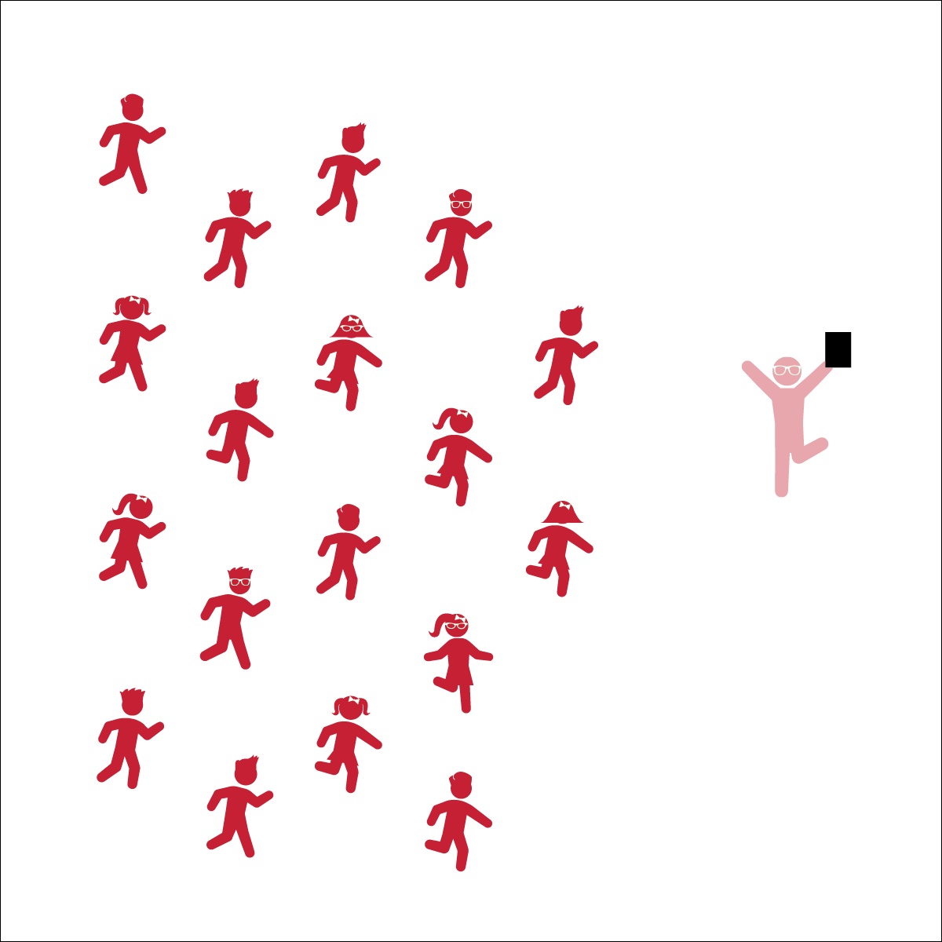

* **Skill:** I will perform movements with the beat and tempo of the music.
* **Cognitive:** I will remember and perform the dance’s movements.
* **Fitness:** I will actively engage during the activity.
* **Personal & Social Responsibility:** I will encourage my classmates as we all learn and perform this dance.
* Follow Teacher’s Cues
* Find and Follow the Beat of the Music

**Equipment:**

* Music player
* *Looking Up* by Safety Suit (available on [iTunes](https://itunes.apple.com/us/album/looking-up-single/id1051357812) and [YouTube](https://www.youtube.com/watch?v=8FtdtnDbwmQ))

**Set-Up:**

1. Scatter students in self-space throughout the activity area.
2. Be sure students have enough space to dance safely.

**Activity Procedures:**

1. Today we will perform a dynamic warm-up dance to the song *Looking Up* by Safety Suit.
2. Follow along with my movements (and/or movements being projected on the screen). Find and stay with beat of the song and try to start to remember the sequence of the dance movements.
3. Teachers: use the Looking Up Activity Card to teach the choreography of this dance.

**Grade Level Progression:**

**3rd:** Teach the choreography in parts, helping students learn each section both with and without music. Add them all together with music only when students have each section mastered.

**4th:** Have students follow along with music and attempt to learn the steps, going back to teach sections where they need extra practice.

**5th:** Once students have mastered this dance, have them create and perform their own “supercharged” movements.

**LOOKING UP**



Beat, Bounce, Clockwise, Count, Counter-Clockwise, Leader, Follower, Grapevine, Locomotor Skills, Non-Locomotor Skills, Responsibility, Respect, Sequence



* **Standard 1 [E5.3-5]** Performs teacher-selected and developmentally appropriate dance steps and movement patterns (3); Combines locomotor movement patterns and dance steps to create and perform an original dance (4); Combines locomotor skills in cultural as well as creative dances (self and group) with correct rhythm and pattern (5).
* **Standard 2 [E2.3-5]** Recognizes locomotor skills specific to a wide variety of physical activities (3); Combines movement concepts with skills in small-sided practice tasks, gymnastics, and dance environments (4); Combines movement concepts with skills in small-sided practice tasks in game environments, gymnastics, and dance with self-direction (5).
* **Standard 4 [E4.3-5]** Works cooperatively with others (3a); Praises others for their success in movement performance (3b); Praises the movement performance of others, both more and less-skilled (4a); Accepts players of all skill levels into the physical activity (4b); Accepts, recognizes, and actively involves others with both higher and lower skill abilities into physical activities and group projects (5).
* **Standard 5 [E2.3-5]** Discusses the challenge that comes from learning a new physical activity (3); Rates the enjoyment of participating in challenging and mastered physical activities (4); Expresses (via written essay, visual art, creative dance) the enjoyment and/or challenge of participating in a favorite physical activity (5).
* **Standard 5 [E4.3-5]** Describes the positive social interactions that come when engaged with others in physical activity (3); Describes and compares the positive social interactions when engaged in partner, small-group, and large-group physical activities (.4); Describes the social benefits gained from participating in physical activity (e.g., recess, youth sport) (5).



* **DOK 1:** What dance movements did we use to perform in this dance?
* **DOK 2:** What were the different levels and directions we used to performe this dance?
* **DOK 2:** Can you explain the effect the supercharged movements had on your body as you performed this dance?

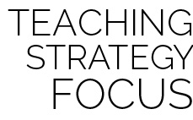

**Dance Strategy Focus:** This is a great dynamic warm-up dance. Teach this dance in parts and then add the parts together. When the dance says to “freestyle,” encourage your students to get as creative as they are and express themselves through their movements. Encourage them to dance big and give their effort. The bigger they make their movements, the more benefits the dance will have on their body.



* Spend extra time teaching and demonstrating each section before adding music.
* List or draw the movements and cues on chart paper so students can follow along.
* Provide alternative movements for students who have movement disabilities.



* Perform the dance without following the teacher’s movements.
* Designate one or more students as leaders to serve as a guide at the front of the class.