­­

**CAN’T STOP THE FEELING**

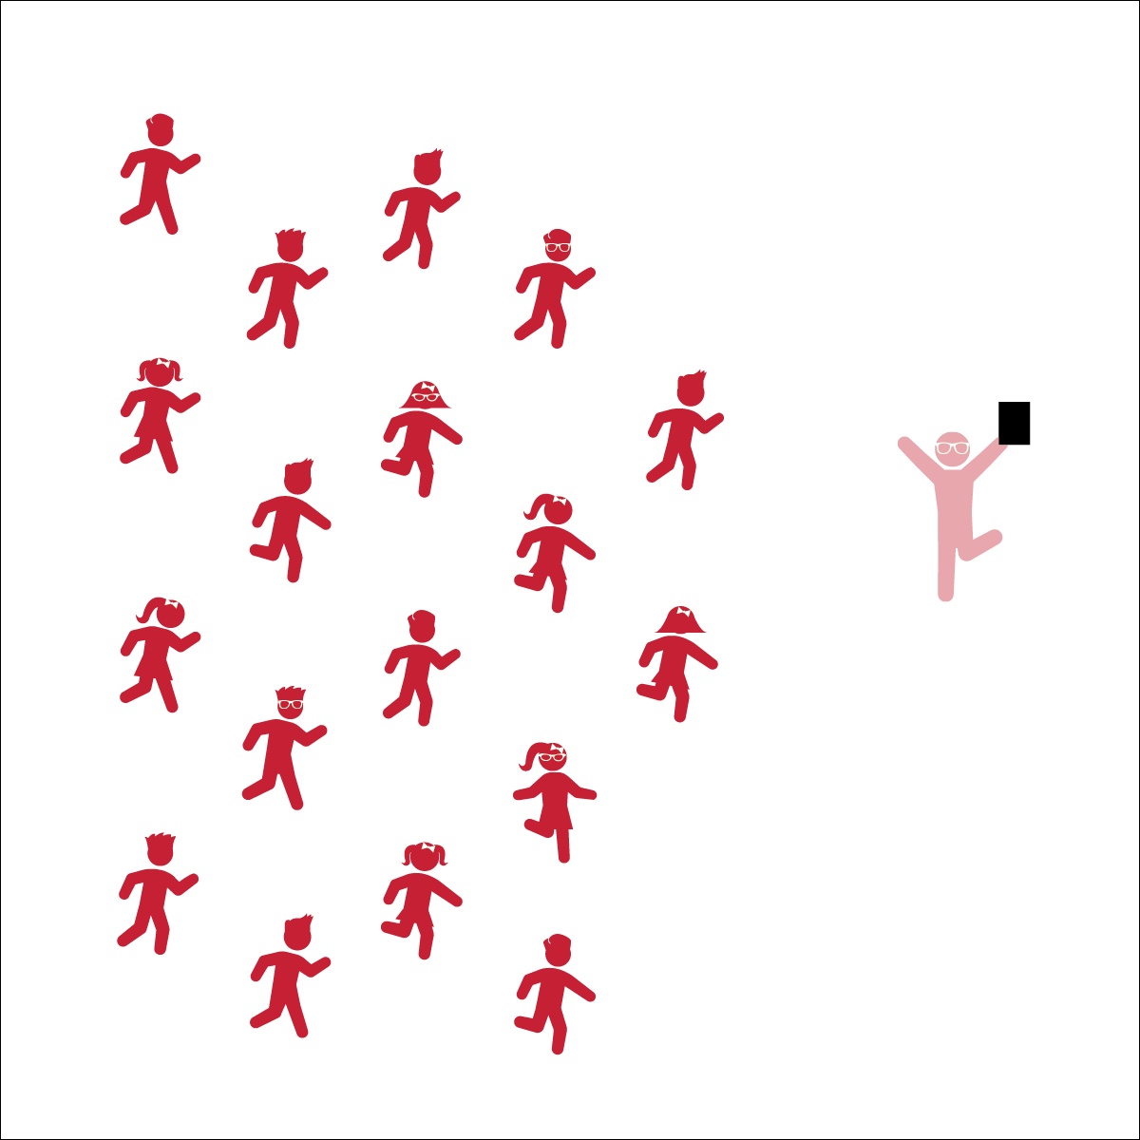

* **Skill:** I will perform movements with the beat and tempo of the music.
* **Cognitive:** I will remember and perform the dance’s movements
* **Fitness:** I will stay actively engaged during the dance.
* **Personal & Social Responsibility:** I will move in self-space in order to keep myself and my classmates safe.
* Follow Teacher’s Cues
* Find and Follow the Beat of the Music

**Equipment:**

* Music Player
* *CAN’T STOP THE FEELING* by Justin Timberlake (available on [iTunes](https://itunes.apple.com/nz/album/cant-stop-feeling-original-song-from-dreamworks-animations/id1110121889) and [YouTube](https://www.youtube.com/watch?v=qEFKkAqb1ww))

**Set-Up:**

1. Scatter students in self-space throughout the activity area.
2. Be sure students have enough space to dance safely.

**Activity Procedures:**

1. Today’s activity is a fun dance to the song *Can’t Stop the Music* by Justin Timberlake. It’s an upbeat song that makes you want to move!
2. Follow along with my movements (and/or movements being projected on the screen). Find and stay with beat of the song and try to start to remember the sequence of the dance movements.
3. Teachers: use Can’t Stop the Feeling Activity Card to teach the choreography of this dance.

**Grade Level Progression:**

**3rd:** Have students follow along with music and attempt to learn the steps.

**4th:**  After students have followed along for a whole, have them perform them with their own style.

**5th:** Once students have mastered this dance, have them create and perform their own “supercharged” movements.

**CAN’T STOP THE FEELING**

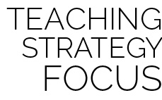

**Dance Strategy Focus:** Use this dance to reinforce and model dancing as a fun and expressive activity that everyone can do. Let students see you enjoy the movement and creative expression of dance. It’s okay if you aren’t the world’s best dancer. To be honest, if your dancing skills are less than perfect, you will provide a powerful example for all students to emulate.



8-Count, Beat, Bounce, Count, Diagonally, Grapevine, Jump, Locomotor Skills, Lyric, Non-Locomotor Skills, Responsibility, Respect, Sequence



* **Standard 1 [E5.3-5]** Performs teacher-selected and developmentally appropriate dance steps and movement patterns (3); Combines locomotor movement patterns and dance steps to create and perform an original dance (4); Combines locomotor skills in cultural as well as creative dances (self and group) with correct rhythm and pattern (5).
* **Standard 3 [E3.3-5]** Engages in the activities of physical education class without teacher prompting (3); Actively engages in the activities of physical education class, both teacher-directed and independent (4); Actively engages in all the activities of physical education (5).
* **Standard 5 [E2.3-5]** Discusses the challenge that comes from learning a new physical activity (3); Rates the enjoyment of participating in challenging and mastered physical activities (4); Expresses (via written essay, visual art, creative dance) the enjoyment and/or challenge of participating in a favorite physical activity (5).



* **DOK 1:** What dance movements did we use to perform this dance?
* **DOK 2:** Can you describe how the music made you feel when it started to play?
* **DOK 3:** How are the dance movements related to the beat and tempo of the music?



* Spend extra time teaching and demonstrating each section before adding music.
* List or draw the movements and cues on chart paper so students can follow along.
* Provide alternative movements for students who have movement disabilities.



* Perform the dance without following the teacher’s movements.
* Designate one or more students as leaders to serve as a guide at the front of the class.