­­

**THE VIRGINIA REEL**

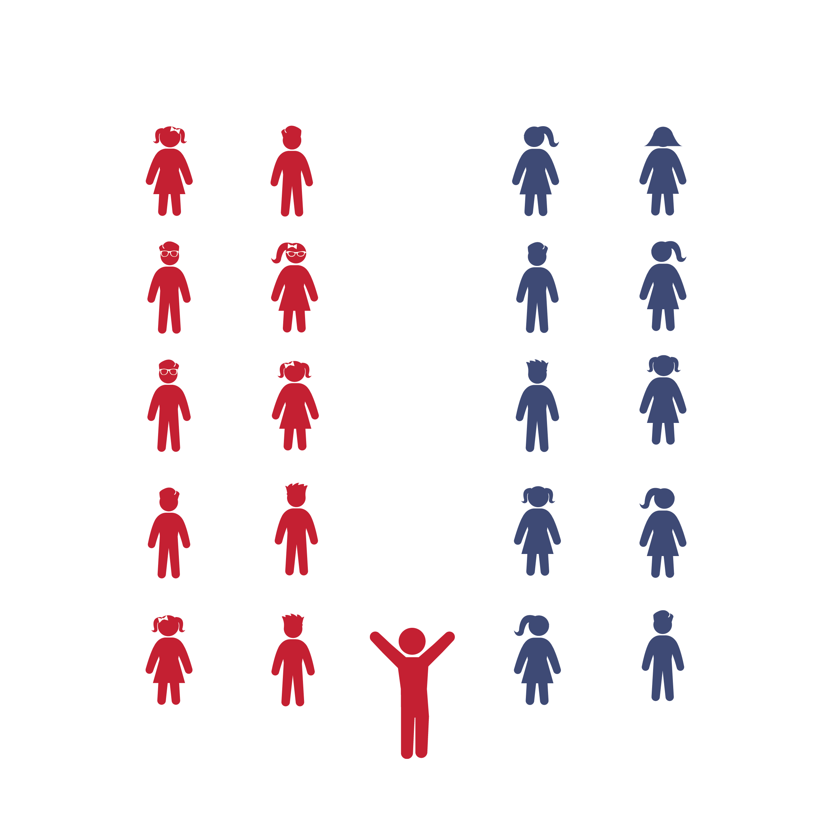

* **Skill:** I will perform movements with the beat and tempo of the music.
* **Cognitive:** I will remember and perform the dance’s movements.
* **Fitness:** I will actively engage during the activity.
* **Personal & Social Responsibility:** I will cooperate with my classmates to learn and perform the dance.
* Follow Caller Cues: Honor Your Partner, Forward and Back, Allemande Right, Allemande Left, Both Hands, Do-Si-Do, Head Partners Slide Down and Back, Reel the Set, Cast Off/Peel, Arch

**Equipment:**

* Music player
* *The Virginia Reel* song (available on [iTunes](https://itunes.apple.com/us/album/australian-traditional-dance-tunes/id216261899) and [YouTube](https://www.youtube.com/watch?v=idyiha1eOCk&list=UUP7A9GpTe-XHmcGf6BBNWwQ&index=7))
* Optional: tempo-modifying app such as Tempo Slow (available on the App Store)

**Set-Up:**

1. Arrange students in parallel lines with no more than 8 students in each line. If you have more than 16 students, form 4 or 6 lines.
2. Students who are facing one another are partners.
3. Designate the pair of students standing closes to the music player as “Head Partners.” The pair at the opposite end of the line are “Foot Partners.”

**Activity Procedures:**

1. Today we are going to learn a dance called *The Virginia Reel.* It originated from other dances that came from Ireland, Scotland, and England, but as we know it today, it has many variations. *The Virginia Reel* was named after the state of Virginia by the American colonists. It was first published in 1685 by a man named Sir Roger de Coverly, making it one of the oldest dances that is still performed in our country today.
2. First, we’ll learn the movements without music while we count out loud. We’ll learn one movement, practice it, and then learn another movement to add on. We’ll keep adding movements until we’ve learned the whole dance. Then we’ll add the music and dance to the song’s beat.
3. *The Virginia Reel* has a clear, steady beat. Each movement will take 8 beats. Listen closely to the beat so that you can follow along. If it helps, you can count out loud 1-2-3-4-5-6-7-8 as we dance.
4. Teachers, teach the movements using the Virginia Reel Activity Card. Then add music and enjoy!

**Grade Level Progression:**

**3rd:** Perform the activity as described above.

**4th:** Have students perform the dance multiple times, switching partners each time.

**5th:** Add the additional “Reel the Set” challenge listed on the activity card.

History of The Virginia Reel found at: http://users.rowan.edu/~conet/rhythms/CulturalDances/VirginiaReel.html

**VIRGINIA REEL**



Beat, Caller, Calls, Choreography, Count, Cues, Do-Si-Do, Line Dance, Partner, Single-File Line, Skip, Slide, Tempo, Walk



* **Standard 1 [E5.3-5]** Performs teacher-selected and developmentally appropriate dance steps and movement patterns (3); Combines locomotor movement patterns and dance steps to create and perform an original dance (4); Combines locomotor skills in cultural as well as creative dances (self and group) with correct rhythm and pattern (5).
* **Standard 2 [E2.3-5]** Recognizes locomotor skills specific to a wide variety of physical activities (3); Combines movement concepts with skills in small-sided practice tasks, gymnastics, and dance environments (4); Combines movement concepts with skills in small-sided practice tasks in game environments, gymnastics, and dance with self-direction (5).
* **Standard 4 [E4.3-5]** Works cooperatively with others (3a); Praises others for their success in movement performance (3b); Praises the movement performance of others, both more and less-skilled (4a); Accepts players of all skill levels into the physical activity (4b); Accepts, recognizes, and actively involves others with both higher and lower skill abilities into physical activities and group projects (5).



* **DOK 1:** Describe the choreography we used to perform this dance.
* **DOK 2:** What pattern did the Virginia Reel follow?
* **DOK 3:** Considering that the movements follow the same order every time, how would you know when to do the next movement if the teacher/caller did not call it out?
* **DOK 4:** What role do you think the Virginia Reel had in the lives of Scottish immigrants when they brought this dance with them when they moved to America?

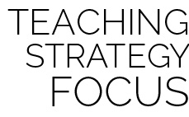

**Dance Strategy Focus:** The Virginia Reel is great partner line dance that fosters a wonderful sense of teamwork and community. Teach each movement slowly and give students time to master the chroegraphy before moving to the music. As you do, gradually increase the tempo at which students repeat 1-2-3-4-5-6-7-8 and practice the movements so they are not caught off guard when they first hear the tempo of the song. Allow time for everyone to be the head couple. Consider performing this dance at a school event or inviting parents to try it with your class.



* Have students hold a scarf instead of their partners’ hands.
* Do not include the “Reel the Set” movement.
* Find a slower version of the song or use a tempo-modifying app to slow the beat.
* Perform to a 16-count rather than an 8-count (dance in *half-time*).
* List or draw the movements and cues on chart paper so students can follow along.
* Provide alternative movements for students who have movement disabilities.



* Perform the dance without following the teacher’s verbal cues.
* If there is an odd number of students, challenge the class to think of a solution on their own.