­­

**Equipment:**

* Music player
* *Good Feeling* by Flo Rida or other favorite hip-hop song (available on [iTunes](https://itunes.apple.com/us/album/good-feeling/id613867183?i=613867349) and [YouTube](https://www.youtube.com/watch?v=h94gvPDapvw))
* Optional: tempo-modifying app such as Tempo Slow (available on the [App Store](https://itunes.apple.com/us/app/tempo-slowmo-original-bpm-slow-downer/id635275615?mt=8))

**Set-Up:**

1. Pair students. Try to maintain pairings from the original Virginia Reel lesson.
2. Group pairs such that there are 4 pairs (8 students) in each group.

**THE HIP HOP VIRGINIA REEL**

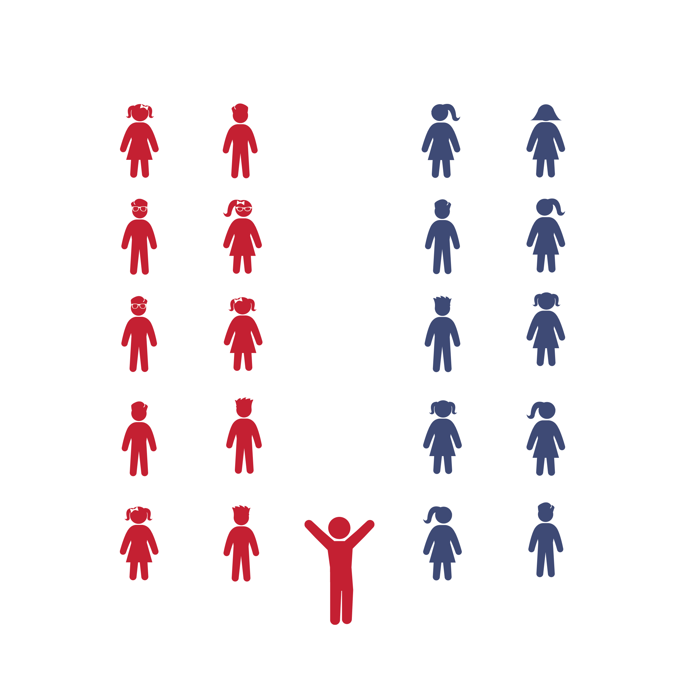

* **Skill:** I will perform movements with the beat and tempo of the music.
* **Cognitive:** I will create, remember, and perform my own 8-count dance routine.
* **Fitness:** I will actively engage during the activity.
* **Personal & Social Responsibility:** I will cooperate with my classmates and accept new ideas while we create, practice, and perform our own original dance movements.
* Think Creatively
* Find and Follow the Beat of the Music

**Activity Procedures:**

1. In today’s class, we are going to get creative with the *Virginia Reel* dance we learned last time.
2. You and your partner will create your own 8-count movement. Then, you’ll get together with your group to teach them your choreography and also learn theirs. As a group, you will decide what order your choreography should go in. Then you’ll practice your new dance and perform it for the rest of us.
3. Teachers, help kick off the creativity by playing YouTube videos or demonstrating potential hip-hop movements. Additional examples are included on the Hip Hop Virginia Reel Activity Card.
4. To help students generate ideas and remember them, you can write their movements on chart paper, have them give their movements unique names, and ask students to demonstrate.
5. If you have time, have the class perform the Hip Hop Virginia Reel as you would the traditional *Virginia Reel*, only with the new movements.

**Grade Level Progression:**

**3rd:** Move from group to group, helping students brainstorm. Or, have everyone suggest ideas as a class.

**4th:** Have each pair create 2-3 sequences, of which they’ll share 1-2.

**5th:** Have students in each group take turns calling out the names of their dance steps as they’re performed.



8-Count, Beat, Caller, Charge, Choreography, Collaboration, Count, Creativity, Cues, Follower, Grapevine, Hip Hop, Leader, Movement, Partner, Sequence, Tempo



* **Standard 3 [E3.3-5]** Engages in the activities of physical education class without teacher prompting (3); Actively engages in the activities of physical education class, both teacher-directed and independent (4); Actively engages in all the activities of physical education (5).
* **Standard 4 [E4.3-5]** Works cooperatively with others (3a); Praises others for their success in movement performance (3b); Praises the movement performance of others, both more and less-skilled (4a); Accepts players of all skill levels into the physical activity (4b); Accepts, recognizes, and actively involves others with both higher and lower skill abilities into physical activities and group projects (5).
* **Standard 5 [E4.3-5]** Describes the positive social interactions that come when engaged with others in physical activity (3); Describes and compares the positive social interactions when engaged in partner, small-group, and large-group physical activities (.4); Describes the social benefits gained from participating in physical activity (e.g., recess, youth sport) (5).



* **DOK 1:** How many beats do we have to perform our newly created dance sequence?
* **DOK 2:** How would you summarize your new dance to a friend or family member?
* **DOK 3:** What inspired the new dance movements you created for the Hip Hop Viriginia Reel?
* **DOK 3:** How were the movements we created as a class different than the movements we performed in the traditional Virginia Reel? How were they similar?
* **DOK 3:** How could you use the Hip Hop Virginia Reel to create and tell a story?

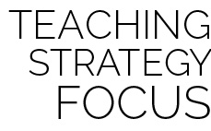

**Dance Strategy Focus:** Build confidence and excitement as you work your way up to this activity. Not only do the students have to show their creativity, but they also have to try and follow the structure of the 8-count the reel style of dancing is known for. Be fully present to provide any help they need. Encourage your students to draw on inspiration from things that are relevant and important to their lives, dances they like to do, movies they like to watch, or other activities they enjoy. Remember that all the movements they come up with are expressions of themselves that should be accepted and celebrated by the class. Have fun!



* Use slower songs or use a tempo-modifying app to slow the beat.
* Perform to a 16-count rather than an 8-count (dance in *half-time*).
* List or draw the movements and cues on chart paper so students can follow along.
* Provide alternative movements for students who have movement disabilities.



* Attempt to perform students’ choreography to several different songs.
* Create variations of the new movements, such as faster, slower, bigger, smaller, in a different direction, etc.
* Perform the dance without anyone calling out the movement cues.

**HIP HOP VIRGINIA REEL**