­­

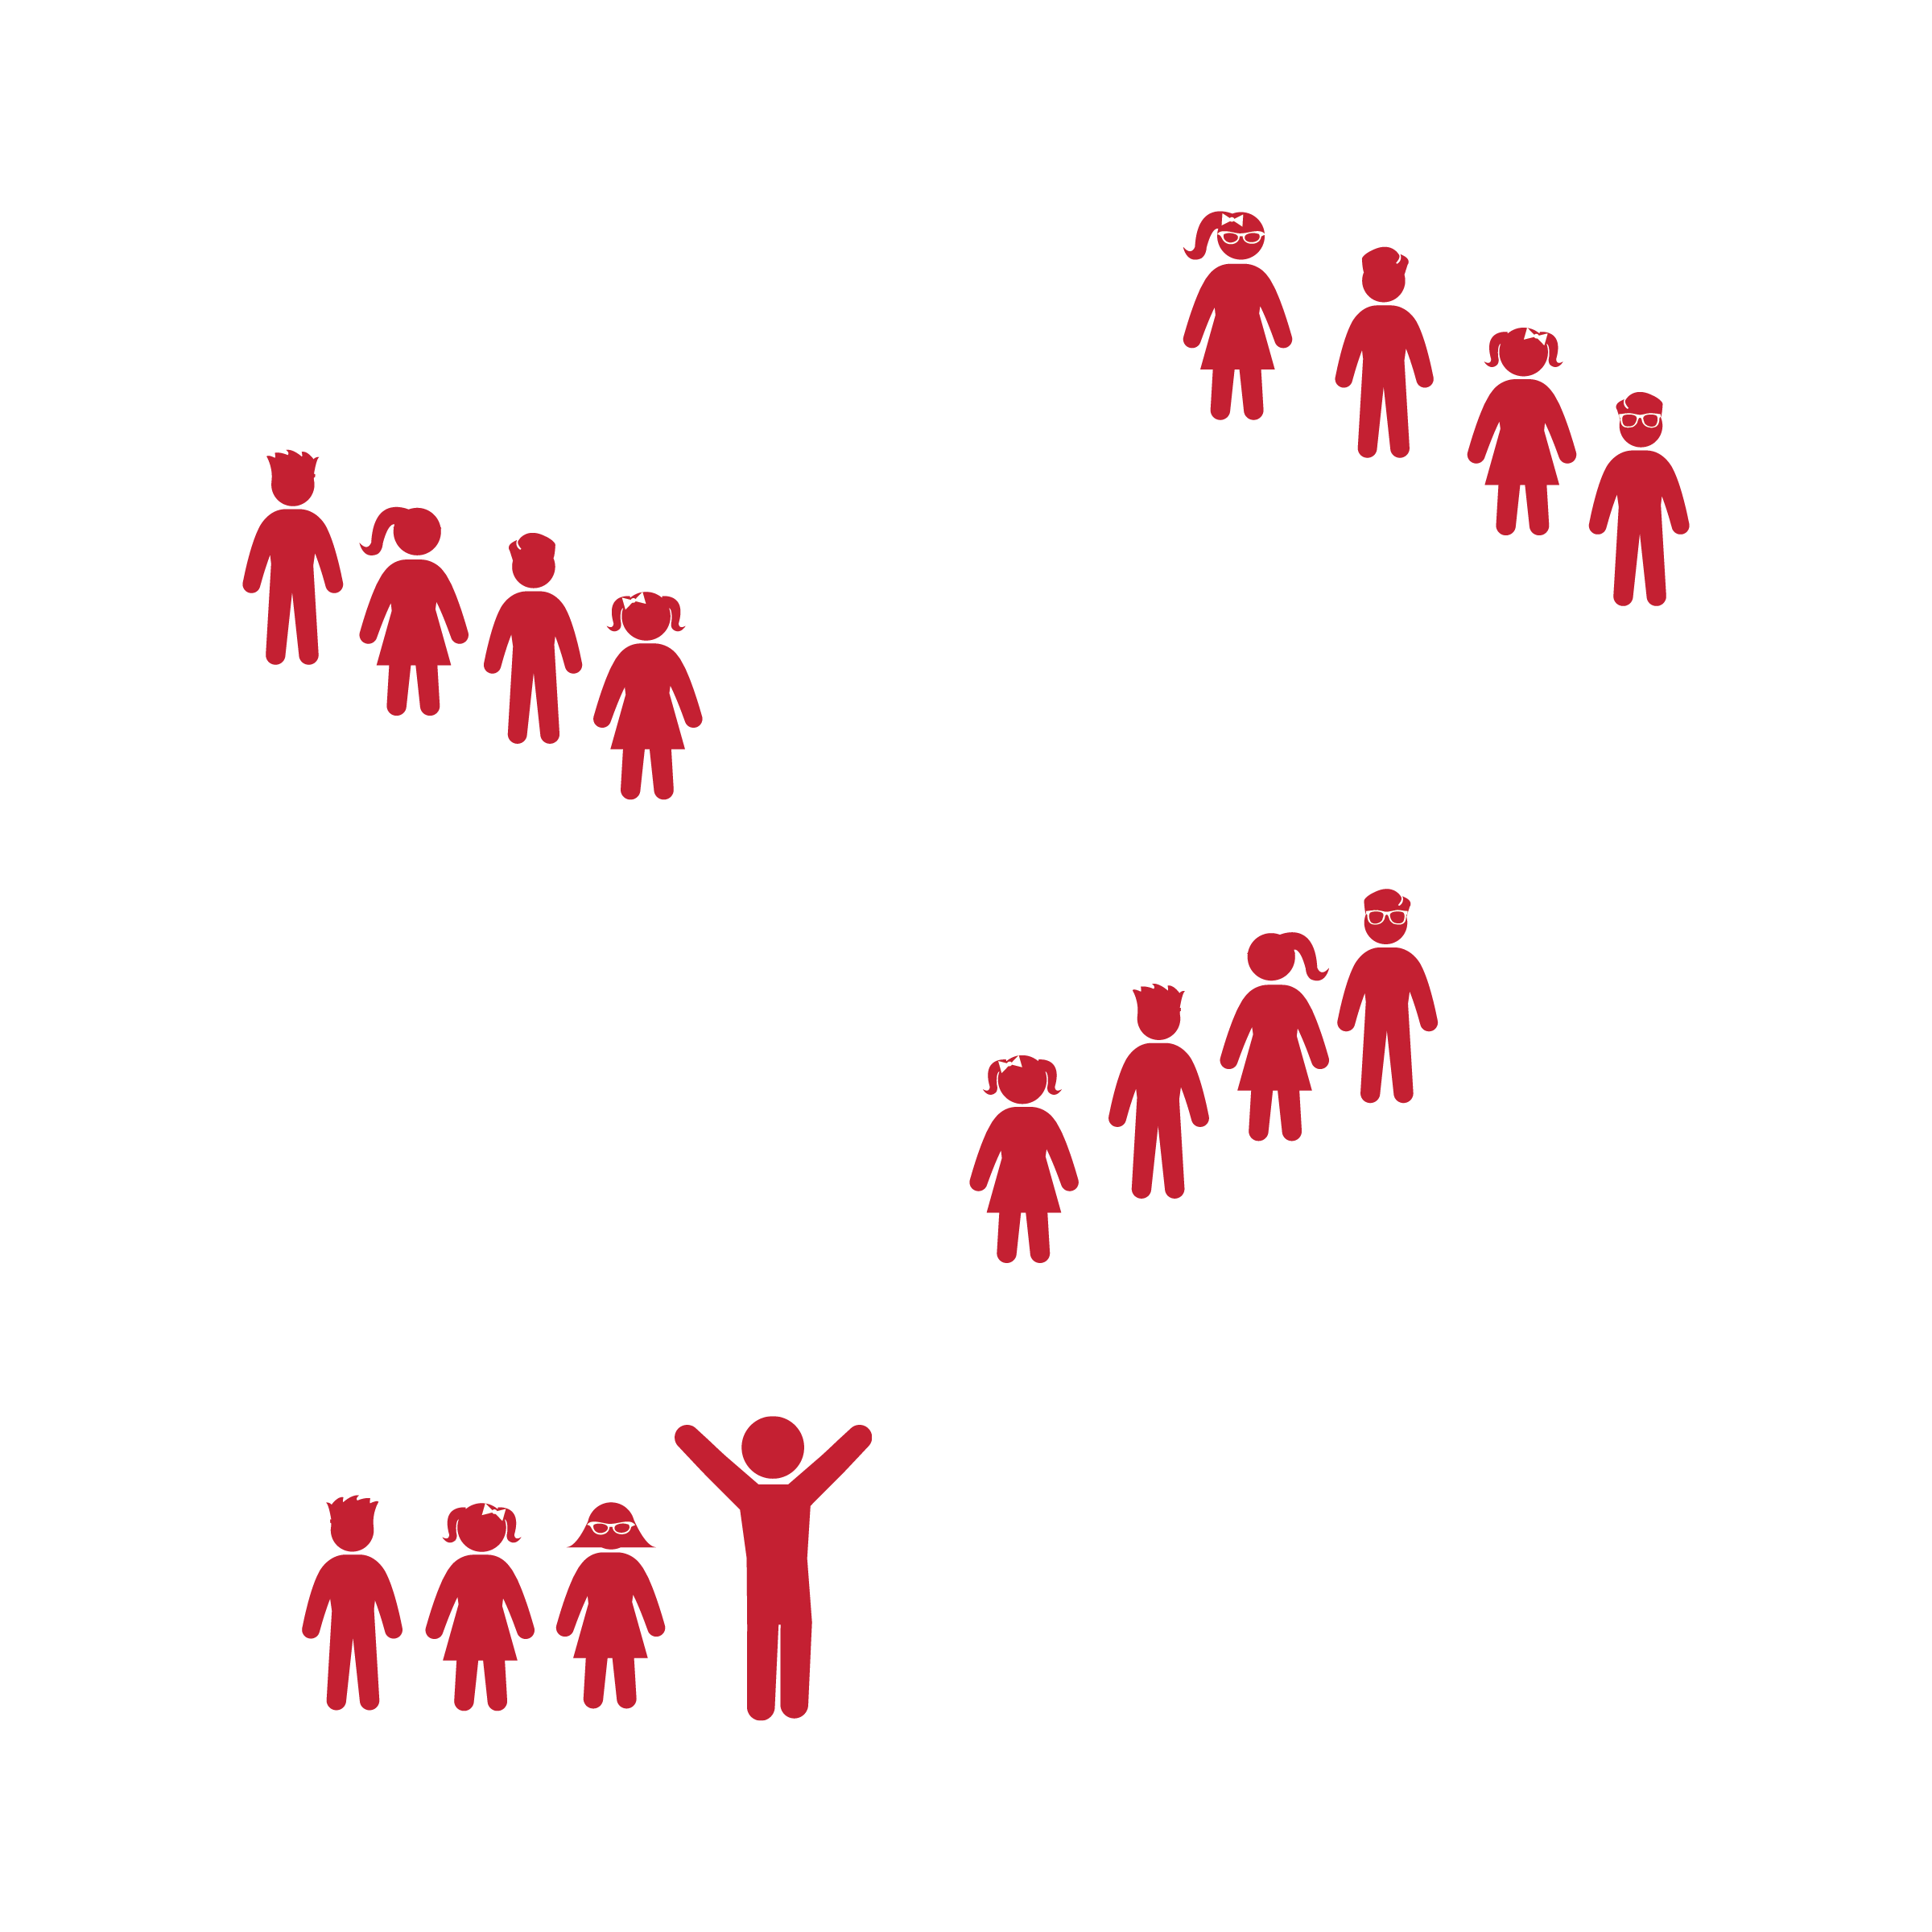



* **Standard 3** **[S3.K-5]** Actively participates in physical education class (K); Actively engages in physical education class (1); Actively engages in physical education class in response to instruction and practice (2); Engages in the activities of physical education class without teacher prompting (3); Actively engages in the activities of physical education class, both teacher-directed and independent (4); Actively engages in all the activities of physical education (5).
* **Fitness:** I will actively engage during the dance by following my classmates’ movements.
* Follow Along with Conductor
* Follow Teacher’s Cues
* Find and Follow the Beat of the Music

**Equipment:**

* Music Player
* *C’mon Ride It* by Quad City DJs (available on [iTunes](https://itunes.apple.com/us/album/cmon-n-ride-it-the-train/id1236901060) and [YouTube](https://www.youtube.com/watch?v=x5kr--mN7n8))

**Set-Up:**

1. Place students into groups of 4 or more
2. Each group lines up in their own single-file “train” line.

**Activity Procedures:**

1. Today we’re going to warm up our bodies by riding the Dancing Train! We’re going to ride the train all around the room, dancing and having fun.
2. Once students are in their train formation, establish that the person at the front of the line will start as the conductor and lead the group around the room.
3. The students “riding the train” follow the conductor’s movements as they make their way around the room.
4. Students rotate positions based on the teacher’s instructions from the Dancin’ Train Activity Card.

**Grade Level Progression:**

**K–2nd:** (K) The teacher is the conductor and all students are on one train. (1) The teacher is the conductor and performs both locomotor and non-locomotor movements. (2) Play the activity as described above.

**3rd–5th:** (3) Play the activity as described above. (4) Have conductors choose their own dance steps and movement patterns. (5) Have conductors choose their own dance steps and movement patterns with a focus on following the rhythm and tempo of the song.



* **DOK 1:** What locomotor and/or dance movements did you use in this activity?
* **DOK 2:** How did the music affect your movements as you traveled around the room?
* **DOK 2:** What did you notice about each conductor’s movement choices as they led the group around the room?