­­

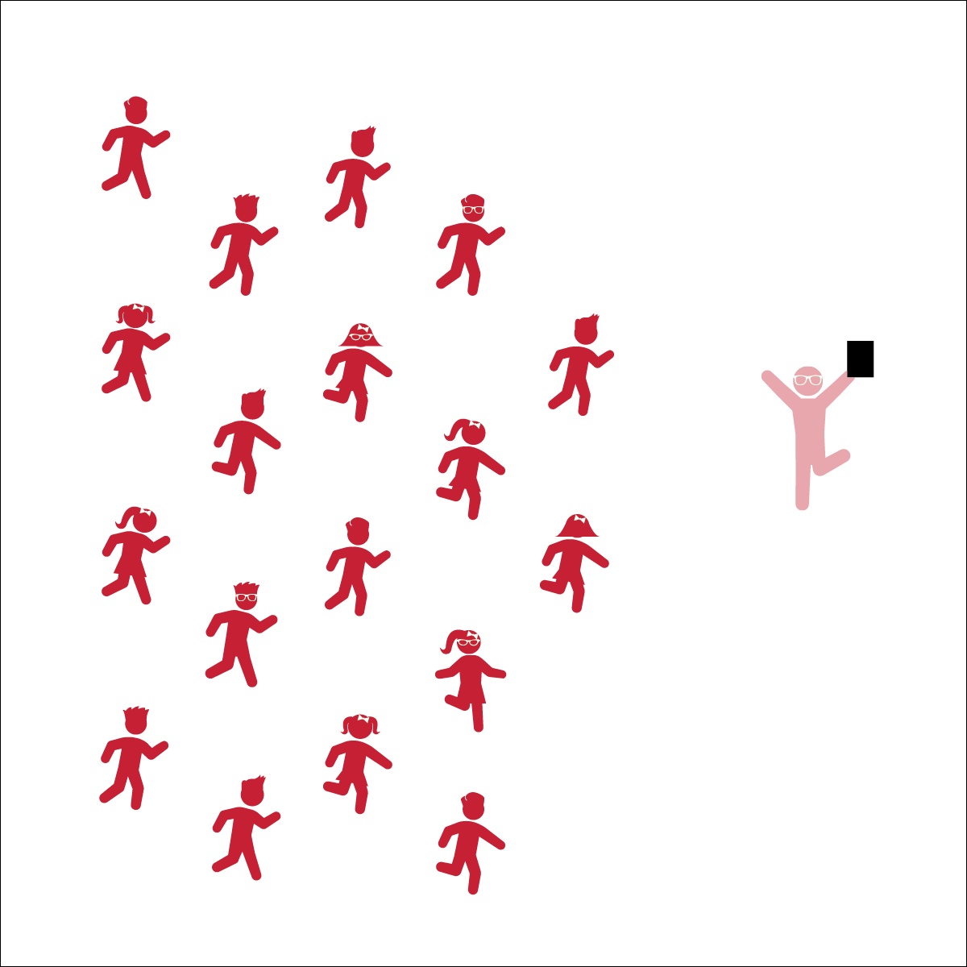

* Follow Along with Dancers
* Follow Teacher’s Cues
* Find and Follow the Beat of the Music

**Equipment:**

* Music Player
* *September* by Justin Timberlake and Anna Kendrick & Earth, Wind & Fire (available on [iTunes](https://itunes.apple.com/us/album/trolls-original-motion-picture-soundtrack/id1154238159) and [YouTube](https://www.youtube.com/watch?v=lU6ZXl6YgI0))
* Trolls September Activity Card

**Set-Up:**

1. Scatter students in self-space throughout the activity area.
2. Be sure students have enough space to dance safely.



* **DOK 1:** What dance movements did we use to perform this dance?
* **DOK 2:** Can you explain how the music affected how you felt once it started to play?
* **DOK 3:** How are the dance movements related to the beat and tempo of the music?
* **Fitness:** I will actively engage by following all movement cues for this dance.

**Activity Procedures:**

1. This dance was created with fun choreography that is meant to be fun and warm up the whole body.
2. Follow along with my movements (and/or movements being projected on the screen). Find and stay with the beat of the song and try to remember the sequence of the dance movements.
3. Teachers: use Trolls September Activity Card to teach the choreography of this dance.

**Grade Level Progression:**

**3rd:** Have students follow along with your movements or the movements being projected on the screen.

**4th:** Students begin to perform the movements with their own style.

**5th:** Once students have mastered this dance, have them create and perform their own “supercharged” movements.



* **Standard 3 [E3.3-5]** Engages in the activities of physical education class without teacher prompting (3); Actively engages in the activities of physical education class, both teacher-directed and independent (4); Actively engages in all the activities of physical education (5).