­­

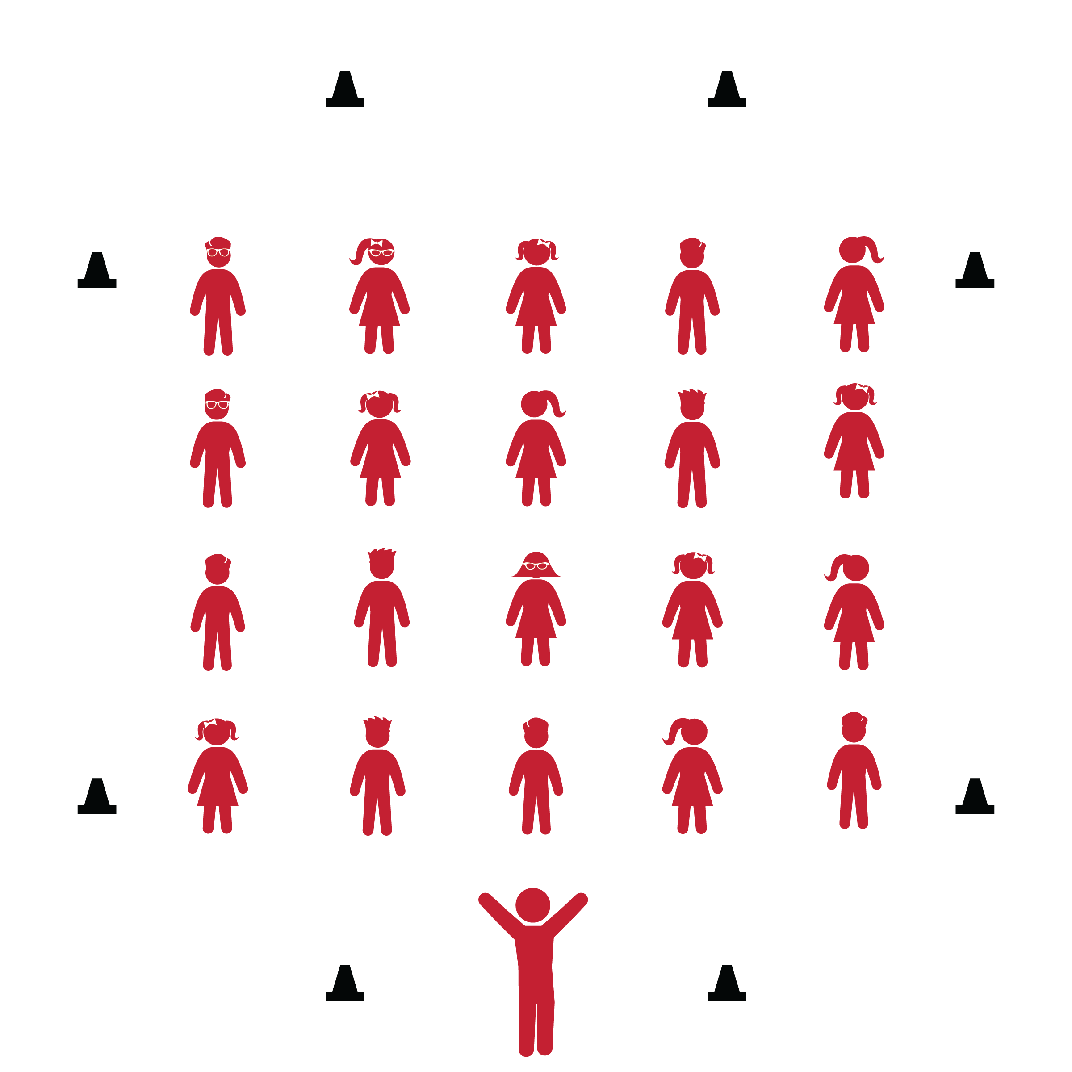

**CHA CHA SLIDE**

* **Skill:** I will perform the correct movements with the beat of the music.
* **Cognitive:** I will remember and the names of dance steps and perform the correct movements when they are called.
* **Fitness:** I will actively engage during the activity.
* **Personal & Social Responsibility:** I will move safely and respectfully in self-space.
* Follow Lyric Cues: To the Left, Take it Back, One Hop, Stomp, Cha Cha, Charlie Brown, Criss Cross.

**Equipment:**

* Music player
* *The Cha Cha Slide* by Mr. C (available on [iTunes](https://itunes.apple.com/ie/album/cha-cha-slide-ep/id1190695934) and [YouTube](https://www.youtube.com/watch?v=gIdLRftdrH8))
* 6–8 cones

**Set-Up:**

1. Set cones across from one other on each side of the activity area.
2. Arrange students in lines between the cones. Be sure students have enough space to dance safely.

**Activity Procedures:**

1. Today’s dance is called *The Cha Cha Slide*. It is a 4-wall dance created by Chicago DJ and performer Mr. C, which is short for Casper. During 4-wall dances, you turn to face each wall of the gymnasium as you perform the dance.
2. The purpose of the dance is to exercise and have fun while following the lyrical cues and rhythm of the song.
3. Throughout the song, listen closely to the lyrics. They will guide you through the dance’s movements as you face each of the 4 walls multiple times throughout the song.

**Grade Level Progression:**

**3rd:** Perform the dance in its original form, following the cues of the song.

**4th:** Students add bigger movements and their own style to the original steps.

**5th:** Students create their own choreography for each lyrical cue throughout the song.

**CHA CHA SLIDE**



Beat, Choreography, Crouch, Cues, Dance, Diagonally, Four-Wall Dance, Freeze, Grapevine, Hop, Jump, Lyric, Movement, Quarter-Turn, Rock, Rhythm, Side Step, Stomp



* **Standard 1 [E5.3-5]** Performs teacher-selected and developmentally appropriate dance steps and movement patterns (3); Combines locomotor movement patterns and dance steps to create and perform an original dance (4); Combines locomotor skills in cultural as well as creative dances (self and group) with correct rhythm and pattern (5).
* **Standard 2 [E2.3-5]** Recognizes locomotor skills specific to a wide variety of physical activities (3); Combines movement concepts with skills in small-sided practice tasks, gymnastics, and dance environments (4); Combines movement concepts with skills in small-sided practice tasks in game environments, gymnastics, and dance with self-direction (5).
* **Standard 3 [E3.3-5]** Engages in the activities of physical education class without teacher prompting (3); Actively engages in the activities of physical education class, both teacher-directed and independent (4); Actively engages in all the activities of physical education (5).
* **Standard 4 [E1.3-5]** Exhibits personal responsibility in teacher-directed activities (3); Exhibits responsible behavior in independent group situations (4); Engages in physical activity with responsible interpersonal behavior (e.g., peer to peer, student to teacher, student to referee) (5).



* **DOK 1:** What dance movements did we use to perform this dance?
* **DOK 2:** What locomotor skill did we perform differently in this dance than we normally would perform it?
* **DOK 2:** What were the different levels and directions we used to perform this dance?
* **DOK 3:** How would a dance like this help people come together in a social setting?

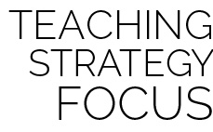

**Dance Strategy Focus:** Use this dance to highlight how dances can include different levels, pathways, and directions. Have students think of their own interpretations of the musical cues and, as always, encourage them to be creative in their movements.



* Teach and demonstrate each lyrical cue before adding music.
* List or draw the movements and cues on chart paper so students can follow along.
* Provide alternative movements for students who have movement disabilities.



* Perform the dance while dribbling a basketball.
* Pick a student leader to serve as group leader for each of the 4 wall directions.
* Have student leaders add a special flare to the choreography for the class to follow.

**CUPID SHUFFLE**



* **Skill:** I will perform the correct movements with the beat of the music.
* **Cognitive:** I will remember the names of dance steps and perform the correct movements when they are called.
* **Fitness:** I will actively engage during the activity.
* **Personal & Social Responsibility:** I will move safely and respectfully in self-space.
* Follow Lyric Cues: To the Right, To the Left, Now Kick, Now Walk it by Yourself

**Equipment:**

* Music player
* *Cupid Shuffle* by DJ Cupid (available on [iTunes](https://itunes.apple.com/us/album/cupid-shuffle-ep/id260167050) and [YouTube](https://www.youtube.com/watch?v=fAhXfcm_v40))
* 6–8 cones

**Set-Up:**

1. Set cones across from one other on each side of the activity area.
2. Arrange students in lines between the cones. Be sure students have enough space to dance safely.

**Activity Procedures:**

1. Today’s dance is called the *Cupid Shuffle*. It is a 4-wall dance created by DJ Cupid.
2. The purpose of the dance is to exercise while following the lyrical cues and rhythm of the song.
3. Listen closely to the lyrics at the beginning of the song. They will teach you the movements that you’ll repeat over and over throughout this dance. They’ll also repeat multiple times, so don’t worry if you can’t remember them the first time. You’ll face each of the 4 walls multiple times throughout the song.

**Grade Level Progression:**

**3rd:** Perform the dance in its original form, following the cues of the song.

**4th:** Students add bigger movements and their own style to the original steps.

**5th:** Students create their own choreography for each lyrical cue throughout the song.

**CUPID SHUFFLE**



Beat, Choreography, Count, Cues, Four-Wall Dance, Heel Touch, Lyric, Movement, Quarter-Turn, Rhythm



* Teach and demonstrate each lyrical cue before adding music.
* List or draw the movements and cues on chart paper so students can follow along.
* Provide alternative movements for students who have movement disabilities.



* Perform the dance with fitness movements such as running in place, jumping jacks or high-leg kicks (see activity card).
* Pick a student leader to serve as group leader for each of the 4 wall directions.
* Have student leaders add a special flare to the choreography for the class to follow.



* **Standard 1 [E5.3-5]** Performs teacher-selected and developmentally appropriate dance steps and movement patterns (3); Combines locomotor movement patterns and dance steps to create and perform an original dance (4); Combines locomotor skills in cultural as well as creative dances (self and group) with correct rhythm and pattern (5).
* **Standard 2 [E2.3-5]** Recognizes locomotor skills specific to a wide variety of physical activities (3); Combines movement concepts with skills in small-sided practice tasks, gymnastics, and dance environments (4); Combines movement concepts with skills in small-sided practice tasks in game environments, gymnastics, and dance with self-direction (5).
* **Standard 3 [E3.3-5]** Engages in the activities of physical education class without teacher prompting (3); Actively engages in the activities of physical education class, both teacher-directed and independent (4); Actively engages in all the activities of physical education (5).
* **Standard 4 [E1.3-5]** Exhibits personal responsibility in teacher-directed activities (3); Exhibits responsible behavior in independent group situations (4); Engages in physical activity with responsible interpersonal behavior (e.g., peer to peer, student to teacher, student to referee) (5).



* **DOK 1:** What dance movements did we use to perform this dance?
* **DOK 2:** What did you notice about how the dance was organized?
* **DOK 3:** Did the way the dance was organized help make it easier for a lot of people to perform this dance at once?
* **DOK 3:** How is this dance similair to the Cupid Shuffle? How is it different?



**Dance Strategy Focus:** The Cupid Shuffle is a popular 4-wall dance in which many people participate during social events where dancing is involved. This dance is not very complicated, so use this opportunity to help students feel successful and celebrate that feeling individually and as a group. You can also use the fitness challenges included on the activity card to begin to help your students think about how music guides choreography, as well as how fitness and exercise can be a part of both dance and positive social interaction.

**SPACE JAM**

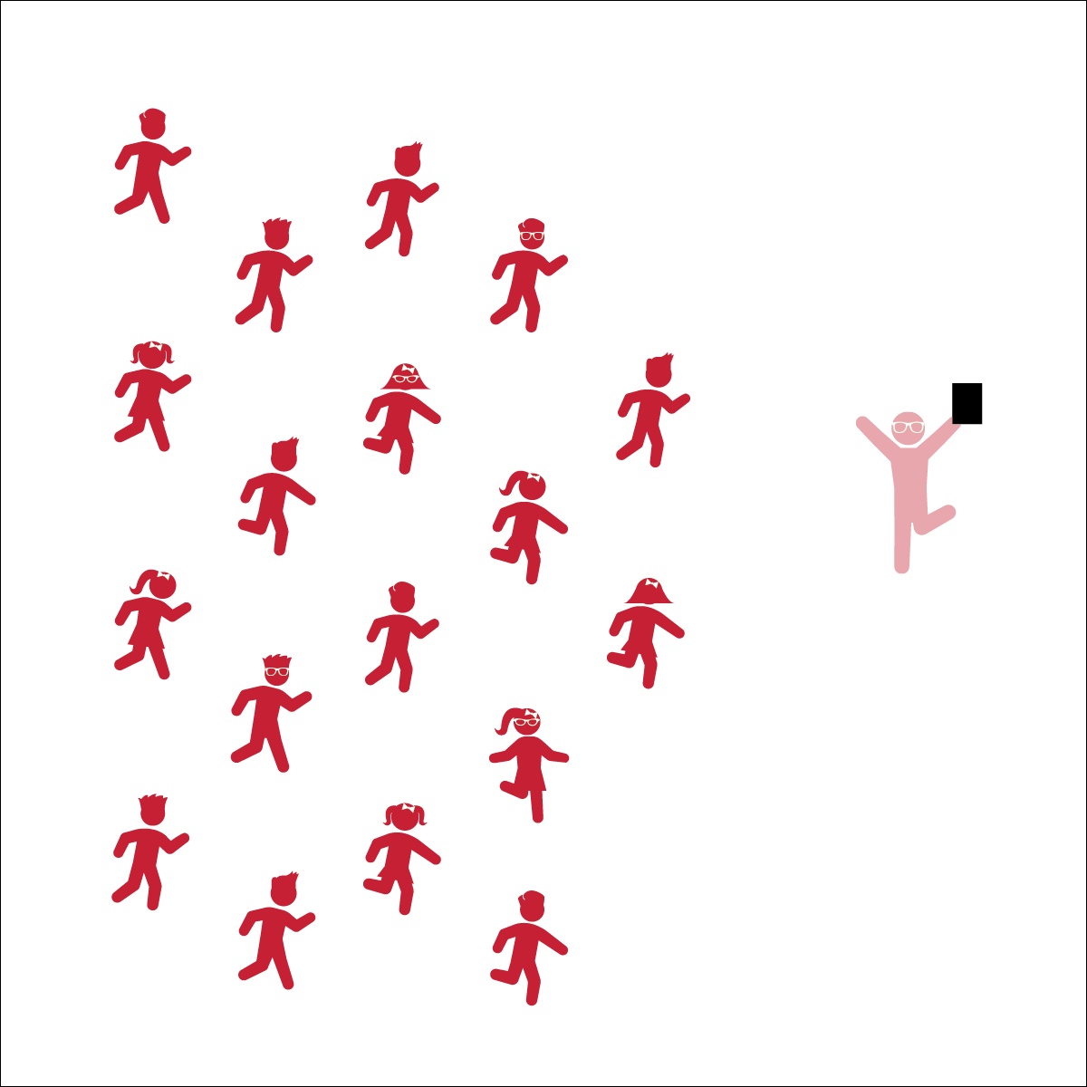

* **Skill:** I will perform movements with the beat and tempo of the music
* **Cognitive:** I will remember and perform the dance’s movements
* **Fitness:** I will perform this dance with my best effort to warm up all the parts of my body.
* **Personal & Social Responsibility:** I will encourage my classmates as we learn the movements and have fun.
* Follow Teacher’s Cues
* Find and Follow the Beat of the Music

**Equipment:**

* Music Player
* *Space Jam* by Quad City DJ’s (available on [iTunes](https://itunes.apple.com/us/album/space-jam/id1170755018?i=1170755174) and [YouTube](https://www.youtube.com/watch?v=J9FImc2LOr8)

**Set-Up:**

1. Scatter students in self-space throughout the activity area.
2. Be sure students have enough space to dance safely.

**Activity Procedures:**

1. Today’s dance is to the song *Space Jam* by Quad City DJ’s. It was designed to provide a fun movement experience to get the whole body moving.
2. Follow along with my movements (and/or movements being projected on the screen). Find and stay with beat of the song, and try to start to remember the sequence of the dance movements.
3. Teachers: use Space Jam Activity Card to teach the choreography of this dance.

**Grade Level Progression:**

**3rd:** Teach the choreography in parts, helping students learn each section both with and without music. Add them all together with music only when students have each section mastered.

**4th:** Have students follow along with music and attempt to learn the steps, going back to teach sections where they need extra practice. Once they know the steps, have them perform them with their own style.

**5th:** Once students have mastered this dance, have them create and perform their own “supercharged” movements.

**SPACE JAM**



8-Count, Beat, Bounce, Choreography, Count, Grapevine, Jump, Locomotor Skills, Movement, Non-Locomotor Skills, Respect, Responsibility, Sequence



* **Standard 2 [E2.3-5]** Recognizes locomotor skills specific to a wide variety of physical activities (3); Combines movement concepts with skills in small-sided practice tasks, gymnastics, and dance environments (4); Combines movement concepts with skills in small-sided practice tasks in game environments, gymnastics, and dance with self-direction (5).
* **Standard 3 [E4.3-5]** Recognizes the importance of warm-up and cool-down relative to vigorous physical activity (3); Demonstrates warm-up and cool-down relative to the cardio-respiratory fitness assessment (4); Identifies the need for warm-up and cool-down relative to various physical activities (5).
* **Standard 5 [E4.3-5]** Describes the positive social interactions that come when engaged with others in physical activity (3); Describes and compares the positive social interactions when engaged in partner, small-group, and large-group physical activities (.4); Describes the social benefits gained from participating in physical activity (e.g., recess, youth sport) (5).



* **DOK 1:** What dance movements did we use to perform this dance?
* **DOK 2:** Can you explain how the different movements affected different parts of your body?
* **DOK 3:** If we changed the music, would you have to perform the dance differently? If yes, how?



**Dance Strategy Focus:** Dance is like any other activity category in that skills require practice and concepts require explanation and processing. It’s the teacher’s job to help students process their experiences in ways that are student-centered and allow them to connect physical education lessons to their physical and emotional feelings. Take time for dance debrief sessions, and encourage deep discussion through tiered questioning techniques.



* Spend extra time teaching and demonstrating each section before adding music.
* List or draw the movements and cues on chart paper so students can follow along.
* Provide alternative movements for students who have movement disabilities.



* Perform the dance without following the teacher’s movements.
* Designate one or more students as leaders to serve as a guide at the front of the class.

**FJASKERN**

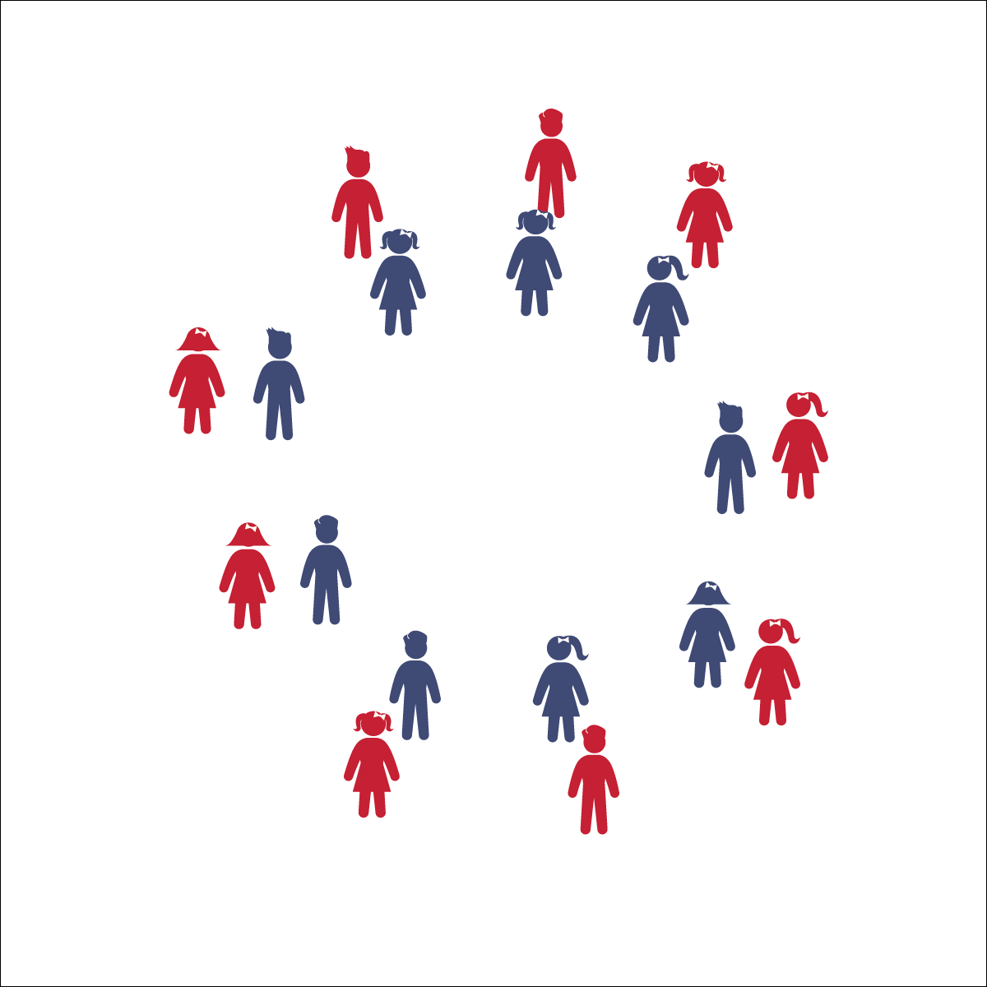

* **Skill:** I will perform movements with the beat and tempo of the music.
* **Cognitive:** I will remember and perform the dance’s movements.
* **Fitness:** I will actively engage during the activity.
* **Personal & Social Responsibility:** I will move safely and respectfully in self-space and with a partner.
* Follow Teacher’s Cues
* Find and Follow the Beat of the Music
* Dance Faster as the Tempo Increases

**Equipment:**

* Music player
* *Fjaskern* song (available on [iTunes](https://itunes.apple.com/us/album/dance-music-for-children-level-1/id459845807) and [YouTube](https://www.youtube.com/watch?v=_ZVCQ7YUg58&list=UUP7A9GpTe-XHmcGf6BBNWwQ&index=27))

**Set-Up:**

1. Divide the class evenly and arrange students into two circles: an outer circle and an inner circle.
2. Students who are standing across from one another in the circles are partners.
3. All students face the counter-clockwise direction.
4. Be sure students have enough space to dance safely.

**Activity Procedures:**

1. Today we’re going to perform a Swedish dance named Fjaskern (pronounced ‘FYEHS-kern’). In English, “fjaskern” means “hurry-scurry.” The dance starts slow but gets faster and faster.
2. We will learn the movements of this dance first without music and then perform the dance with music together.
3. Teachers, use the Fjaskern Activity Card to teach the movements.
4. Make sure to listen to the music closely, especially when the tempo—the speed of the song—increases. You will have to dance faster to keep up with the music.

**Grade Level Progression:**

**3rd:** Focus on learning the steps and movement patterns. Take ample time to teach students the dance without music before adding music and increasing the tempo.

**4th:** Once students have mastered the traditional steps, allow them to insert their own movements.

**5th:** Try the dance with 2 sets of outer and inner circles, all inside one another (4 concentric circles). Provide additional information about Sweden to deepen the cultural aspects of the lesson.

**FJASKERN**



8-Count, Beat, Clockwise, Count, Counter-Clockwise, Line Dance, Movement, Partner, Tempo



* **Standard 1 [E5.3-5]** Performs teacher-selected and developmentally appropriate dance steps and movement patterns (3); Combines locomotor movement patterns and dance steps to create and perform an original dance (4); Combines locomotor skills in cultural as well as creative dances (self and group) with correct rhythm and pattern (5).
* **Standard 2 [E2.3-5]** Recognizes locomotor skills specific to a wide variety of physical activities (3); Combines movement concepts with skills in small-sided practice tasks, gymnastics, and dance environments (4); Combines movement concepts with skills in small-sided practice tasks in game environments, gymnastics, and dance with self-direction (5).
* **Standard 4 [E4.3-5]** Works cooperatively with others (3a); Praises others for their success in movement performance (3b); Praises the movement performance of others, both more and less-skilled (4a); Accepts players of all skill levels into the physical activity (4b); Accepts, recognizes, and actively involves others with both higher and lower skill abilities into physical activities and group projects (5).



* **DOK 1:** What dance movements did we use to perform this dance?
* **DOK 1:** What does the word ‘fjaskern’ mean in English?
* **DOK 2:** What did you have to do to make sure you stayed with your partner? What was it like to dance with a partner?
* **DOK 3:** Did the activity get harder as the tempo got faster and faster? Why do you think that was?
* **DOK 4:** Does this dance tell a story? Share with us a story you created around the movements of this dance and explain how that story gives it more meaning.



**Dance Strategy Focus:** Fjaskern is a dance that provides many teachable moments. It is a cultural dance that can start conversation about acknowledging similarities and celebrating differences. It also provides an opportunity for students to practice handling the challenges of working with a partner and keeping on beat with the increasing tempo. Like all dances, teach the choreography slowly at first and then move faster, finally incorporating the music once the students understand the movements. Remember to make dance fun by committing yourself fully, not fearing mistakes, and laughing often.



* Instead of using circles, have pairs perform the movements around hula hoops (1 hoop per pair).
* List or draw the movements on chart paper so students can follow along.
* Provide a teacher to dance alongside students who cannot remember the movements.
* Provide alternative movements for students who have movement disabilities.



* Perform the dance without teacher cues.
* If there is an odd number of students, challenge the class to think of a solution on their own.

**LOOKING UP**



* **Skill:** I will perform movements with the beat and tempo of the music.
* **Cognitive:** I will remember and perform the dance’s movements.
* **Fitness:** I will actively engage during the activity.
* **Personal & Social Responsibility:** I will encourage my classmates as we all learn and perform this dance.
* Follow Teacher’s Cues
* Find and Follow the Beat of the Music

**Equipment:**

* Music player
* *Looking Up* by Safety Suit (available on [iTunes](https://itunes.apple.com/us/album/looking-up-single/id1051357812) and [YouTube](https://www.youtube.com/watch?v=8FtdtnDbwmQ))

**Set-Up:**

1. Scatter students in self-space throughout the activity area.
2. Be sure students have enough space to dance safely.

**Activity Procedures:**

1. Today we will perform a dynamic warm-up dance to the song *Looking Up* by Safety Suit.
2. Follow along with my movements (and/or movements being projected on the screen). Find and stay with beat of the song and try to start to remember the sequence of the dance movements.
3. Teachers: use the Looking Up Activity Card to teach the choreography of this dance.

**Grade Level Progression:**

**3rd:** Teach the choreography in parts, helping students learn each section both with and without music. Add them all together with music only when students have each section mastered.

**4th:** Have students follow along with music and attempt to learn the steps, going back to teach sections where they need extra practice.

**5th:** Once students have mastered this dance, have them create and perform their own “supercharged” movements.

**LOOKING UP**



Beat, Bounce, Clockwise, Count, Counter-Clockwise, Leader, Follower, Grapevine, Locomotor Skills, Non-Locomotor Skills, Responsibility, Respect, Sequence



* **Standard 1 [E5.3-5]** Performs teacher-selected and developmentally appropriate dance steps and movement patterns (3); Combines locomotor movement patterns and dance steps to create and perform an original dance (4); Combines locomotor skills in cultural as well as creative dances (self and group) with correct rhythm and pattern (5).
* **Standard 2 [E2.3-5]** Recognizes locomotor skills specific to a wide variety of physical activities (3); Combines movement concepts with skills in small-sided practice tasks, gymnastics, and dance environments (4); Combines movement concepts with skills in small-sided practice tasks in game environments, gymnastics, and dance with self-direction (5).
* **Standard 4 [E4.3-5]** Works cooperatively with others (3a); Praises others for their success in movement performance (3b); Praises the movement performance of others, both more and less-skilled (4a); Accepts players of all skill levels into the physical activity (4b); Accepts, recognizes, and actively involves others with both higher and lower skill abilities into physical activities and group projects (5).
* **Standard 5 [E2.3-5]** Discusses the challenge that comes from learning a new physical activity (3); Rates the enjoyment of participating in challenging and mastered physical activities (4); Expresses (via written essay, visual art, creative dance) the enjoyment and/or challenge of participating in a favorite physical activity (5).
* **Standard 5 [E4.3-5]** Describes the positive social interactions that come when engaged with others in physical activity (3); Describes and compares the positive social interactions when engaged in partner, small-group, and large-group physical activities (.4); Describes the social benefits gained from participating in physical activity (e.g., recess, youth sport) (5).



* **DOK 1:** What dance movements did we use to perform in this dance?
* **DOK 2:** What were the different levels and directions we used to perform this dance?
* **DOK 2:** Can you explain the effect the supercharged movements had on your body as you performed this dance?



**Dance Strategy Focus:** This is a great dynamic warm-up dance. Teach this dance in parts and then add the parts together. When the dance says to “freestyle,” encourage your students to get as creative as they are and express themselves through their movements. Encourage them to dance big and give their effort. The bigger they make their movements, the more benefits the dance will have on their body.



* Spend extra time teaching and demonstrating each section before adding music.
* List or draw the movements and cues on chart paper so students can follow along.
* Provide alternative movements for students who have movement disabilities.



* Perform the dance without following the teacher’s movements.
* Designate one or more students as leaders to serve as a guide at the front of the class.

**CAN’T STOP THE FEELING**



* **Skill:** I will perform movements with the beat and tempo of the music.
* **Cognitive:** I will remember and perform the dance’s movements
* **Fitness:** I will stay actively engaged during the dance.
* **Personal & Social Responsibility:** I will move in self-space in order to keep myself and my classmates safe.
* Follow Teacher’s Cues
* Find and Follow the Beat of the Music

**Equipment:**

* Music Player
* *CAN’T STOP THE FEELING* by Justin Timberlake (available on [iTunes](https://itunes.apple.com/nz/album/cant-stop-feeling-original-song-from-dreamworks-animations/id1110121889) and [YouTube](https://www.youtube.com/watch?v=qEFKkAqb1ww))

**Set-Up:**

1. Scatter students in self-space throughout the activity area.
2. Be sure students have enough space to dance safely.

**Activity Procedures:**

1. Today’s activity is a fun dance to the song *Can’t Stop the Music* by Justin Timberlake. It’s an upbeat song that makes you want to move!
2. Follow along with my movements (and/or movements being projected on the screen). Find and stay with beat of the song and try to start to remember the sequence of the dance movements.
3. Teachers: use Can’t Stop the Feeling Activity Card to teach the choreography of this dance.

**Grade Level Progression:**

**3rd:** Have students follow along with music and attempt to learn the steps.

**4th:**  After students have followed along for a whole, have them perform them with their own style.

**5th:** Once students have mastered this dance, have them create and perform their own “supercharged” movements.

**CAN’T STOP THE FEELING**



**Dance Strategy Focus:** Use this dance to reinforce and model dancing as a fun and expressive activity that everyone can do. Let students see you enjoy the movement and creative expression of dance. It’s okay if you aren’t the world’s best dancer. To be honest, if your dancing skills are less than perfect, you will provide a powerful example for all students to emulate.



8-Count, Beat, Bounce, Count, Diagonally, Grapevine, Jump, Locomotor Skills, Lyric, Non-Locomotor Skills, Responsibility, Respect, Sequence



* **Standard 1 [E5.3-5]** Performs teacher-selected and developmentally appropriate dance steps and movement patterns (3); Combines locomotor movement patterns and dance steps to create and perform an original dance (4); Combines locomotor skills in cultural as well as creative dances (self and group) with correct rhythm and pattern (5).
* **Standard 3 [E3.3-5]** Engages in the activities of physical education class without teacher prompting (3); Actively engages in the activities of physical education class, both teacher-directed and independent (4); Actively engages in all the activities of physical education (5).
* **Standard 5 [E2.3-5]** Discusses the challenge that comes from learning a new physical activity (3); Rates the enjoyment of participating in challenging and mastered physical activities (4); Expresses (via written essay, visual art, creative dance) the enjoyment and/or challenge of participating in a favorite physical activity (5).



* **DOK 1:** What dance movements did we use to perform this dance?
* **DOK 2:** Can you describe how the music made you feel when it started to play?
* **DOK 3:** How are the dance movements related to the beat and tempo of the music?



* Spend extra time teaching and demonstrating each section before adding music.
* List or draw the movements and cues on chart paper so students can follow along.
* Provide alternative movements for students who have movement disabilities.



* Perform the dance without following the teacher’s movements.
* Designate one or more students as leaders to serve as a guide at the front of the class.

**THE VIRGINIA REEL**

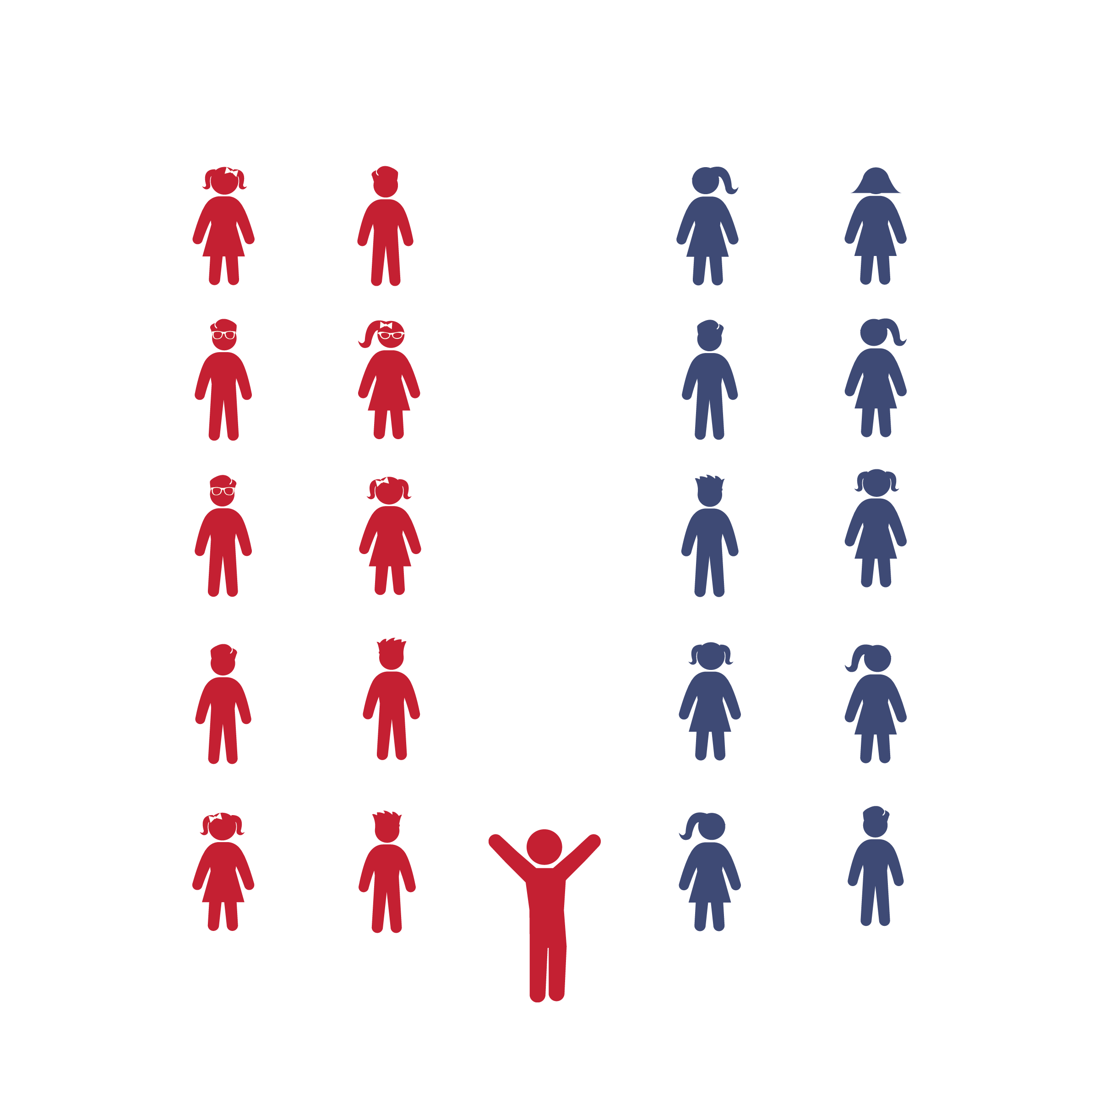

* **Skill:** I will perform movements with the beat and tempo of the music.
* **Cognitive:** I will remember and perform the dance’s movements.
* **Fitness:** I will actively engage during the activity.
* **Personal & Social Responsibility:** I will cooperate with my classmates to learn and perform the dance.
* Follow Caller Cues: Honor Your Partner, Forward and Back, Allemande Right, Allemande Left, Both Hands, Do-Si-Do, Head Partners Slide Down and Back, Reel the Set, Cast Off/Peel, Arch

**Equipment:**

* Music player
* *The Virginia Reel* song (available on [iTunes](https://itunes.apple.com/us/album/australian-traditional-dance-tunes/id216261899) and [YouTube](https://www.youtube.com/watch?v=idyiha1eOCk&list=UUP7A9GpTe-XHmcGf6BBNWwQ&index=7))
* Optional: tempo-modifying app such as Tempo Slow (available on the App Store)

**Set-Up:**

1. Arrange students in parallel lines with no more than 8 students in each line. If you have more than 16 students, form 4 or 6 lines.
2. Students who are facing one another are partners.
3. Designate the pair of students standing closes to the music player as “Head Partners.” The pair at the opposite end of the line are “Foot Partners.”

**Activity Procedures:**

1. Today we are going to learn a dance called *The Virginia Reel.* It originated from other dances that came from Ireland, Scotland, and England, but as we know it today, it has many variations. *The Virginia Reel* was named after the state of Virginia by the American colonists. It was first published in 1685 by a man named Sir Roger de Coverly, making it one of the oldest dances that is still performed in our country today.
2. First, we’ll learn the movements without music while we count out loud. We’ll learn one movement, practice it, and then learn another movement to add on. We’ll keep adding movements until we’ve learned the whole dance. Then we’ll add the music and dance to the song’s beat.
3. *The Virginia Reel* has a clear, steady beat. Each movement will take 8 beats. Listen closely to the beat so that you can follow along. If it helps, you can count out loud 1-2-3-4-5-6-7-8 as we dance.
4. Teachers, teach the movements using the Virginia Reel Activity Card. Then add music and enjoy!

**Grade Level Progression:**

**3rd:** Perform the activity as described above.

**4th:** Have students perform the dance multiple times, switching partners each time.

**5th:** Add the additional “Reel the Set” challenge listed on the activity card.

History of The Virginia Reel found at: http://users.rowan.edu/~conet/rhythms/CulturalDances/VirginiaReel.html

**VIRGINIA REEL**



Beat, Caller, Calls, Choreography, Count, Cues, Do-Si-Do, Line Dance, Partner, Single-File Line, Skip, Slide, Tempo, Walk



* **Standard 1 [E5.3-5]** Performs teacher-selected and developmentally appropriate dance steps and movement patterns (3); Combines locomotor movement patterns and dance steps to create and perform an original dance (4); Combines locomotor skills in cultural as well as creative dances (self and group) with correct rhythm and pattern (5).
* **Standard 2 [E2.3-5]** Recognizes locomotor skills specific to a wide variety of physical activities (3); Combines movement concepts with skills in small-sided practice tasks, gymnastics, and dance environments (4); Combines movement concepts with skills in small-sided practice tasks in game environments, gymnastics, and dance with self-direction (5).
* **Standard 4 [E4.3-5]** Works cooperatively with others (3a); Praises others for their success in movement performance (3b); Praises the movement performance of others, both more and less-skilled (4a); Accepts players of all skill levels into the physical activity (4b); Accepts, recognizes, and actively involves others with both higher and lower skill abilities into physical activities and group projects (5).



* **DOK 1:** Describe the choreography we used to perform this dance.
* **DOK 2:** What pattern did the Virginia Reel follow?
* **DOK 3:** Considering that the movements follow the same order every time, how would you know when to do the next movement if the teacher/caller did not call it out?
* **DOK 4:** What role do you think the Virginia Reel had in the lives of Scottish immigrants when they brought this dance with them when they moved to America?



**Dance Strategy Focus:** The Virginia Reel is great partner line dance that fosters a wonderful sense of teamwork and community. Teach each movement slowly and give students time to master the choreography before moving to the music. As you do, gradually increase the tempo at which students repeat 1-2-3-4-5-6-7-8 and practice the movements so they are not caught off guard when they first hear the tempo of the song. Allow time for everyone to be the head couple. Consider performing this dance at a school event or inviting parents to try it with your class.



* Have students hold a scarf instead of their partners’ hands.
* Do not include the “Reel the Set” movement.
* Find a slower version of the song or use a tempo-modifying app to slow the beat.
* Perform to a 16-count rather than an 8-count (dance in *half-time*).
* List or draw the movements and cues on chart paper so students can follow along.
* Provide alternative movements for students who have movement disabilities.



* Perform the dance without following the teacher’s verbal cues.
* If there is an odd number of students, challenge the class to think of a solution on their own.

**Equipment:**

* Music player
* *Good Feeling* by Flo Rida or other favorite hip-hop song (available on [iTunes](https://itunes.apple.com/us/album/good-feeling/id613867183?i=613867349) and [YouTube](https://www.youtube.com/watch?v=h94gvPDapvw))
* Optional: tempo-modifying app such as Tempo Slow (available on the [App Store](https://itunes.apple.com/us/app/tempo-slowmo-original-bpm-slow-downer/id635275615?mt=8))

**Set-Up:**

1. Pair students. Try to maintain pairings from the original Virginia Reel lesson.
2. Group pairs such that there are 4 pairs (8 students) in each group.

**THE HIP HOP VIRGINIA REEL**



* **Skill:** I will perform movements with the beat and tempo of the music.
* **Cognitive:** I will create, remember, and perform my own 8-count dance routine.
* **Fitness:** I will actively engage during the activity.
* **Personal & Social Responsibility:** I will cooperate with my classmates and accept new ideas while we create, practice, and perform our own original dance movements.
* Think Creatively
* Find and Follow the Beat of the Music

**Activity Procedures:**

1. In today’s class, we are going to get creative with the *Virginia Reel* dance we learned last time.
2. You and your partner will create your own 8-count movement. Then, you’ll get together with your group to teach them your choreography and also learn theirs. As a group, you will decide what order your choreography should go in. Then you’ll practice your new dance and perform it for the rest of us.
3. Teachers, help kick off the creativity by playing YouTube videos or demonstrating potential hip-hop movements. Additional examples are included on the Hip Hop Virginia Reel Activity Card.
4. To help students generate ideas and remember them, you can write their movements on chart paper, have them give their movements unique names, and ask students to demonstrate.
5. If you have time, have the class perform the Hip Hop Virginia Reel as you would the traditional *Virginia Reel*, only with the new movements.

**Grade Level Progression:**

**3rd:** Move from group to group, helping students brainstorm. Or, have everyone suggest ideas as a class.

**4th:** Have each pair create 2-3 sequences, of which they’ll share 1-2.

**5th:** Have students in each group take turns calling out the names of their dance steps as they’re performed.



8-Count, Beat, Caller, Charge, Choreography, Collaboration, Count, Creativity, Cues, Follower, Grapevine, Hip Hop, Leader, Movement, Partner, Sequence, Tempo



* **Standard 3 [E3.3-5]** Engages in the activities of physical education class without teacher prompting (3); Actively engages in the activities of physical education class, both teacher-directed and independent (4); Actively engages in all the activities of physical education (5).
* **Standard 4 [E4.3-5]** Works cooperatively with others (3a); Praises others for their success in movement performance (3b); Praises the movement performance of others, both more and less-skilled (4a); Accepts players of all skill levels into the physical activity (4b); Accepts, recognizes, and actively involves others with both higher and lower skill abilities into physical activities and group projects (5).
* **Standard 5 [E4.3-5]** Describes the positive social interactions that come when engaged with others in physical activity (3); Describes and compares the positive social interactions when engaged in partner, small-group, and large-group physical activities (.4); Describes the social benefits gained from participating in physical activity (e.g., recess, youth sport) (5).



* **DOK 1:** How many beats do we have to perform our newly created dance sequence?
* **DOK 2:** How would you summarize your new dance to a friend or family member?
* **DOK 3:** What inspired the new dance movements you created for the Hip Hop Viriginia Reel?
* **DOK 3:** How were the movements we created as a class different than the movements we performed in the traditional Virginia Reel? How were they similar?
* **DOK 3:** How could you use the Hip Hop Virginia Reel to create and tell a story?



**Dance Strategy Focus:** Build confidence and excitement as you work your way up to this activity. Not only do the students have to show their creativity, but they also have to try and follow the structure of the 8-count the reel style of dancing is known for. Be fully present to provide any help they need. Encourage your students to draw on inspiration from things that are relevant and important to their lives, dances they like to do, movies they like to watch, or other activities they enjoy. Remember that all the movements they come up with are expressions of themselves that should be accepted and celebrated by the class. Have fun!



* Use slower songs or use a tempo-modifying app to slow the beat.
* Perform to a 16-count rather than an 8-count (dance in *half-time*).
* List or draw the movements and cues on chart paper so students can follow along.
* Provide alternative movements for students who have movement disabilities.



* Attempt to perform students’ choreography to several different songs.
* Create variations of the new movements, such as faster, slower, bigger, smaller, in a different direction, etc.
* Perform the dance without anyone calling out the movement cues.

**HIP HOP VIRGINIA REEL**