­­

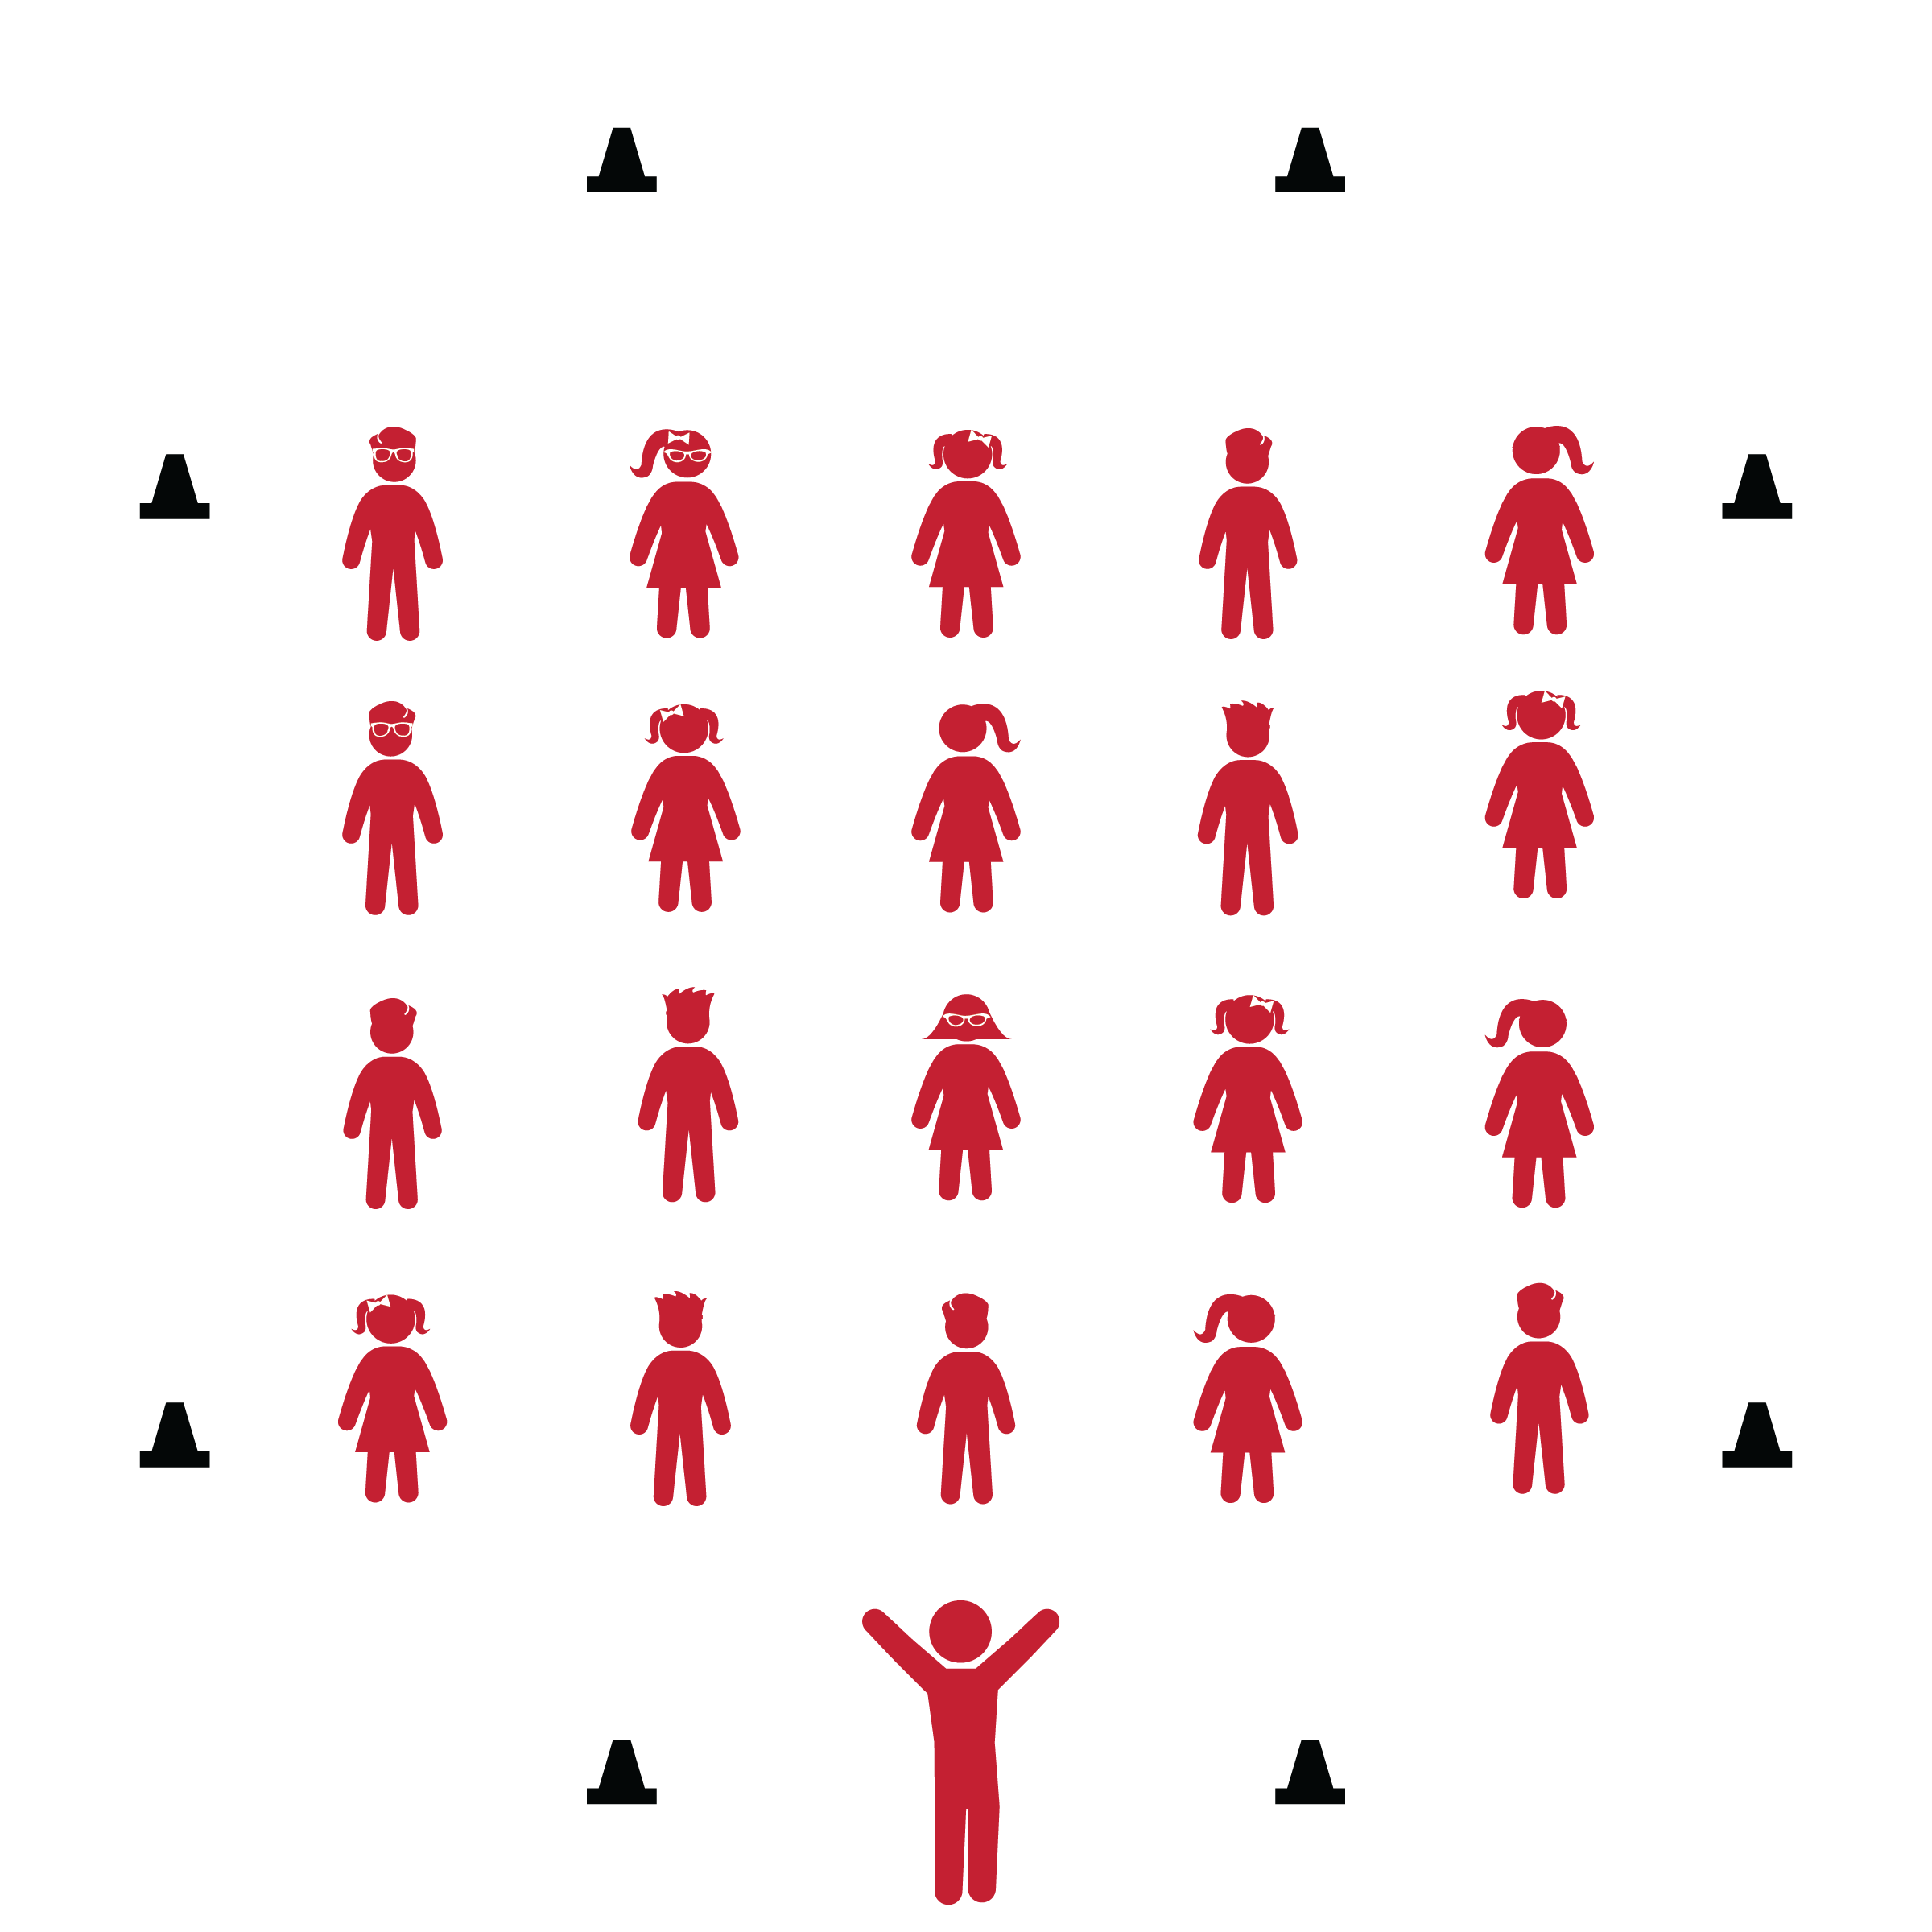

**DANCE NAME HERE**

* **Skill:** I will…
* **Cognitive:** I will…
* **Fitness:** I will…
* **Personal & Social Responsibility:** I will…
* Follow Lyric Cues: 1
* Follow Lyric Cues: 2

**Equipment:**

* Music player
* *Song with Link*
* Equip 3

**Set-Up:**

1. Set-up activity area
2. Arrange students

**Activity Procedures:**

1. Today’s dance is called…
2. The purpose of the dance is to…
3. Throughout the song…

**Grade Level Progression:**

**3rd:** Progression 1

**4th:** Progression 2

**5th:** Progression 3

**DANCE NAME HERE**



Words, Words, Words



* **Standard ? [E?.3-5]** Text goes here…
* **Standard ? [E?.3-5]** Text goes here…
* **Standard ? [E?.3-5]** Text goes here…



* **DOK 1:** Question…?
* **DOK 2:** Question…?
* **DOK 2:** Question…?
* **DOK 3:** Question…?

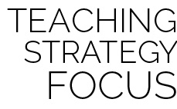

**Dance Strategy Focus:** Use this dance to…



* Universal Design Modifications…
* Universal Design Modifications…



* More challenges
* Even more…