­­

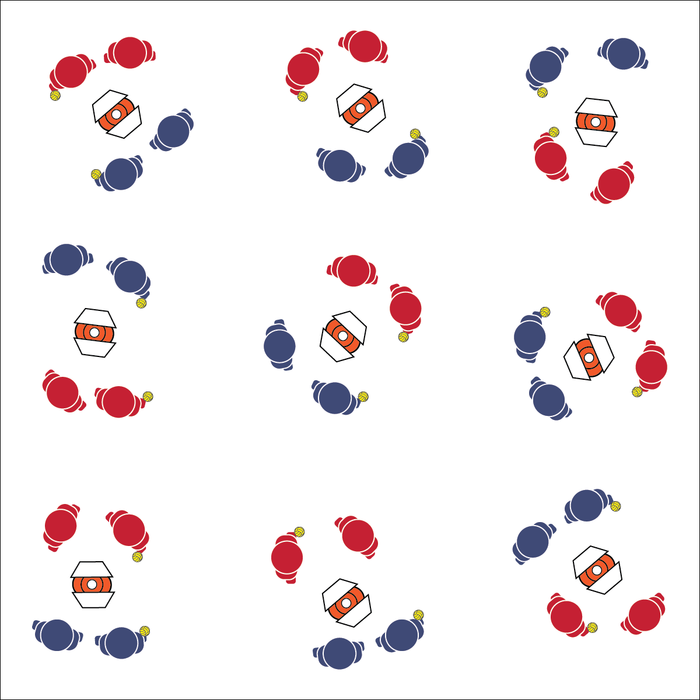

* **Skill:** I will demonstrate skill cues for under- and above-chest passing.
* **Cognitive:** I will define and use a minimum of 4 Roundnet academic language words in proper context.
* **Fitness:** I will remain focused and actively engaged in practice tasks.
* **Personal & Social Responsibility:** I will demonstrate safe behaviors during all practice tasks.

**SELF-PASSING CHALLENGES**

* Athletic Stance (Feet, Knees, Hands, Eyes Ready)
* Hand Placement (Below-Chest: Palms Up, Fingers Away; Above-Chest: Palms Out, Fingers Toward Head)
* Palm Strike (Palm Flat, Strike Between Heel and Fingers)

**Equipment:**

* 1 Spikeball® (or foam ball) per group of 2–4 students
* 1 Task Tent and 1 large cone per group
* 1 Self-Passing Challenge Card per group
* 1 Passing Cue Chart per group

**Set-Up:**

1. Scatter cones, Task Tents, and Roundnet cards in the activity area with enough space for groups to move freely.
2. Create groups of 2–4 students, each group at a cone with a Spikeball®.

**Activity Procedures:**

1. Today we’re going to start our Roundnet training by completing a series of self-passing challenges. There are two types of passes used in Roundnet: 1) below-chest and 2) above-chest.
2. Both passes require you to be ready in an athletic stance, use proper hand placement, and use a palm strike to hit the ball (demonstrate and practice critical elements).
3. Below-chest passing requires hand placement at waist level, palms out, and fingers away from the body. above-chest passing requires hand placement at shoulder level, palms out, and fingers pointing up toward the head.
4. On the start signal, work to complete the self-passing challenges found on the challenge card. Reach JV level with 10 successful self-passes. Reach Varsity level with 20 successful self-passes. Take turns with group members after you’ve attempted to complete a challenge level 3 times.
5. Freeze and be ready to listen when you hear the stop signal.

**Grade Level Progression:**

**L1:** Complete each skill challenge with a focus on reciting skill cues and using correct academic language.

**L2:** Discuss and utilize the Stages of Motor Learning Worksheet.

**SELF-PASSING CHALLENGES**



* **Standard 1 [H1.L1-2]** Demonstrates competency and/or refines activity-specific movement skills in two or more lifetime activities (outdoor pursuits, individual-performance activities, aquatics, net/wall games, or target games) (L1); Refines activity-specific movement skills in one or more lifetime activities (outdoor pursuits, individual-performance activities, aquatics, net/wall games, or target games) (L2).
* **Standard 2 [H1.L1]** Applies the terminology associated with exercise and participation in selected individual-performance activities, dance, net/wall games, target games, aquatics, and/or outdoor pursuits appropriately (L1).
* **Standard 2 [H3.L1-2]** Creates a practice plan to improve performance for a self-selected skill (L1); Identifies the stages of learning a motor skill (L2).
* **Standard 4 [H5.L1]** Applies best practices for participating safely in physical activity, exercise, and dance (e.g., injury prevention, proper alignment, hydration, use of equipment, implementation of rules, sun protection) (L1).



Above-Chest Pass, Accuracy, Below-Chest Pass, Control, Purposeful Practice, Safety, Stages of Motor Learning



* Provide a variety of balls or balloons and allow students to choose their challenge preference.



* **DOK 1:** How can you recognize a below-chest and above-chest pass?
* **DOK 2:** How does the position/placement of a pass, spike, or serve affect the pass you would give?
* **DOK 3:** How is the pass related to Spikeball® game play?

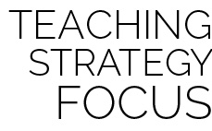

**Help students practice skills:** Self-passing challenges are basic drills that provide students opportunities to refine and become competent in Roundnet’s most essential skills. Discuss and encourage students to find opportunities to practice these challenges outside of class using foam or inflatable balls they may have at home.



**Equipment:**

* 1 Spikeball® (or foam ball) per pair
* 1 Task Tent and large cone per 2 pairs
* 1 Partner Passing Challenge Card per pair
* 1 Passing Cue Chart per pair

**Set-Up:**

1. Scatter cones, Task Tents, and Roundnet cards in the activity area with enough space for groups to move freely.
2. Create pairs or 2 students. Send 2 pairs to a cone, each pair with a Spikeball®.

**Activity Procedures:**

1. It’s time to practice Roundnet passing with a partner. Be sure to use the cues for accurate passing. Focus on body and ball control.
2. On the start signal, work to complete the partner passing challenges found on the challenge card. Reach JV level with 10 successful self-passes. Reach Varsity level with 20 successful self-passes. Take turns with other pairs in your group after you’ve attempted to complete a challenge level 3 times.
3. Freeze and be ready to listen when you hear the stop signal.

**Grade Level Progression:**

**L1:** Complete each skill challenge with a focus on reciting skill cues and using correct academic language.

**L2:** Use the Stages of Motor Learning Worksheet to analyze partner’s skill development.

* **Skill:** I will demonstrate skill cues for under- and above-chest passing.
* **Cognitive:** I will create a practice plan for improving my Roundnet passing skills.
* **Fitness:** I will remain focused and actively engaged in practice tasks.
* **Personal & Social Responsibility:** I will demonstrate safe and cooperative behaviors during all practice tasks.

**PARTNER PASSING**

* Hand Placement (Below-Chest: Palms Up, Fingers Away; Above-Chest: Palms Out, Fingers Toward Head)
* Palm Strike (Palm Flat, Strike Between Heel and Fingers)

**PARTNER PASSING**



* **Standard 1 [H1.L1-2]** Demonstrates competency and/or refines activity-specific movement skills in two or more lifetime activities (outdoor pursuits, individual-performance activities, aquatics, net/wall games, or target games) (L1); Refines activity-specific movement skills in one or more lifetime activities (outdoor pursuits, individual-performance activities, aquatics, net/wall games, or target games) (L2).
* **Standard 2 [H1.L1]** Applies the terminology associated with exercise and participation in selected individual-performance activities, dance, net/wall games, target games, aquatics, and/or outdoor pursuits appropriately (L1).
* **Standard 2 [H3.L1-2]** Creates a practice plan to improve performance for a self-selected skill (L1); Identifies the stages of learning a motor skill (L2).
* **Standard 4 [H5.L1]** Applies best practices for participating safely in physical activity, exercise, and dance (e.g., injury prevention, proper alignment, hydration, use of equipment, implementation of rules, sun protection) (L1).



Above-Chest Pass, Accuracy, Below-Chest Pass, Control, Practice Plan, Rally, Safety, Set



* Provide implements for striking (such as a paddle) if students have difficulty striking with their hands.
* Allow 1 student to toss the ball while the other students perform various passes.



* **DOK 1:** What is a practice plan?
* **DOK 2:** How can you apply the skills you’ve learned so far and today’s drill in the development of a practice plan?
* **DOK 3:** How is purposeful practice related to skill development?



**Organize students to interact with content:** Partner passing challenges and the use of challenge cards allow students to interact with skill-development content with both independence and the freedom to focus on individual skill development. As students choose their partners, help guide their choices with a focus on enjoyment, focus, and cooperation.

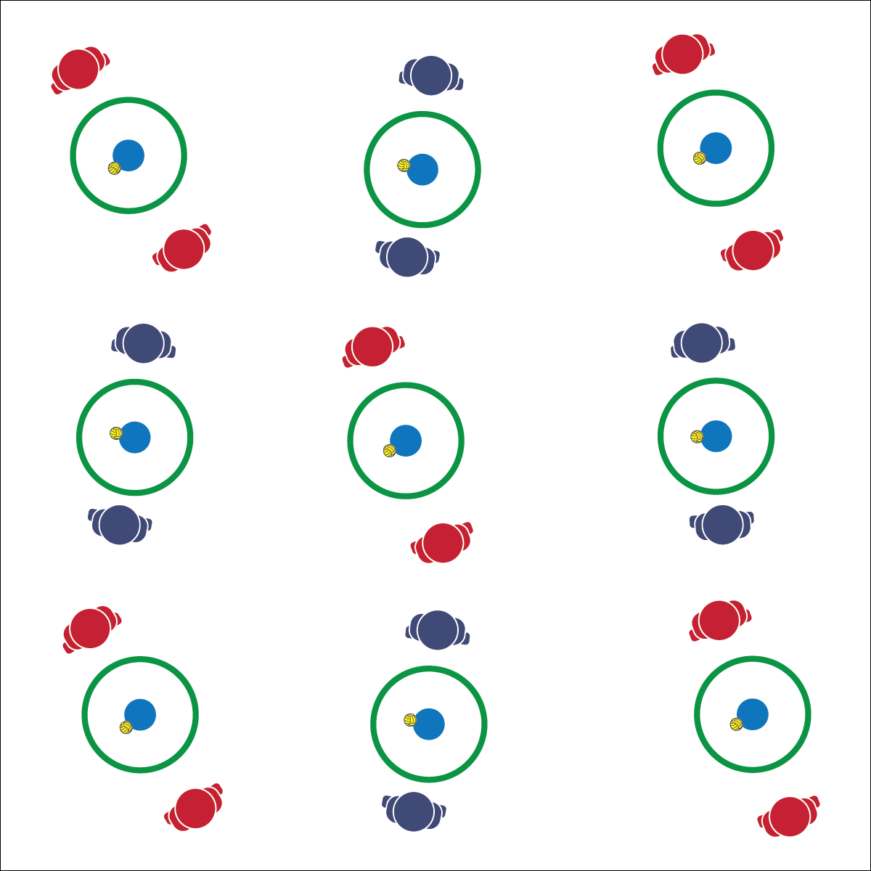

**Activity Procedures:**

1. This activity is called Selfie Spikes. The object is to land your spikes inside of the hoop.
2. On the start signal, your partner will toss you the ball just above waist level. Self-pass the ball and then spike it into the hoop.
3. Complete 5 attempted spikes and then change roles.
4. When you believe you’ve mastered level 1 by hitting inside the hoop, move to level 2 by attempting to hit the spot marker.
5. When you hear the stop signal, hold the ball and be ready to listen.

**Grade Level Progression:**

**L1:** Actively engage in skill practice with some discussion on ways to improve their performance.

**L2:** Specifically discuss the speed/accuracy trade-off with respect to improving their Selfie Spikes performance.

**Equipment:**

* 1 hoop per pair of students
* 1 spot marker per pair
* 1 Spikeball® or foam ball per pair

**Set-Up:**

1. In a large activity area, place 1 spot marker and 1 ball in the center of a hoop for each pair of students.
2. Pair students, each pair at a hoop.

**SELFIE SPIKES**

* **Skill:** I will demonstrate skill cues for spiking.
* **Cognitive:** I will discuss the speed/accuracy trade-off that exists when spiking.
* **Fitness:** I will remain focused and actively engaged in practice tasks.
* **Personal & Social Responsibility:** I will demonstrate safe behaviors during all practice tasks.
* Partner Toss
* Self-Set
* Accurate Spike

**SELFIE SPIKES**



* **Standard 1 [H1.L1-2]** Demonstrates competency and/or refines activity-specific movement skills in two or more lifetime activities (outdoor pursuits, individual-performance activities, aquatics, net/wall games, or target games) (L1); Refines activity-specific movement skills in one or more lifetime activities (outdoor pursuits, individual-performance activities, aquatics, net/wall games, or target games) (L2).
* **Standard 2 [H2.L1-2]** Uses movement concepts and principles (e.g., force, motion, rotation) to analyze and improve performance of self and/or others in a selected skill (L1); Describes the speed/accuracy trade-off in throwing and striking skills (L2).
* **Standard 4 [H5.L1]** Applies best practices for participating safely in physical activity, exercise, and dance (e.g., injury prevention, proper alignment, hydration, use of equipment, implementation of rules, sun protection) (L1).



* Increase the size of the target area or remove the target altogether.
* Allow students Increase the number of self-passes allowed before a spike.



Accuracy, Grit, Speed, Spike, Trade-off, Purposeful Practice



* **DOK 1:** What would you include on a list describing the pros and cons of hitting a Spikeball® with speed?
* **DOK 1:** What would you include on a list of reasons why it is important to hit a Spikeball® accurately?
* **DOK 2:** How would you summarize the speed/accuracy trade-off related to Roundnet spikes?
* **DOK 3:** How is speed related to accuracy when spiking?



**Preview new content:** Help students see and understand the importance of skill development with Roundnet videos from cooperative Spikeball® teams. You can find dozens of amazing videos at [www.USASpikeball.com](http://www.USASpikeball.com).

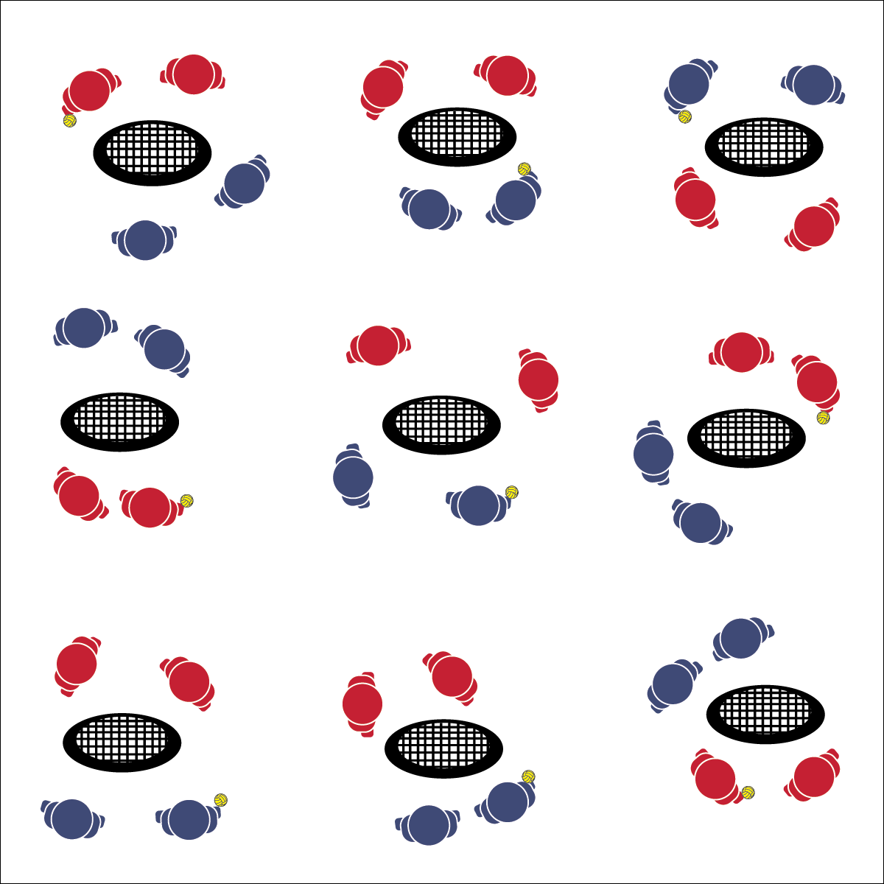

**Activity Procedures:**

1. Today’s activity is a cooperative game called Rally Time.
2. The object of the activity is to build a rally with consecutive Roundnet passes and spikes.
3. Begin each rally with a tossed serve to a member of the opposite team. Teams have a maximum of 3 hits (2 passes and 1 spike) to send the ball down to the net for a change of possession.
4. Each change of possession scores a rally point. Score 10 consecutive possession changes to achieve JV status. Score 20 to achieve Varsity status.
5. Hold the ball and be ready to listen when you hear the stop signal.

**Grade Level Progression:**

**L1:** Participate cooperatively and demonstrate skill elements related to passing and spiking.

**L2:** Analyze personal and group performance, discuss opportunities for improvement, and then execute a plan for purposeful skill refinement.

**Equipment:**

* 1 Spikeball® net or hoop and 1 ball per group of 4 students
* Use hoops and foam balls if you do not have enough Spikeball® sets for your entire class.

**Set-Up:**

1. Scatter nets/hoops in the activity area, allowing space for vigorous activity.
2. Place 1 Spikeball® at each net.
3. Pair students and send 2 pairs (4 players) to each net.

* **Skill:** I will demonstrate a variety of Roundnet skills required for maintaining a rally.
* **Cognitive:** I will discuss the movement concepts and principles related to Roundnet performance.
* **Fitness:** I will remain focused and actively engaged in practice tasks.
* **Personal & Social Responsibility:** I will work cooperatively to maintain an extended rally.

**RALLY TIME**

* Focus on Form
* Controlled Passes
* Set to the Net
* Spike to be Nice

**RALLY TIME**



* Increase the size of the target area (net) or remove the net altogether.
* Allow the ball to bounce in between passes and spikes.



Accuracy, Control, Cooperation, Rally, Respect, Teamwork



* **Standard 1 [H1.L1-2]** Demonstrates competency and/or refines activity-specific movement skills in two or more lifetime activities (outdoor pursuits, individual-performance activities, aquatics, net/wall games, or target games) (L1); Refines activity-specific movement skills in one or more lifetime activities (outdoor pursuits, individual-performance activities, aquatics, net/wall games, or target games) (L2).
* **Standard 2 [H2.L1-2]** Uses movement concepts and principles (e.g., force, motion, rotation) to analyze and improve performance of self and/or others in a selected skill (L1); Describes the speed/accuracy trade-off in throwing and striking skills (L2).
* **Standard 4 [H2.L1-2]** Exhibits proper etiquette, respect for others, and teamwork while engaging in physical activity and/or social dance (L1); Examines moral and ethical conduct in specific competitive situations (e.g., intentional fouls, performance-enhancing substances, gambling, current events in sport) (L2).



* **DOK 1:** What are the movement concepts related to Roundnet participation?
* **DOK 2:** How do those concepts affect the performance of specific skills or tactical plays?
* **DOK 2:** How can you apply what you’ve learned to develop your Roundnet skills? (Teachers: include specific skills when you ask this question. E.g., “How can you apply what you’ve learned to develop your spiking skills?”



**Help students process content:** It’s critical to provide students opportunities for discussing and processing the essential components of Roundnet play. Utilize the movement concept resources in this OPEN module and take time for in-depth discussion, both within small groups and as a class.

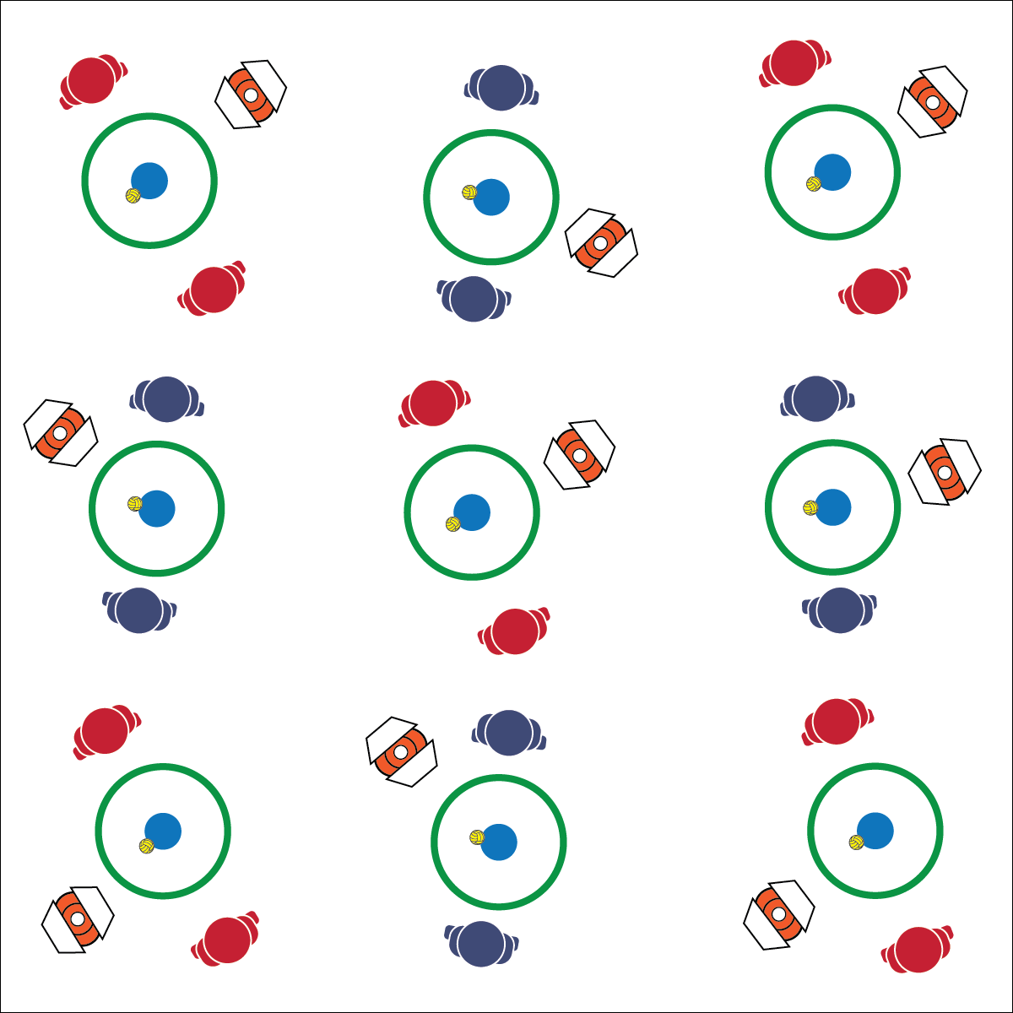

**Activity Procedures:**

1. We’re going to blend Roundnet skill practice with a Tabata fitness routine. Our Tabata intervals will run with 20 seconds of activity followed by 10 seconds of rest. We’ll complete a series of 4-minute mini workouts using our Roundnet Tabata Cards.
2. When the music starts, begin with task 1 on the card. When the music stops, stop, rest, and prepare for task 2. This pattern will continue until we’ve completed all of the tasks on the card.

**Grade Level Progression:**

**L1:** Complete the activity with a focus on form and safety.

**L2:** Create personal Roundnet Tabata cards with a focus on skill refinement and progress toward personal fitness goals.

* **Skill:** I will demonstrate a variety of fitness and Roundnet skills during Tabata routines.
* **Cognitive:** I will discuss the possibilities for organizing Roundnet opportunities in my community.
* **Fitness:** I will demonstrate safe participation in fitness and Roundnet practice tasks.
* **Personal & Social Responsibility:** I will work with a partner or group to plan a community Roundnet event.

**ROUNDNET TABATA**

* Music is On—Get Active
* Music is Off—Rest and Get Ready

**Equipment:**

* 1 Spikeball® (or foam ball) per pair of students
* 1 Spikeball® net or hoop per pair
* 1 Task Tent and large cone per group of 2–6 students
* 1 Roundnet Tabata Card per group

**Set-Up:**

1. Scatter nets/hoops, cones, Task Tents, and Roundnet Tabata cards in the activity area with enough space for groups to move freely.
2. Create groups of 2–6 students, each group at a cone with 1 Spikeball® or foam ball for each pair of students.

**ROUNDNET TABATA**



**Help students elaborate on content:** With any class discussion, providing a safe space and time for students to discuss content in depth is important to their ability to apply what they learn in a variety of settings. It can be difficult to allow discussions to spill into planed activity time. However, if the discussion is focused and rich with learning, it’s important to validate student ideas and encourage their enthusiasm for the content you’ve been teaching.



* **Standard 1 [H1.L1-2]** Demonstrates competency and/or refines activity-specific movement skills in two or more lifetime activities (outdoor pursuits, individual-performance activities, aquatics, net/wall games, or target games) (L1); Refines activity-specific movement skills in one or more lifetime activities (outdoor pursuits, individual-performance activities, aquatics, net/wall games, or target games) (L2).
* **Standard 2 [H2.L1-2]** Uses movement concepts and principles (e.g., force, motion, rotation) to analyze and improve performance of self and/or others in a selected skill (L1); Describes the speed/accuracy trade-off in throwing and striking skills (L2).
* **Standard 3 [H4.L1]** Evaluates—according to their benefits, social support network and participation requirements—activities that can be pursued in the local environment (L1).
* **Standard 4 [H5.L1]** Applies best practices for participating safely in physical activity, exercise, and dance (e.g., injury prevention, proper alignment, hydration, use of equipment, implementation of rules, sun protection) (L1).



Community Recreation, Health-Related Fitness, Organize, Skill-Related Fitness, Tabata Interval Training



* Create skill and fitness challenges that match student ability and comfort levels.



* **DOK 1:** What would you include on a list about planning a weekend Roundnet tournament or event?
* **DOK 2:** What do you know about places in the community where you could hold a Roundnet event?
* **DOK 3:** How would you adapt the Roundnet activities you’ve learned in class so that new players in the community who have various skill levels could play?

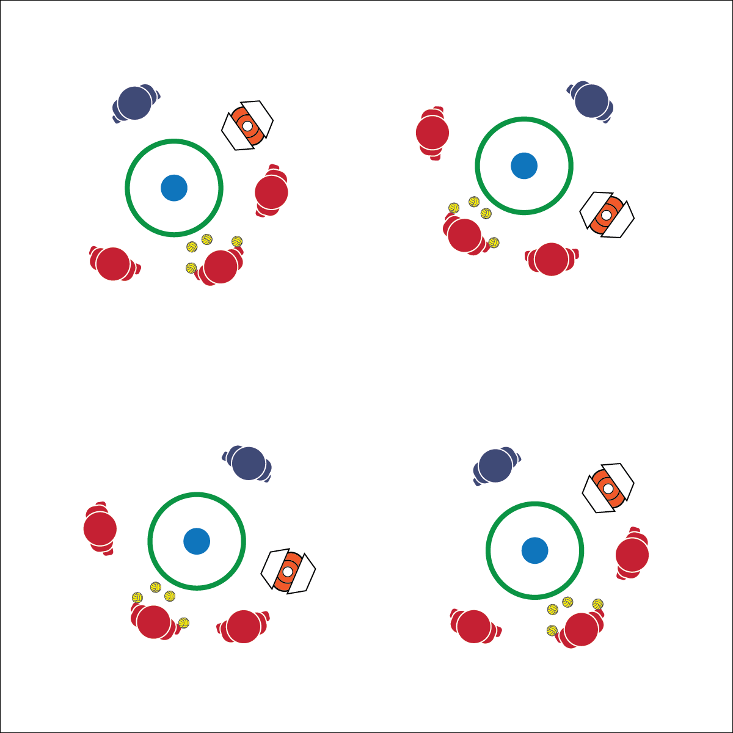

* **Skill:** I will demonstrate the variety of Roundnet skills required to complete each Toss Drill.
* **Cognitive:** I will discuss the movement concepts and principles related to my Toss Drill performance.
* **Fitness:** I will remain focused and actively engaged in practice tasks.
* **Personal & Social Responsibility:** I will work cooperatively in order to help my teammates practice Roundnet skills and strategy.

**Activity Procedures:**

1. It’s time to work on strategic spikes by doing toss drills. Designate 1 player to practice spikes, 1 to act as the tosser, and the other 2 to retrieve spiked balls.
2. On the start signal, begin with Clock Drop (task 1 on the instruction card). The spiker will stand next to the hoop, and the tosser will stand 5 feet from the opposite side of the hoop with a handful of Spikeballs®. The other players will space themselves opposite the spiker.
3. On the start signal, the tosser will toss a set over the hoop. The spiker will practice hitting drop shots in all directions. After a series of 10–15 hits, rotate positions so that all players get a turn. Repeat Clock Drops through 2 complete rotations, and then move on to Scramble (task 2 on the instruction card).
4. The set-up for Scramble is the same as Clock Drop. However, now the spiker will be hitting for power. The tosser will rotate around the hoop, forcing the spiker to adjust her/his position. Players retrieving spiked balls will work to prevent spikes from interrupting the play of other groups.

**Grade Level Progression:**

**L1:** After each rotation through a drill, discuss areas of weakness and how to adjust practice to help improve performance.

**L2:** Identify and discuss the states of motor learning with group members with a focus on moving to the next stage.

**TOSS DRILLS**

* Demonstrate Control
* Focus on Form
* Toss for Success

**Equipment:**

* 3–6 Spikeballs® (or foam balls) per group of 4 students
* 1 Spikeball® net or hoop per group
* 1 Task Tent and large cone per group
* 1 Toss Drills Instruction Card per group

**Set-Up:**

1. Scatter nets/hoops, cones, Task Tents, and Toss Drill Cards in the activity area with enough space for groups to move freely.
2. Create groups of 4 students, each group at a cone with 3–6 Spikeballs® or foam balls.

**TOSS DRILLS**



* **Standard 1 [H1.L1-2]** Demonstrates competency and/or refines activity-specific movement skills in two or more lifetime activities (outdoor pursuits, individual-performance activities, aquatics, net/wall games, or target games) (L1); Refines activity-specific movement skills in one or more lifetime activities (outdoor pursuits, individual-performance activities, aquatics, net/wall games, or target games) (L2).
* **Standard 2 [H2.L1-2]** Uses movement concepts and principles (e.g., force, motion, rotation) to analyze and improve performance of self and/or others in a selected skill (L1); Describes the speed/accuracy trade-off in throwing and striking skills (L2).
* **Standard 2 [H3.L1-2]** Creates a practice plan to improve performance for a self-selected skill (L1); Identifies the stages of learning a motor skill (L2).



* Increase the size of the target area (net) or remove the net altogether.
* Ensure the tosser has the skills to make accurate tosses. Use an adult if necessary.
* Use balloons.



Drill, Cooperation, Effort, Force, Lifetime Activity, Movement Concepts Stages of Motor Learning, Set, Strategy



* **DOK 1:** List the Roundnet skills you’ve learned that you were able to use in today’s Toss Drills.
* **DOK 2:** What did you notice about your performance when you were hitting a drop shot compared to when you were hitting for power?
* **DOK 3:** Which movement concepts did you demonstrate during each drill? Provide examples to support your answer.



**Help students practice skills, strategies, and processes:** Activity drills are an essential part of skill development in physical education. Toss drills provide an opportunity for this type of skill development while also allowing students to practice the cooperative and personal responsibility needed for this type of learning.



* Controlled Passes
* Set to the Net

**Equipment:**

* 1 Spikeball® (or foam ball) per pair of students
* 1 Spikeball® net or hoop per pair

**Set-Up:**

1. Scatter nets/hoops in the activity area with enough space for groups to move freely.
2. Pair students, each pair at a net/hoop with a Spikeball® or foam ball.

* **Skill:** I will demonstrate the Roundnet skills and strategies required to play Pepper.
* **Cognitive:** I will discuss the movement concepts and principles related to my Pepper performance.
* **Fitness:** I will remain actively engaged in practice tasks.
* **Personal & Social Responsibility:** I will demonstrate respect for my classmates by using positive and encouraging language during challenging tasks.

**PEPPER**

**Activity Procedures:**

1. It’s time to practice our first-touch defense with a game of Pepper. The object is for you and your partner to keep your Pepper rally going as long as possible using a series of 3 hits (pass, set, spike).
2. Player 1 will serve the ball to player 2. Player 2 will defend the serve with a good pass back to player 1. Player 1 will then set the ball back to player 2, who will spike the ball onto the net.
3. Player 1 will then defend the spike with a good pass back to player 2. Player 2 will set the ball back to player 1, who will spike the ball onto the net.
4. Keep this alternating pattern going as long as you can. When a dead ball occurs, restart with a fresh serve.

**Grade Level Progression:**

**L1:** Demonstrate all Roundnet-specific skills required for successful Pepper rallies.

**L2:** Discuss movement concepts and principles in relation to the speed/accuracy trade-off in spiking.

**PEPPER**



* Increase the size of the target area (net) or remove the net altogether.
* Allow the ball to bounce in between passes/spikes.



Accuracy, Competency, Etiquette, Refine, Speed, Teamwork



* **Standard 1 [H1.L1-2]** Demonstrates competency and/or refines activity-specific movement skills in two or more lifetime activities (outdoor pursuits, individual-performance activities, aquatics, net/wall games, or target games) (L1); Refines activity-specific movement skills in one or more lifetime activities (outdoor pursuits, individual-performance activities, aquatics, net/wall games, or target games) (L2).
* **Standard 2 [H2.L1-2]** Uses movement concepts and principles (e.g., force, motion, rotation) to analyze and improve performance of self and/or others in a selected skill (L1); Describes the speed/accuracy trade-off in throwing and striking skills (L2).
* **Standard 4 [H2.L1-2]** Exhibits proper etiquette, respect for others, and teamwork while engaging in physical activity and/or social dance (L1); Examines moral and ethical conduct in specific competitive situations (e.g., intentional fouls, performance-enhancing substances, gambling, current events in sport) (L2).



* **DOK 1:** What would you include on a list about the relationships involved within the game of Roundnet?
* **DOK 2:** How does the relationship between the ball’s trajectory off the net and your positioning affect your performance?
* **DOK 3:** What facts can you select to support the existence of the relationships included on your previous list? Elaborate on why you chose those facts.



**Review content:** Success in Pepper requires the combination of all basic passing and spiking skills. As students perform with partners, find individual and group moments in which you can stop play, discuss ways students can improve, and then help them apply what has been discussed in their performance.



**Activity Procedures:**

1. Let’s play some 1v1. The rules are the same as classic Roundnet with 2 modifications.
2. First, players can self-pass the ball before spiking. Each player gets up to 3 hits per possession (2 self-passes and a spike). Second, the court is split into 2 sides, and you can only hit the ball toward your opponent’s side.
3. Games will run for 3 minutes (or any time limit), and then we’ll rotate to a new opponent. Begin on the start signal and keep your own score.

**Grade Level Progression:**

**L1:** Identify and demonstrate proper etiquette for competitive Roundnet play.

**L2:** Self-identify a preferred challenge level and choose opponents based on that preference.

* **Skill:** I will demonstrate the Roundnet skills and strategies required to play 1v1.
* **Cognitive:** I will identify and then demonstrate proper etiquette for competitive Roundnet play.
* **Fitness:** I will remain actively engaged in order to increase my heart rate.
* **Personal & Social Responsibility:** I will choose an appropriate level of challenge in order to experience both success and improvement.

**1 V 1**

* Self-Set and then Spike
* Be Ready to Move in Athletic Stance

**Equipment:**

* 1 Spikeball® (or foam ball) per pair of students
* 1 Spikeball® net or hoop per pair
* Roundnet Etiquette Discussion Card

**Set-Up:**

1. Scatter nets/hoops in the activity area with enough space for groups to move freely.
2. Pair students, each pair at a net/hoop with a Spikeball® or foam ball.

**1 V 1**



* Increase the size of the target area (net) or remove the net altogether.
* Increase the number of allowed self-passes.
* Allow the ball to bounce in between passes/spikes.



Challenge, Etiquette, Movement Concepts, Safety, Success



* **Standard 4 [H2.L1-2]** Exhibits proper etiquette, respect for others, and teamwork while engaging in physical activity and/or social dance (L1); Examines moral and ethical conduct in specific competitive situations (e.g., intentional fouls, performance-enhancing substances, gambling, current events in sport) (L2).
* **Standard 4 [H5.L1]** Applies best practices for participating safely in physical activity, exercise, and dance (e.g., injury prevention, proper alignment, hydration, use of equipment, implementation of rules, sun protection) (L1).
* **Standard 5 [H2.L2]** Chooses an appropriate level of challenge to experience success and desire to participate in a self-selected physical activity (L2).



* **DOK 1:** How would you describe the different elements of Roundnet etiquette?
* **DOK 2:** How does following etiquette affect the experience of Roundnet participants?
* **DOK 3:** What facts would you select to support the importance of respecting Roundnet etiquette? Elaborate on why you chose those facts.



**Help students examine their reasoning:** Due to past competitive experiences (as either a participant or a spectator), it may be easier for students to discuss proper etiquette than to actually demonstrate it. When etiquette missteps occur, it is a teachable moment for individuals and the class. Work to demonstrate patience and understanding in these situations in order to encourage the development of attitudes and values that will eventually promote and defend proper etiquette.

## 

* Player that Spikes Now Plays Defense
* Set to the Net
* **Skill:** I will demonstrate the Roundnet skills and strategies required to play 1 on 1 on 1.
* **Cognitive:** I will discuss best practices for safe Roundnet participation.
* **Fitness:** I will remain actively engaged in order to increase my heart rate.
* **Personal & Social Responsibility:** I will value and demonstrate safe behaviors.

**1 ON 1 ON 1**

**Equipment:**

* 1 Spikeball® (or foam ball) per group of 3 students
* 1 Spikeball® net or hoop per group

**Set-Up:**

1. Scatter nets/hoops in the activity area with enough space for groups to move freely.
2. Create groups of 3 students, each group at a net/hoop with a Spikeball® or foam ball.

**Activity Procedures:**

1. Let’s keep working on our passing and striking skills with a game of 1 on 1 on 1. The rules are the same as classic Roundnet, but with 3 players.
2. Play starts with player 1 serving to player 2. Player 2 and player 3 are now on a team and have 3 touches to hit the ball off the net. If player 3 hits the ball off the net, players 1 and 2 are on a team and have 3 hits to make a Spike.
3. Play continues in this way, with the player who makes the spike then working to defend against the hits of the other two players.
4. No score is kept during 1 on 1 on 1. Each rally is a mini-game of its own.

**Grade Level Progression:**

**L1:** Identify and demonstrate best practices for safe Roundnet participation.

**L2:** Self-identify a preferred challenge level and choose opponents based on that preference.

**1 ON 1 ON 1**



* Increase the size of the target area (net) or remove the net altogether.
* Allow the ball to bounce in between passes/spikes.



Ethical, Respect, Safety, Strategy, Value



* **Standard 4 [H2.L1-2]** Exhibits proper etiquette, respect for others, and teamwork while engaging in physical activity and/or social dance (L1); Examines moral and ethical conduct in specific competitive situations (e.g., intentional fouls, performance-enhancing substances, gambling, current events in sport) (L2).
* **Standard 4 [H5.L1]** Applies best practices for participating safely in physical activity, exercise, and dance (e.g., injury prevention, proper alignment, hydration, use of equipment, implementation of rules, sun protection) (L1).
* **Standard 5 [H2.L2]** Chooses an appropriate level of challenge to experience success and desire to participate in a self-selected physical activity (L2).



* **DOK 1:** How can you recognize safe participation? How can you recognize unsafe participation?
* **DOK 2:** How is hydration related to safe participation? How is the use of equipment related to safe participation?
* **DOK 3:** Can you predict participants’ level of enjoyment if all players practice safe behaviors?



**Manage response rates with tiered questioning techniques:** Safety is the most important aspect of physical activity participation, and because of this, physical educators often remain direct when it comes to safety instruction. While it is important for safety rules to be clearly and directly established, it’s also important to help students discuss and process the reasons why safety is paramount. The use of tiered question sets like the one above can help students explore multiple aspects of safe participation while allowing them to express their ideas and concerns.

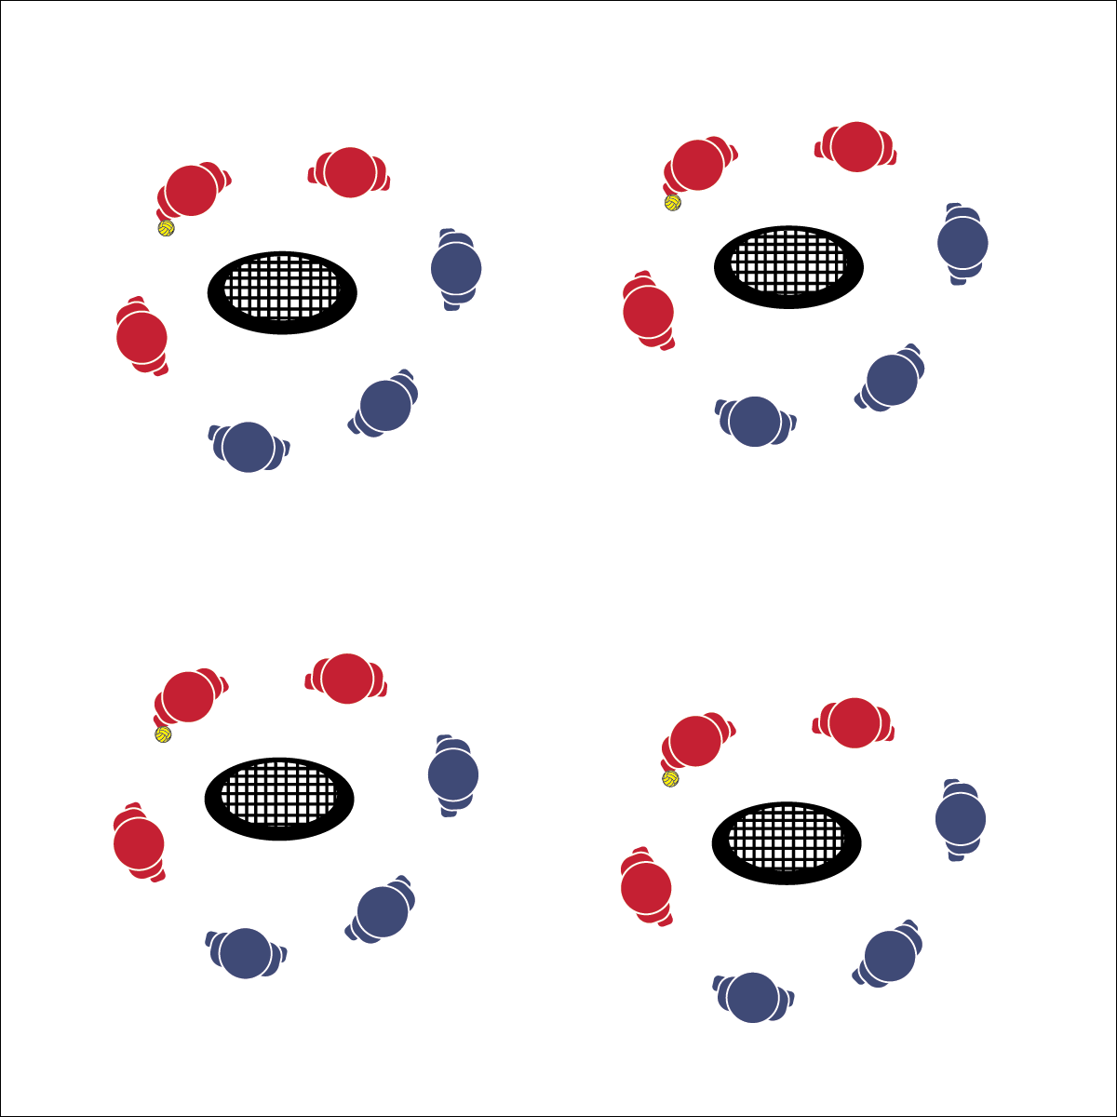

* Safe Play
* Fair Play
* Honor the Game
* **Skill:** I will demonstrate the Roundnet skills and strategies required to play 3v3.
* **Cognitive:** I will discuss the importance of teamwork with respect to Roundnet performance.
* **Fitness:** I will remain actively engaged in order to increase my heart rate.
* **Personal & Social Responsibility:** I will demonstrate teamwork and cooperative behaviors.

**3 V 3**

**Equipment:**

* 1 Spikeball® (or foam ball) per group of 6 students
* 1 Spikeball® net or hoop per group

**Set-Up:**

1. Scatter nets/hoops in the activity area with enough space for groups to move freely.
2. Create teams of 3 students, with 2 teams at a net/hoop with a Spikeball® or foam ball.

**Activity Procedures:**

1. We’re going to work on our game play with teams of 3 playing classic Roundnet rules. (Adding the 3rd player makes it a little easier for teams to return serves and extend rallies.)
2. Each team still gets only 3 hits (pass, set, spike) per possession. Any time there is player interference because the play area is crowded, simply redo the point.
3. Games will run for 3 minutes (or any time limit), and then we’ll rotate to a new opponent. Begin on the start signal and keep your own score.

**Grade Level Progression:**

**L1:** Identify and demonstrate proper etiquette for competitive Roundnet play.

**L2:** Self-identify a preferred challenge level and choose opponents based on that preference.

**3 V 3**



* Increase the size of the target area (net) or remove the net altogether.
* Allow the ball to bounce in between passes/spikes.



Challenge, Competition, Etiquette, Movement Concepts, Safety



* **Standard 4 [H2.L1-2]** Exhibits proper etiquette, respect for others, and teamwork while engaging in physical activity and/or social dance (L1); Examines moral and ethical conduct in specific competitive situations (e.g., intentional fouls, performance-enhancing substances, gambling, current events in sport) (L2).
* **Standard 4 [H5.L1]** Applies best practices for participating safely in physical activity, exercise, and dance (e.g., injury prevention, proper alignment, hydration, use of equipment, implementation of rules, sun protection) (L1).
* **Standard 5 [H2.L2]** Chooses an appropriate level of challenge to experience success and desire to participate in a self-selected physical activity (L2).



* **DOK 1:** What is teamwork?
* **DOK 2:** How would you compare and/or contrast a team’s Roundnet performance that demonstrates teamwork with a performance that doesn’t?
* **DOK 3:** What facts would you select to support the importance of teamwork to Roundness success? Can you elaborate on why you chose those facts?



**Help students practice skills:** Organizing students to play 3v3 Roundnet aligns with the importance of modifying games and activities to encourage participation. Using experiences this this, older students can often create additional modifications that meet their needs and activity preferences.



* Safe Play
* Fair Play
* Honor the Game

**Activity Procedures:**

1. Now we’re ready for classic Roundnet play.
2. This is a 2v2 game with a maximum of 3 touches per possession (pass, set, spike).
3. Rally scoring is in effect (a team is awarded a point after each possession). Teams winning the point also win the right to make the next serve.
4. Games will run for 3 minutes (or any time limit), and then we’ll rotate to a new opponent. Begin on the start signal and keep your own score.

**Grade Level Progression:**

**L1:** Define and govern play with the Spirit of the Game.

**L2:** Self-identify a preferred challenge level and choose opponents based on that preference.

* **Skill:** I will demonstrate the skills and strategies required to play a full game of Roundnet.
* **Cognitive:** I will discuss space as a movement concept related to Roundnet performance.
* **Fitness:** I will remain actively engaged in order to increase my heart rate.
* **Personal & Social Responsibility:** I will demonstrate behaviors appropriate for competitive environments.

**ROUNDNET**

**Equipment:**

* 1 Spikeball® (or foam ball) per group of 4
* 1 Spikeball® net or hoop per group

**Set-Up:**

1. Scatter nets/hoops in the activity area with enough space for groups to move freely.
2. Create teams of 2 students, with 2 teams at a net/hoop with a Spikeball® or foam ball.

**ROUNDNET**



* **Standard 1 [H1.L1-2]** Demonstrates competency and/or refines activity-specific movement skills in two or more lifetime activities (outdoor pursuits, individual-performance activities, aquatics, net/wall games, or target games) (L1); Refines activity-specific movement skills in one or more lifetime activities (outdoor pursuits, individual-performance activities, aquatics, net/wall games, or target games) (L2).
* **Standard 2 [H1.L1-2]** Applies the terminology associated with exercise and participation in selected individual-performance activities, dance, net/wall games, target games, aquatics, and/or outdoor pursuits appropriately (L1); Identifies and discusses the historical and cultural roles of games, sports, and dance in a society (L2).
* **Standard 4 [H2.L1-2]** Exhibits proper etiquette, respect for others, and teamwork while engaging in physical activity and/or social dance (L1); Examines moral and ethical conduct in specific competitive situations (e.g., intentional fouls, performance-enhancing substances, gambling, current events in sport) (L2).
* **Standard 5 [H2.L2]** Chooses an appropriate level of challenge to experience success and desire to participate in a self-selected physical activity (L2).



* **DOK 1:** How would you describe the importance of space as a movement concept related to Roundnet performance?
* **DOK 2:** How does spacing affect performance on offense? Defense?
* **DOK 3:** What facts or examples from today’s game play would you select to support the importance of space for Roundnet performance? Elaborate on why you chose those facts/examples.



Appropriate, Competition, Ethical, Movement Concepts, Respect, Spirit of the Game, Teamwork



* Increase the size of the target area (net) or remove the net altogether.
* Allow the ball to bounce in between passes/spikes.



**Help students elaborate on content:** At this point in a module, students are combining multiple skills with essential strategies and concepts, often without recognizing the complex nature of their performance. Use group discussion opportunities to challenge students cognitively and to encourage deeper thinking through elaboration on facts, examples, and personal experiences.

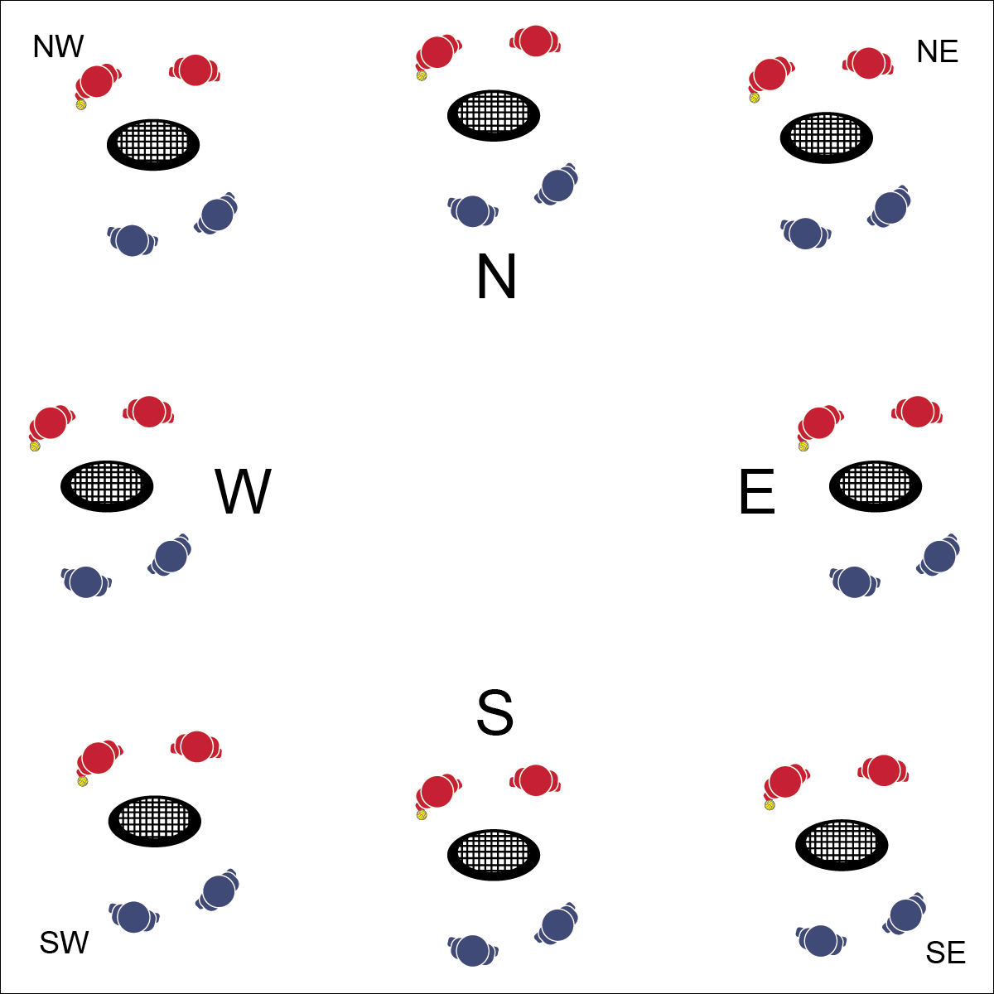

* **Skill:** I will demonstrate the skills and strategies required play Roundnet.
* **Cognitive:** I will discuss the meaning of completion, including some of the benefits it can have on skill development.
* **Fitness:** I will remain actively engaged.
* **Personal & Social Responsibility:** I will exhibit proper etiquette and respect for my teammate and opponents.
* Safe Play
* Fair Play
* Honor the Game

**Equipment:**

* 1 Spikeball® (or foam ball) per group of 4
* 1 Spikeball® net or hoop per group
* 1 Task Tent, Compass Card, and large cone per compass point (see set-up)

**Set-Up:**

1. Set nets/hoops in a compass formation (N,S,E,W) with enough space for groups to move freely. Use NW, NE, SW, SE if necessary.
2. Use Task Tents, Compass Cards, and cones to identify compass points.
3. Create teams of 2 students, with 2 teams at a net/hoop with a Spikeball® or foam ball.

**COMPASS DRAW TOURNAMENT**

**Activity Procedures:**

1. We’re going to participate in a Compass Draw Tournament. Your team’s objective is to make it to the North net.
2. Winning teams rotate clockwise toward the North net. Losing teams rotate counterclockwise. Winners on the North net stay and defend their net. Losing teams at the Northeast net stay and try to win their way to the East net.
3. With large classes, place a champion net and a challenger net at each compass point. Teams must work their way to the champion net and win there before advancing to the next compass point. Likewise, teams losing at the champion net move to the challenger net.

**Grade Level Progression:**

**L1:** Define and govern play with the Spirit of the Game.

**L2:** Create a pro-circuit tournament and a recreation league tournament. Allow students to self-identify a preferred challenge level and choose a tournament based on that preference.

**TOURNAMENT PLAY**



* **Standard 1 [H1.L1-2]** Demonstrates competency and/or refines activity-specific movement skills in two or more lifetime activities (outdoor pursuits, individual-performance activities, aquatics, net/wall games, or target games) (L1); Refines activity-specific movement skills in one or more lifetime activities (outdoor pursuits, individual-performance activities, aquatics, net/wall games, or target games) (L2).
* **Standard 2 [H1.L1-2]** Applies the terminology associated with exercise and participation in selected individual-performance activities, dance, net/wall games, target games, aquatics, and/or outdoor pursuits appropriately (L1); Identifies and discusses the historical and cultural roles of games, sports, and dance in a society (L2).
* **Standard 4 [H2.L1-2]** Exhibits proper etiquette, respect for others, and teamwork while engaging in physical activity and/or social dance (L1); Examines moral and ethical conduct in specific competitive situations (e.g., intentional fouls, performance-enhancing substances, gambling, current events in sport) (L2).
* **Standard 5 [H2.L2]** Chooses an appropriate level of challenge to experience success and desire to participate in a self-selected physical activity (L2).



Appropriate, Competition, Ethical, Movement Concepts, Respect, Teamwork



* Increase the size of the target area (net) or remove the net altogether.
* Allow the ball to bounce in between passes/spikes.



* **DOK 1:** What is competition?
* **DOK 2:** How does competition affect your effort during game play?
* **DOK 3:** How is competition related to skill development in Roundnet and other sport activities?



**Organize students to interact with content:** The use of the Compass Draw Tournament format provides a competitive structure that typically results in teams pairing with teams at a similar skill level. There is an element of competitive progression without an over-emphasis on crowning a tournament champion. Experiment with this format and modify it to meet the needs of your classes.