­­

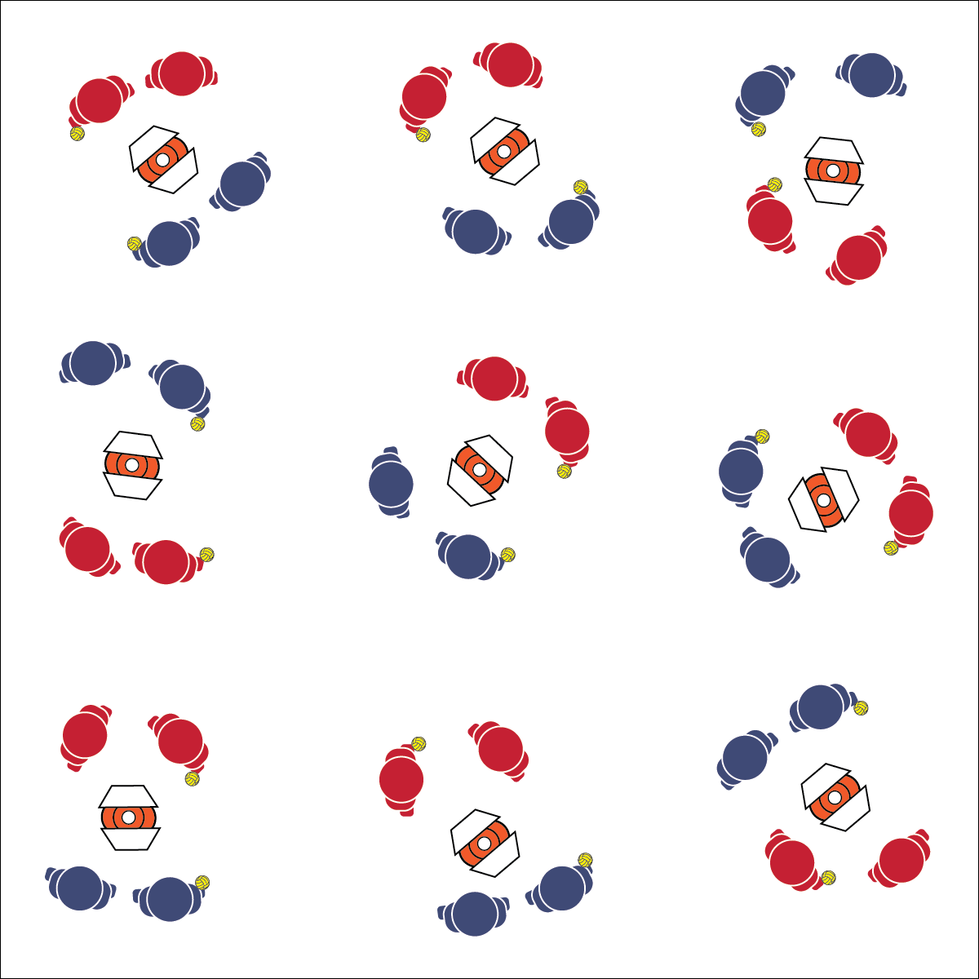

* **Skill:** I will demonstrate skill cues for under- and above-chest passing.
* **Cognitive:** I will define and use a minimum of 4 Roundnet academic language words in proper context.
* **Fitness:** I will remain focused and actively engaged in practice tasks.
* **Personal & Social Responsibility:** I will demonstrate safe behaviors during all practice tasks.

**SELF-PASSING CHALLENGES**

* Athletic Stance (Feet, Knees, Hands, Eyes Ready)
* Hand Placement (Below-Chest: Palms Up, Fingers Away; Above-Chest: Palms Out, Fingers Toward Head)
* Palm Strike (Palm Flat, Strike Between Heel and Fingers)

**Equipment:**

* 1 Spikeball® (or foam ball) per group of 2–4 students
* 1 Task Tent and 1 large cone per group
* 1 Self-Passing Challenge Card per group
* 1 Passing Cue Chart per group

**Set-Up:**

1. Scatter cones, Task Tents, and Roundnet cards in the activity area with enough space for groups to move freely.
2. Create groups of 2–4 students, each group at a cone with a Spikeball®.

**Activity Procedures:**

1. Today we’re going to start our Roundnet training by completing a series of self-passing challenges. There are two types of passes used in Roundnet: 1) below-chest and 2) above-chest.
2. Both passes require you to be ready in an athletic stance, use proper hand placement, and use a palm strike to hit the ball (demonstrate and practice critical elements).
3. Below-chest passing requires hand placement at waist level, palms out, and fingers away from the body. above-chest passing requires hand placement at shoulder level, palms out, and fingers pointing up toward the head.
4. On the start signal, work to complete the self-passing challenges found on the challenge card. Reach JV level with 10 successful self-passes. Reach Varsity level with 20 successful self-passes. Take turns with group members after you’ve attempted to complete a challenge level 3 times.
5. Freeze and be ready to listen when you hear the stop signal.

**Grade Level Progression:**

**L1:** Complete each skill challenge with a focus on reciting skill cues and using correct academic language.

**L2:** Discuss and utilize the Stages of Motor Learning Worksheet.

**SELF-PASSING CHALLENGES**



* **Standard 1 [H1.L1-2]** Demonstrates competency and/or refines activity-specific movement skills in two or more lifetime activities (outdoor pursuits, individual-performance activities, aquatics, net/wall games, or target games) (L1); Refines activity-specific movement skills in one or more lifetime activities (outdoor pursuits, individual-performance activities, aquatics, net/wall games, or target games) (L2).
* **Standard 2 [H1.L1]** Applies the terminology associated with exercise and participation in selected individual-performance activities, dance, net/wall games, target games, aquatics, and/or outdoor pursuits appropriately (L1).
* **Standard 2 [H3.L1-2]** Creates a practice plan to improve performance for a self-selected skill (L1); Identifies the stages of learning a motor skill (L2).
* **Standard 4 [H5.L1]** Applies best practices for participating safely in physical activity, exercise, and dance (e.g., injury prevention, proper alignment, hydration, use of equipment, implementation of rules, sun protection) (L1).



Above-Chest Pass, Accuracy, Below-Chest Pass, Control, Purposeful Practice, Safety, Stages of Motor Learning



* Provide a variety of balls or balloons and allow students to choose their challenge preference.



* **DOK 1:** How can you recognize a below-chest and above-chest pass?
* **DOK 2:** How does the position/placement of a pass, spike, or serve affect the pass you would give?
* **DOK 3:** How is the pass related to Spikeball® game play?

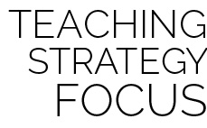

**Help students practice skills:** Self-passing challenges are basic drills that provide students opportunities to refine and become competent in Roundnet’s most essential skills. Discuss and encourage students to find opportunities to practice these challenges outside of class using foam or inflatable balls they may have at home.