­­



**PARTNER PASSING**

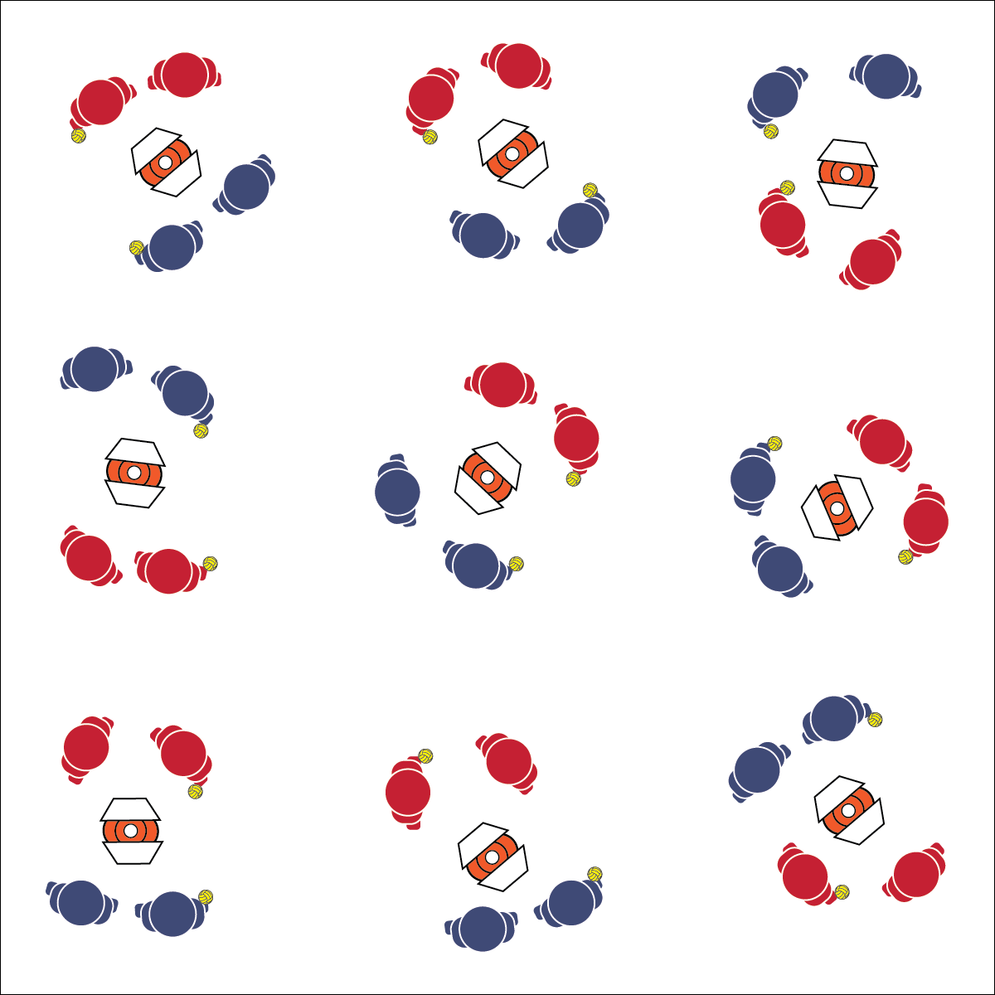

* **Skill:** I will demonstrate skill cues for under- and above-chest passing.
* **Cognitive:** I will create a practice plan for improving my Roundnet passing skills.
* **Fitness:** I will remain focused and actively engaged in practice tasks.
* **Personal & Social Responsibility:** I will demonstrate safe and cooperative behaviors during all practice tasks.
* Hand Placement (Below-Chest: Palms Up, Fingers Away; Above-Chest: Palms Out, Fingers Toward Head)
* Palm Strike (Palm Flat, Strike Between Heel and Fingers)

**Equipment:**

* 1 Spikeball® (or foam ball) per pair
* 1 Task Tent and large cone per 2 pairs
* 1 Partner Passing Challenge Card per pair
* 1 Passing Cue Chart per pair

**Set-Up:**

1. Scatter cones, Task Tents, and Roundnet cards in the activity area with enough space for groups to move freely.
2. Create pairs or 2 students. Send 2 pairs to a cone, each pair with a Spikeball®.

**Activity Procedures:**

1. It’s time to practice Roundnet passing with a partner. Be sure to use the cues for accurate passing. Focus on body and ball control.
2. On the start signal, work to complete the partner passing challenges found on the challenge card. Reach JV level with 10 successful self-passes. Reach Varsity level with 20 successful self-passes. Take turns with other pairs in your group after you’ve attempted to complete a challenge level 3 times.
3. Freeze and be ready to listen when you hear the stop signal.

**Grade Level Progression:**

**L1:** Complete each skill challenge with a focus on reciting skill cues and using correct academic language.

**L2:** Use the Stages of Motor Learning Worksheet to analyze partner’s skill development.

**PARTNER PASSING**



Above-Chest Pass, Accuracy, Below-Chest Pass, Control, Practice Plan, Rally, Safety, Set



* **Standard 1 [H1.L1-2]** Demonstrates competency and/or refines activity-specific movement skills in two or more lifetime activities (outdoor pursuits, individual-performance activities, aquatics, net/wall games, or target games) (L1); Refines activity-specific movement skills in one or more lifetime activities (outdoor pursuits, individual-performance activities, aquatics, net/wall games, or target games) (L2).
* **Standard 2 [H1.L1]** Applies the terminology associated with exercise and participation in selected individual-performance activities, dance, net/wall games, target games, aquatics, and/or outdoor pursuits appropriately (L1).
* **Standard 2 [H3.L1-2]** Creates a practice plan to improve performance for a self-selected skill (L1); Identifies the stages of learning a motor skill (L2).
* **Standard 4 [H5.L1]** Applies best practices for participating safely in physical activity, exercise, and dance (e.g., injury prevention, proper alignment, hydration, use of equipment, implementation of rules, sun protection) (L1).



* **DOK 1:** What is a practice plan?
* **DOK 2:** How can you apply the skills you’ve learned so far and today’s drill in the development of a practice plan?
* **DOK 3:** How is purposeful practice related to skill development?

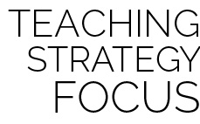

**Organize students to interact with content:** Partner passing challenges and the use of challenge cards allow students to interact with skill-development content with both independence and the freedom to focus on individual skill development. As students choose their partners, help guide their choices with a focus on enjoyment, focus, and cooperation.



* Provide implements for striking (such as a paddle) if students have difficulty striking with their hands.
* Allow 1 student to toss the ball while the other students perform various passes.