­­

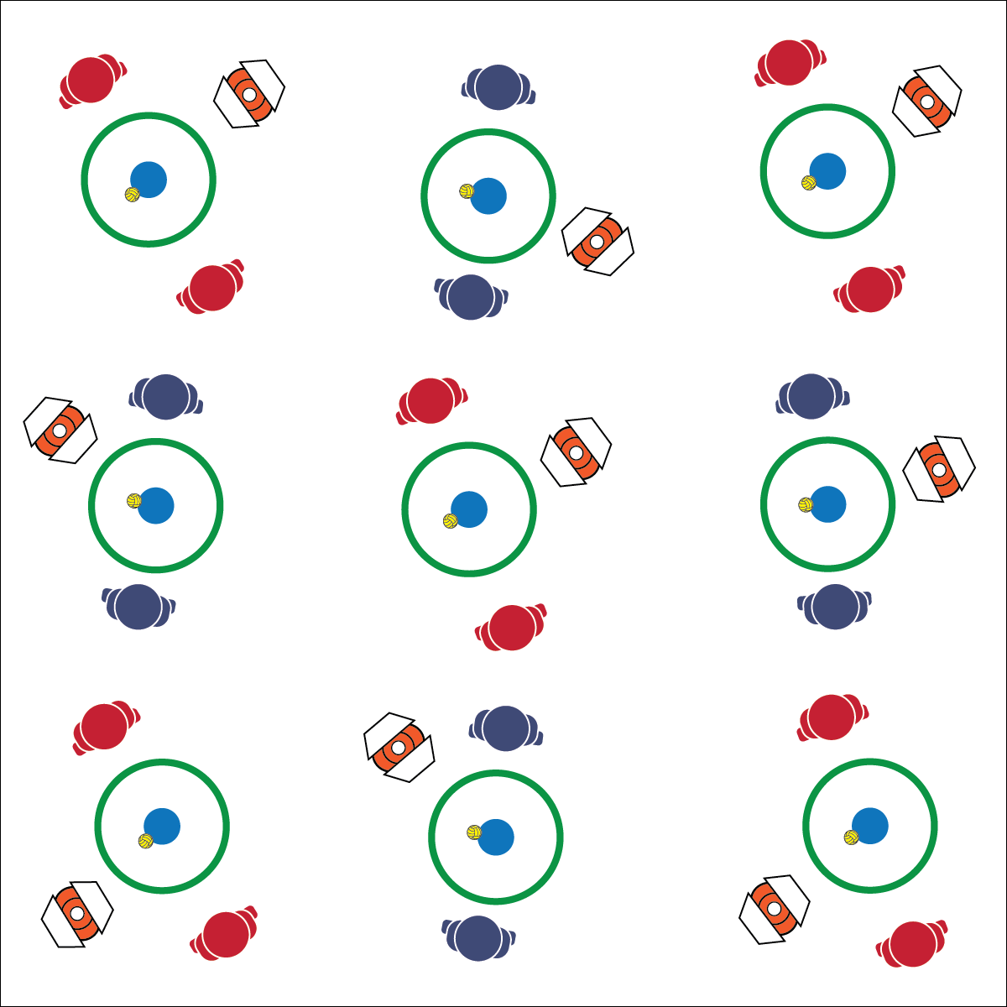

**ROUNDNET TABATA**

* **Skill:** I will demonstrate a variety of fitness and Roundnet skills during Tabata routines.
* **Cognitive:** I will discuss the possibilities for organizing Roundnet opportunities in my community.
* **Fitness:** I will demonstrate safe participation in fitness and Roundnet practice tasks.
* **Personal & Social Responsibility:** I will work with a partner or group to plan a community Roundnet event.
* Music is On—Get Active
* Music is Off—Rest and Get Ready

**Equipment:**

* 1 Spikeball® (or foam ball) per pair of students
* 1 Spikeball® net or hoop per pair
* 1 Task Tent and large cone per group of 2–6 students
* 1 Roundnet Tabata Card per group

**Set-Up:**

1. Scatter nets/hoops, cones, Task Tents, and Roundnet Tabata cards in the activity area with enough space for groups to move freely.
2. Create groups of 2–6 students, each group at a cone with 1 Spikeball® or foam ball for each pair of students.

**Activity Procedures:**

1. We’re going to blend Roundnet skill practice with a Tabata fitness routine. Our Tabata intervals will run with 20 seconds of activity followed by 10 seconds of rest. We’ll complete a series of 4-minute mini workouts using our Roundnet Tabata Cards.
2. When the music starts, begin with task 1 on the card. When the music stops, stop, rest, and prepare for task 2. This pattern will continue until we’ve completed all of the tasks on the card.

**Grade Level Progression:**

**L1:** Complete the activity with a focus on form and safety.

**L2:** Create personal Roundnet Tabata cards with a focus on skill refinement and progress toward personal fitness goals.

**ROUNDNET TABATA**



Community Recreation, Health-Related Fitness, Organize, Skill-Related Fitness, Tabata Interval Training



* **Standard 1 [H1.L1-2]** Demonstrates competency and/or refines activity-specific movement skills in two or more lifetime activities (outdoor pursuits, individual-performance activities, aquatics, net/wall games, or target games) (L1); Refines activity-specific movement skills in one or more lifetime activities (outdoor pursuits, individual-performance activities, aquatics, net/wall games, or target games) (L2).
* **Standard 2 [H2.L1-2]** Uses movement concepts and principles (e.g., force, motion, rotation) to analyze and improve performance of self and/or others in a selected skill (L1); Describes the speed/accuracy trade-off in throwing and striking skills (L2).
* **Standard 3 [H4.L1]** Evaluates—according to their benefits, social support network and participation requirements—activities that can be pursued in the local environment (L1).
* **Standard 4 [H5.L1]** Applies best practices for participating safely in physical activity, exercise, and dance (e.g., injury prevention, proper alignment, hydration, use of equipment, implementation of rules, sun protection) (L1).



* **DOK 1:** What would you include on a list about planning a weekend Roundnet tournament or event?
* **DOK 2:** What do you know about places in the community where you could hold a Roundnet event?
* **DOK 3:** How would you adapt the Roundnet activities you’ve learned in class so that new players in the community who have various skill levels could play?

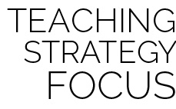

**Help students elaborate on content:** With any class discussion, providing a safe space and time for students to discuss content in depth is important to their ability to apply what they learn in a variety of settings. It can be difficult to allow discussions to spill into planed activity time. However, if the discussion is focused and rich with learning, it’s important to validate student ideas and encourage their enthusiasm for the content you’ve been teaching.



* Create skill and fitness challenges that match student ability and comfort levels.