­­

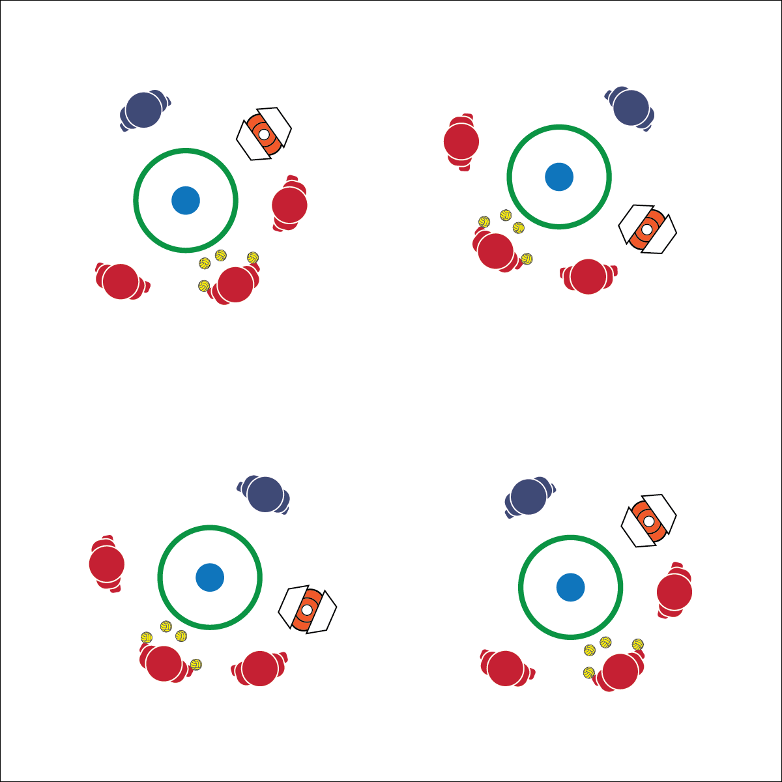

**TOSS DRILLS**

* **Skill:** I will demonstrate the variety of Roundnet skills required to complete each Toss Drill.
* **Cognitive:** I will discuss the movement concepts and principles related to my Toss Drill performance.
* **Fitness:** I will remain focused and actively engaged in practice tasks.
* **Personal & Social Responsibility:** I will work cooperatively in order to help my teammates practice Roundnet skills and strategy.
* Demonstrate Control
* Focus on Form
* Toss for Success

**Equipment:**

* 3–6 Spikeballs® (or foam balls) per group of 4 students
* 1 Spikeball® net or hoop per group
* 1 Task Tent and large cone per group
* 1 Toss Drills Instruction Card per group

**Set-Up:**

1. Scatter nets/hoops, cones, Task Tents, and Toss Drill Cards in the activity area with enough space for groups to move freely.
2. Create groups of 4 students, each group at a cone with 3–6 Spikeballs® or foam balls.

**Activity Procedures:**

1. It’s time to work on strategic spikes by doing toss drills. Designate 1 player to practice spikes, 1 to act as the tosser, and the other 2 to retrieve spiked balls.
2. On the start signal, begin with Clock Drop (task 1 on the instruction card). The spiker will stand next to the hoop, and the tosser will stand 5 feet from the opposite side of the hoop with a handful of Spikeballs®. The other players will space themselves opposite the spiker.
3. On the start signal, the tosser will toss a set over the hoop. The spiker will practice hitting drop shots in all directions. After a series of 10–15 hits, rotate positions so that all players get a turn. Repeat Clock Drops through 2 complete rotations, and then move on to Scramble (task 2 on the instruction card).
4. The set-up for Scramble is the same as Clock Drop. However, now the spiker will be hitting for power. The tosser will rotate around the hoop, forcing the spiker to adjust her/his position. Players retrieving spiked balls will work to prevent spikes from interrupting the play of other groups.

**Grade Level Progression:**

**L1:** After each rotation through a drill, discuss areas of weakness and how to adjust practice to help improve performance.

**L2:** Identify and discuss the states of motor learning with group members with a focus on moving to the next stage.

**TOSS DRILLS**



Drill, Cooperation, Effort, Force, Lifetime Activity, Movement Concepts Stages of Motor Learning, Set, Strategy



* **Standard 1 [H1.L1-2]** Demonstrates competency and/or refines activity-specific movement skills in two or more lifetime activities (outdoor pursuits, individual-performance activities, aquatics, net/wall games, or target games) (L1); Refines activity-specific movement skills in one or more lifetime activities (outdoor pursuits, individual-performance activities, aquatics, net/wall games, or target games) (L2).
* **Standard 2 [H2.L1-2]** Uses movement concepts and principles (e.g., force, motion, rotation) to analyze and improve performance of self and/or others in a selected skill (L1); Describes the speed/accuracy trade-off in throwing and striking skills (L2).
* **Standard 2 [H3.L1-2]** Creates a practice plan to improve performance for a self-selected skill (L1); Identifies the stages of learning a motor skill (L2).



* **DOK 1:** List the Roundnet skills you’ve learned that you were able to use in today’s Toss Drills.
* **DOK 2:** What did you notice about your performance when you were hitting a drop shot compared to when you were hitting for power?
* **DOK 3:** Which movement concepts did you demonstrate during each drill? Provide examples to support your answer.



**Help students practice skills, strategies, and processes:** Activity drills are an essential part of skill development in physical education. Toss drills provide an opportunity for this type of skill development while also allowing students to practice the cooperative and personal responsibility needed for this type of learning.



* Increase the size of the target area (net) or remove the net altogether.
* Ensure the tosser has the skills to make accurate tosses. Use an adult if necessary.
* Use balloons.