­­



**1 V 1**

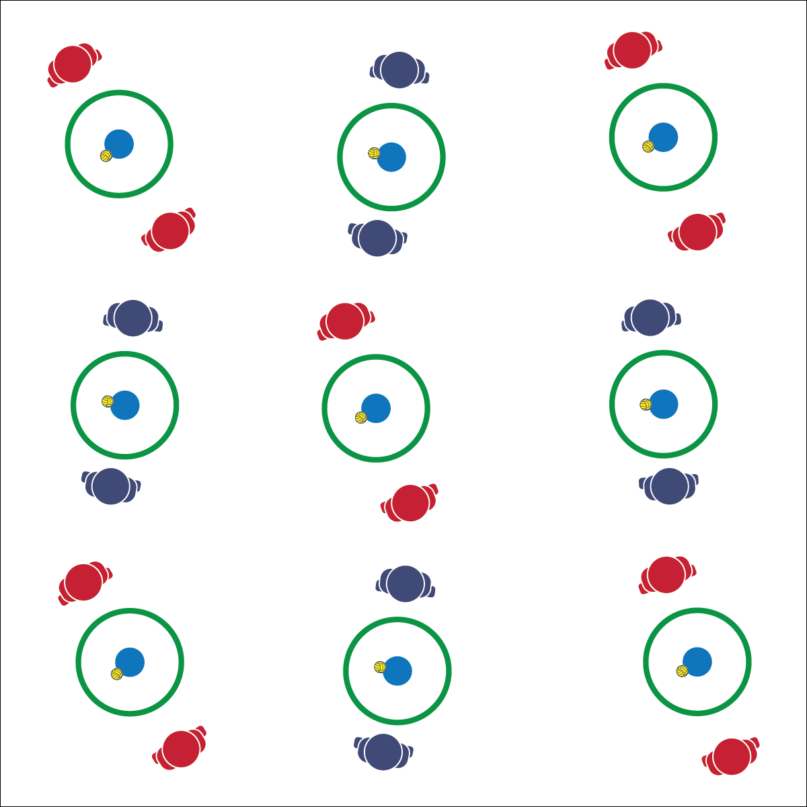

* **Skill:** I will demonstrate the Roundnet skills and strategies required to play 1v1.
* **Cognitive:** I will identify and then demonstrate proper etiquette for competitive Roundnet play.
* **Fitness:** I will remain actively engaged in order to increase my heart rate.
* **Personal & Social Responsibility:** I will choose an appropriate level of challenge in order to experience both success and improvement.
* Self-Set and then Spike
* Be Ready to Move in Athletic Stance

**Equipment:**

* 1 Spikeball® (or foam ball) per pair of students
* 1 Spikeball® net or hoop per pair
* Roundnet Etiquette Discussion Card

**Set-Up:**

1. Scatter nets/hoops in the activity area with enough space for groups to move freely.
2. Pair students, each pair at a net/hoop with a Spikeball® or foam ball.

**Activity Procedures:**

1. Let’s play some 1v1. The rules are the same as classic Roundnet with 2 modifications.
2. First, players can self-pass the ball before spiking. Each player gets up to 3 hits per possession (2 self-passes and a spike). Second, the court is split into 2 sides, and you can only hit the ball toward your opponent’s side.
3. Games will run for 3 minutes (or any time limit), and then we’ll rotate to a new opponent. Begin on the start signal and keep your own score.

**Grade Level Progression:**

**L1:** Identify and demonstrate proper etiquette for competitive Roundnet play.

**L2:** Self-identify a preferred challenge level and choose opponents based on that preference.

**1 V 1**



Challenge, Etiquette, Movement Concepts, Safety, Success



* **Standard 4 [H2.L1-2]** Exhibits proper etiquette, respect for others, and teamwork while engaging in physical activity and/or social dance (L1); Examines moral and ethical conduct in specific competitive situations (e.g., intentional fouls, performance-enhancing substances, gambling, current events in sport) (L2).
* **Standard 4 [H5.L1]** Applies best practices for participating safely in physical activity, exercise, and dance (e.g., injury prevention, proper alignment, hydration, use of equipment, implementation of rules, sun protection) (L1).
* **Standard 5 [H2.L2]** Chooses an appropriate level of challenge to experience success and desire to participate in a self-selected physical activity (L2).



* **DOK 1:** How would you describe the different elements of Roundnet etiquette?
* **DOK 2:** How does following etiquette affect the experience of Roundnet participants?
* **DOK 3:** What facts would you select to support the importance of respecting Roundnet etiquette? Elaborate on why you chose those facts.



**Help students examine their reasoning:** Due to past competitive experiences (as either a participant or a spectator), it may be easier for students to discuss proper etiquette than to actually demonstrate it. When etiquette missteps occur, it is a teachable moment for individuals and the class. Work to demonstrate patience and understanding in these situations in order to encourage the development of attitudes and values that will eventually promote and defend proper etiquette.



* Increase the size of the target area (net) or remove the net altogether.
* Increase the number of allowed self-passes.
* Allow the ball to bounce in between passes/spikes.