­­



**1 ON 1 ON 1**

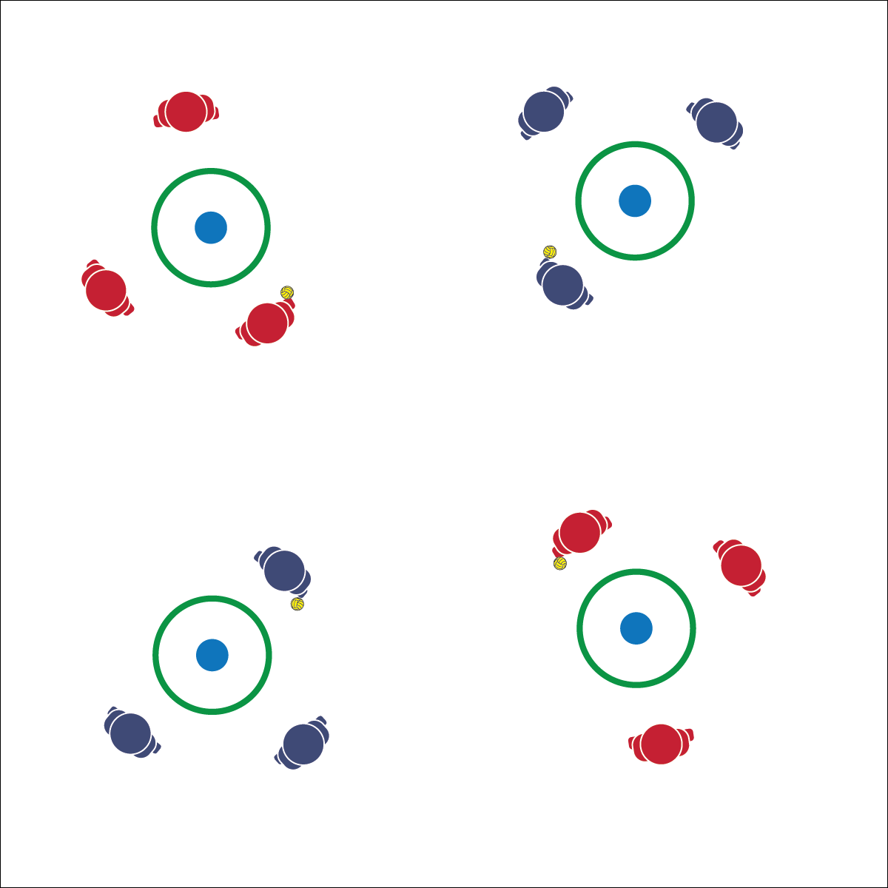

* **Skill:** I will demonstrate the Roundnet skills and strategies required to play 1 on 1 on 1.
* **Cognitive:** I will discuss best practices for safe Roundnet participation.
* **Fitness:** I will remain actively engaged in order to increase my heart rate.
* **Personal & Social Responsibility:** I will value and demonstrate safe behaviors.
* Player that Spikes Now Plays Defense
* Set to the Net

**Equipment:**

* 1 Spikeball® (or foam ball) per group of 3 students
* 1 Spikeball® net or hoop per group

**Set-Up:**

1. Scatter nets/hoops in the activity area with enough space for groups to move freely.
2. Create groups of 3 students, each group at a net/hoop with a Spikeball® or foam ball.

**Activity Procedures:**

1. Let’s keep working on our passing and striking skills with a game of 1 on 1 on 1. The rules are the same as classic Roundnet, but with 3 players.
2. Play starts with player 1 serving to player 2. Player 2 and player 3 are now on a team and have 3 touches to hit the ball off the net. If player 3 hits the ball off the net, players 1 and 2 are on a team and have 3 hits to make a Spike.
3. Play continues in this way, with the player who makes the spike then working to defend against the hits of the other two players.
4. No score is kept during 1 on 1 on 1. Each rally is a mini-game of its own.

**Grade Level Progression:**

**L1:** Identify and demonstrate best practices for safe Roundnet participation.

**L2:** Self-identify a preferred challenge level and choose opponents based on that preference.

**1 ON 1 ON 1**



Ethical, Respect, Safety, Strategy, Value

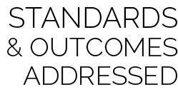

* **Standard 4 [H2.L1-2]** Exhibits proper etiquette, respect for others, and teamwork while engaging in physical activity and/or social dance (L1); Examines moral and ethical conduct in specific competitive situations (e.g., intentional fouls, performance-enhancing substances, gambling, current events in sport) (L2).
* **Standard 4 [H5.L1]** Applies best practices for participating safely in physical activity, exercise, and dance (e.g., injury prevention, proper alignment, hydration, use of equipment, implementation of rules, sun protection) (L1).
* **Standard 5 [H2.L2]** Chooses an appropriate level of challenge to experience success and desire to participate in a self-selected physical activity (L2).



* **DOK 1:** How can you recognize safe participation? How can you recognize unsafe participation?
* **DOK 2:** How is hydration related to safe participation? How is the use of equipment related to safe participation?
* **DOK 3:** Can you predict participants’ level of enjoyment if all players practice safe behaviors?



**Manage response rates with tiered questioning techniques:** Safety is the most important aspect of physical activity participation, and because of this, physical educators often remain direct when it comes to safety instruction. While it is important for safety rules to be clearly and directly established, it’s also important to help students discuss and process the reasons why safety is paramount. The use of tiered question sets like the one above can help students explore multiple aspects of safe participation while allowing them to express their ideas and concerns.



* Increase the size of the target area (net) or remove the net altogether.
* Allow the ball to bounce in between passes/spikes.