­­



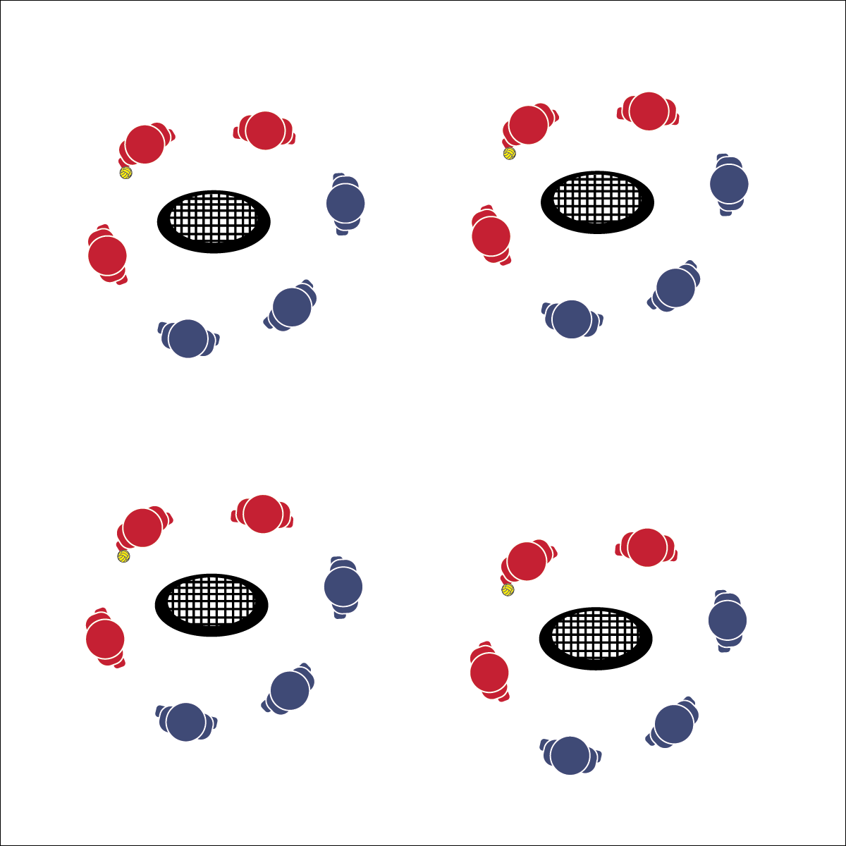

* **Skill:** I will demonstrate the Roundnet skills and strategies required to play 3v3.
* **Cognitive:** I will discuss the importance of teamwork with respect to Roundnet performance.
* **Fitness:** I will remain actively engaged in order to increase my heart rate.
* **Personal & Social Responsibility:** I will demonstrate teamwork and cooperative behaviors.
* Safe Play
* Fair Play
* Honor the Game

**Equipment:**

* 1 Spikeball® (or foam ball) per group of 6 students
* 1 Spikeball® net or hoop per group

**Set-Up:**

1. Scatter nets/hoops in the activity area with enough space for groups to move freely.
2. Create teams of 3 students, with 2 teams at a net/hoop with a Spikeball® or foam ball.

**Activity Procedures:**

1. We’re going to work on our game play with teams of 3 playing classic Roundnet rules. (Adding the 3rd player makes it a little easier for teams to return serves and extend rallies.)
2. Each team still gets only 3 hits (pass, set, spike) per possession. Any time there is player interference because the play area is crowded, simply redo the point.
3. Games will run for 3 minutes (or any time limit), and then we’ll rotate to a new opponent. Begin on the start signal and keep your own score.

**Grade Level Progression:**

**L1:** Identify and demonstrate proper etiquette for competitive Roundnet play.

**L2:** Self-identify a preferred challenge level and choose opponents based on that preference.

**3 V 3**

**3 V 3**



Challenge, Competition, Etiquette, Movement Concepts, Safety



* **Standard 4 [H2.L1-2]** Exhibits proper etiquette, respect for others, and teamwork while engaging in physical activity and/or social dance (L1); Examines moral and ethical conduct in specific competitive situations (e.g., intentional fouls, performance-enhancing substances, gambling, current events in sport) (L2).
* **Standard 4 [H5.L1]** Applies best practices for participating safely in physical activity, exercise, and dance (e.g., injury prevention, proper alignment, hydration, use of equipment, implementation of rules, sun protection) (L1).
* **Standard 5 [H2.L2]** Chooses an appropriate level of challenge to experience success and desire to participate in a self-selected physical activity (L2).



* **DOK 1:** What is teamwork?
* **DOK 2:** How would you compare and/or contrast a team’s Roundnet performance that demonstrates teamwork with a performance that doesn’t?
* **DOK 3:** What facts would you select to support the importance of teamwork to Roundness success? Can you elaborate on why you chose those facts?



**Help students practice skills:** Organizing students to play 3v3 Roundnet aligns with the importance of modifying games and activities to encourage participation. Using experiences this this, older students can often create additional modifications that meet their needs and activity preferences.



* Increase the size of the target area (net) or remove the net altogether.
* Allow the ball to bounce in between passes/spikes.