­­



**ROUNDNET**

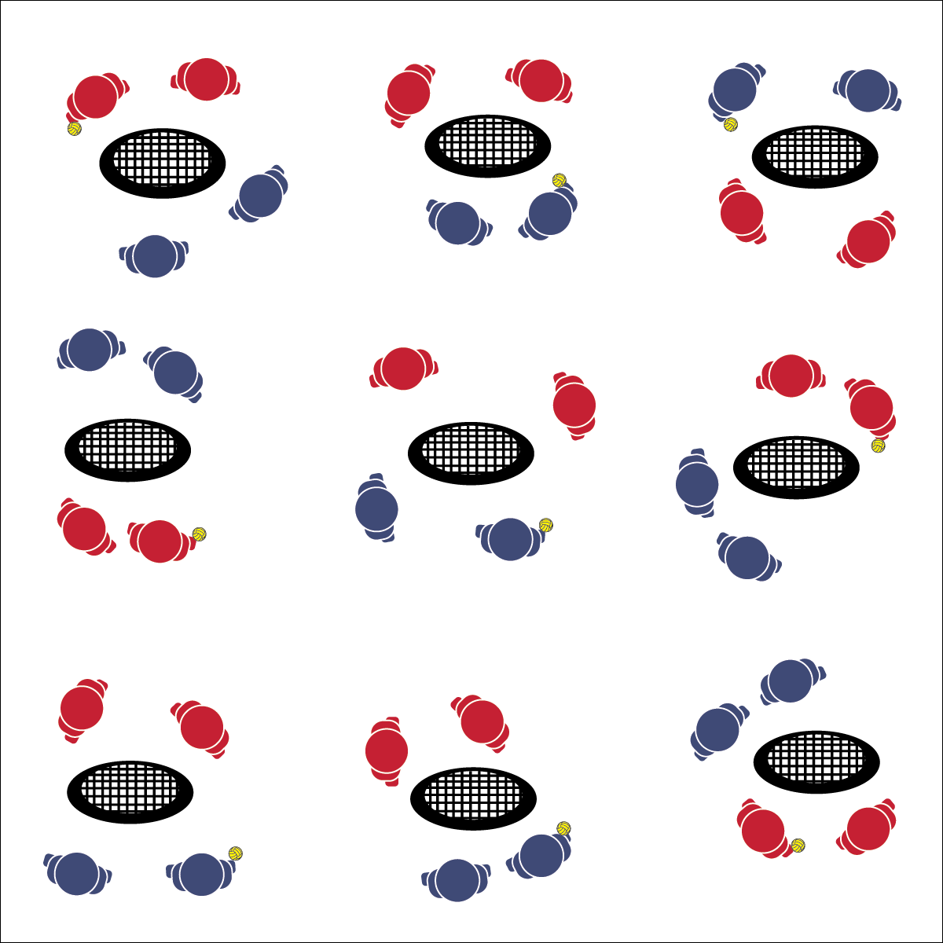

* **Skill:** I will demonstrate the skills and strategies required to play a full game of Roundnet.
* **Cognitive:** I will discuss space as a movement concept related to Roundnet performance.
* **Fitness:** I will remain actively engaged in order to increase my heart rate.
* **Personal & Social Responsibility:** I will demonstrate behaviors appropriate for competitive environments.
* Safe Play
* Fair Play
* Honor the Game

**Equipment:**

* 1 Spikeball® (or foam ball) per group of 4
* 1 Spikeball® net or hoop per group

**Set-Up:**

1. Scatter nets/hoops in the activity area with enough space for groups to move freely.
2. Create teams of 2 students, with 2 teams at a net/hoop with a Spikeball® or foam ball.

**Activity Procedures:**

1. Now we’re ready for classic Roundnet play.
2. This is a 2v2 game with a maximum of 3 touches per possession (pass, set, spike).
3. Rally scoring is in effect (a team is awarded a point after each possession). Teams winning the point also win the right to make the next serve.
4. Games will run for 3 minutes (or any time limit), and then we’ll rotate to a new opponent. Begin on the start signal and keep your own score.

**Grade Level Progression:**

**L1:** Define and govern play with the Spirit of the Game.

**L2:** Self-identify a preferred challenge level and choose opponents based on that preference.

**ROUNDNET**



Appropriate, Competition, Ethical, Movement Concepts, Respect, Spirit of the Game, Teamwork



* **Standard 1 [H1.L1-2]** Demonstrates competency and/or refines activity-specific movement skills in two or more lifetime activities (outdoor pursuits, individual-performance activities, aquatics, net/wall games, or target games) (L1); Refines activity-specific movement skills in one or more lifetime activities (outdoor pursuits, individual-performance activities, aquatics, net/wall games, or target games) (L2).
* **Standard 2 [H1.L1-2]** Applies the terminology associated with exercise and participation in selected individual-performance activities, dance, net/wall games, target games, aquatics, and/or outdoor pursuits appropriately (L1); Identifies and discusses the historical and cultural roles of games, sports, and dance in a society (L2).
* **Standard 4 [H2.L1-2]** Exhibits proper etiquette, respect for others, and teamwork while engaging in physical activity and/or social dance (L1); Examines moral and ethical conduct in specific competitive situations (e.g., intentional fouls, performance-enhancing substances, gambling, current events in sport) (L2).
* **Standard 5 [H2.L2]** Chooses an appropriate level of challenge to experience success and desire to participate in a self-selected physical activity (L2).



* **DOK 1:** How would you describe the importance of space as a movement concept related to Roundnet performance?
* **DOK 2:** How does spacing affect performance on offense? Defense?
* **DOK 3:** What facts or examples from today’s game play would you select to support the importance of space for Roundnet performance? Elaborate on why you chose those facts/examples.

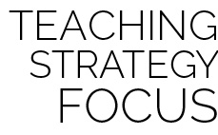

**Help students elaborate on content:** At this point in a module, students are combining multiple skills with essential strategies and concepts, often without recognizing the complex nature of their performance. Use group discussion opportunities to challenge students cognitively and to encourage deeper thinking through elaboration on facts, examples, and personal experiences.



* Increase the size of the target area (net) or remove the net altogether.
* Allow the ball to bounce in between passes/spikes.