­­



**COMPASS DRAW TOURNAMENT**

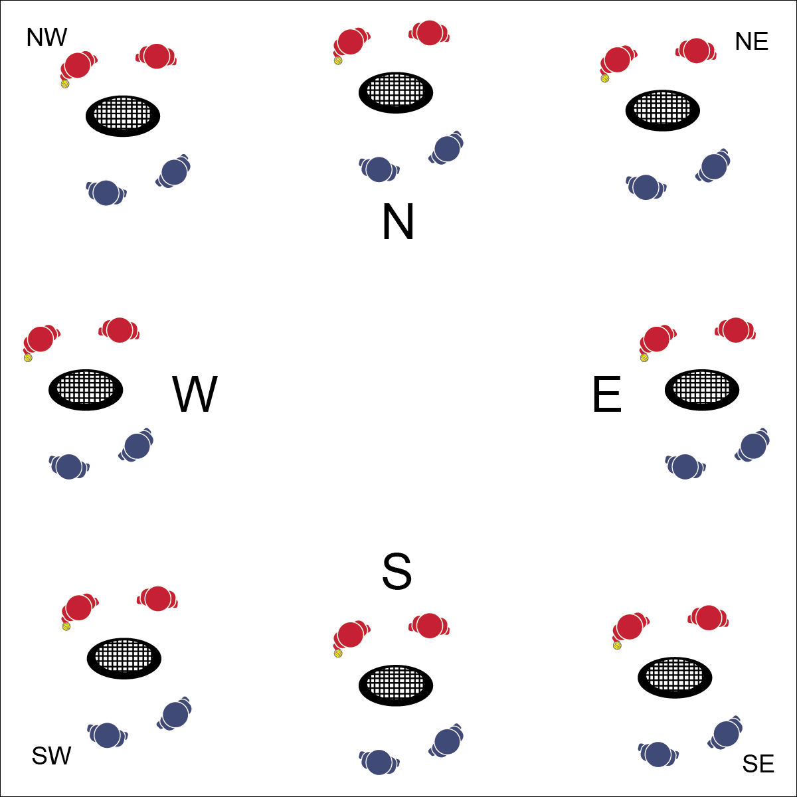

* **Skill:** I will demonstrate the skills and strategies required play Roundnet.
* **Cognitive:** I will discuss the meaning of completion, including some of the benefits it can have on skill development.
* **Fitness:** I will remain actively engaged.
* **Personal & Social Responsibility:** I will exhibit proper etiquette and respect for my teammate and opponents.
* Safe Play
* Fair Play
* Honor the Game

**Equipment:**

* 1 Spikeball® (or foam ball) per group of 4
* 1 Spikeball® net or hoop per group
* 1 Task Tent, Compass Card, and large cone per compass point (see set-up)

**Set-Up:**

1. Set nets/hoops in a compass formation (N,S,E,W) with enough space for groups to move freely. Use NW, NE, SW, SE if necessary.
2. Use Task Tents, Compass Cards, and cones to identify compass points.
3. Create teams of 2 students, with 2 teams at a net/hoop with a Spikeball® or foam ball.

**Activity Procedures:**

1. We’re going to participate in a Compass Draw Tournament. Your team’s objective is to make it to the North net.
2. Winning teams rotate clockwise toward the North net. Losing teams rotate counterclockwise. Winners on the North net stay and defend their net. Losing teams at the Northeast net stay and try to win their way to the East net.
3. With large classes, place a champion net and a challenger net at each compass point. Teams must work their way to the champion net and win there before advancing to the next compass point. Likewise, teams losing at the champion net move to the challenger net.

**Grade Level Progression:**

**L1:** Define and govern play with the Spirit of the Game.

**L2:** Create a pro-circuit tournament and a recreation league tournament. Allow students to self-identify a preferred challenge level and choose a tournament based on that preference.

**TOURNAMENT PLAY**



Appropriate, Competition, Ethical, Movement Concepts, Respect, Teamwork



* **Standard 1 [H1.L1-2]** Demonstrates competency and/or refines activity-specific movement skills in two or more lifetime activities (outdoor pursuits, individual-performance activities, aquatics, net/wall games, or target games) (L1); Refines activity-specific movement skills in one or more lifetime activities (outdoor pursuits, individual-performance activities, aquatics, net/wall games, or target games) (L2).
* **Standard 2 [H1.L1-2]** Applies the terminology associated with exercise and participation in selected individual-performance activities, dance, net/wall games, target games, aquatics, and/or outdoor pursuits appropriately (L1); Identifies and discusses the historical and cultural roles of games, sports, and dance in a society (L2).
* **Standard 4 [H2.L1-2]** Exhibits proper etiquette, respect for others, and teamwork while engaging in physical activity and/or social dance (L1); Examines moral and ethical conduct in specific competitive situations (e.g., intentional fouls, performance-enhancing substances, gambling, current events in sport) (L2).
* **Standard 5 [H2.L2]** Chooses an appropriate level of challenge to experience success and desire to participate in a self-selected physical activity (L2).



* **DOK 1:** What is competition?
* **DOK 2:** How does competition affect your effort during game play?
* **DOK 3:** How is competition related to skill development in Roundnet and other sport activities?



**Organize students to interact with content:** The use of the Compass Draw Tournament format provides a competitive structure that typically results in teams pairing with teams at a similar skill level. There is an element of competitive progression without an over-emphasis on crowning a tournament champion. Experiment with this format and modify it to meet the needs of your classes.



* Increase the size of the target area (net) or remove the net altogether.
* Allow the ball to bounce in between passes/spikes.