Court Coordinates Card
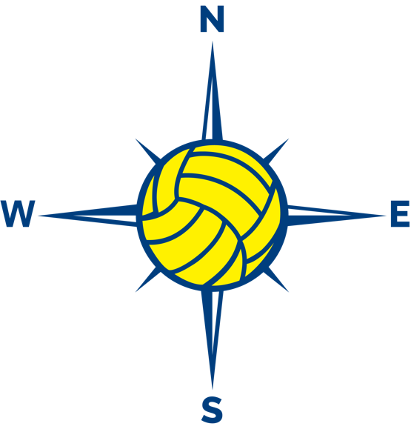
North
Court
Court Coordinates Card

Northeast
Court

Court Coordinates Card

East
Court

Court Coordinates Card

Southeast
Court

Court Coordinates Card

South
Court

Court Coordinates Card

Southwest
Court

Court Coordinates Card

West
Court

Court Coordinates Card

Northwest
Court

