­­

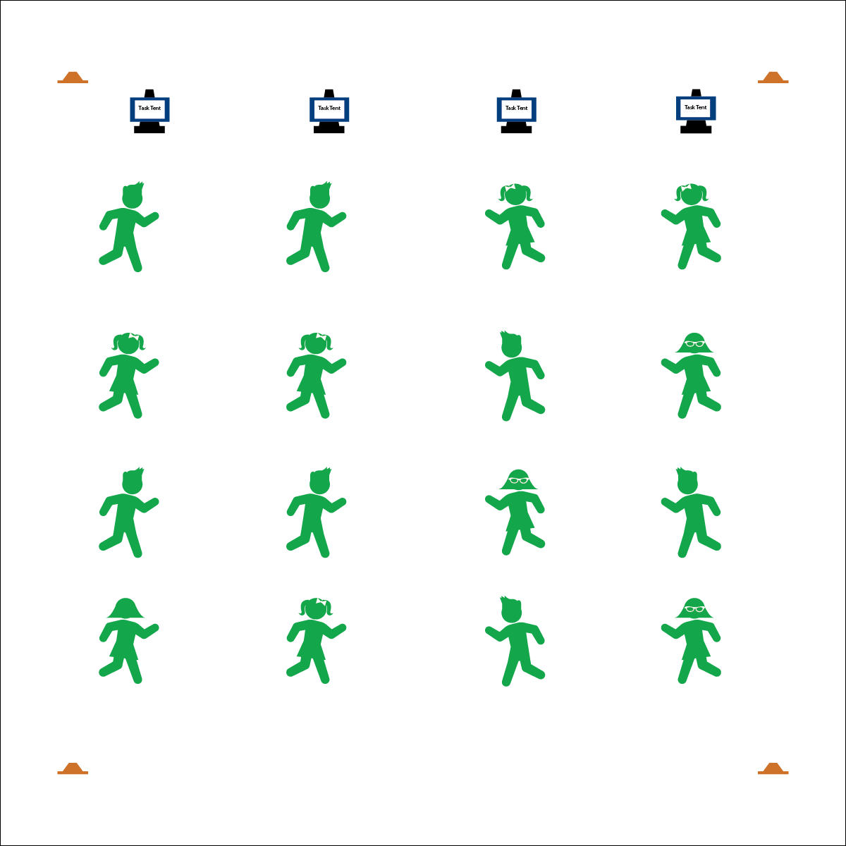

* **Skill:** I will participate in this activity with proper form and attention to safety.
* **Cognitive:** I will explain how to demonstrate safe participation.
* **Fitness:** I will pace myself so that I increase my heart rate and warm up my muscles.
* **Personal & Social Responsibility:** I will work independently.

**TRAIN LIKE AN OLYMPIAN**

* Follow Exercise Cues
* Listen for Start/Stop Signals
* Pace Your Activity to Warm Up Your Muscles

**Equipment:**

* Train Like an Olympic Athlete Routine Cards
* Tabata audio cues (Tabata timer app)
* Task tents
* 4 low-profile cones

**Set-Up:**

1. Use cones to create a large activity area.
2. Place Routine Cards in task tents or display them using a projector.
3. Scatter students in view of the routine cards and with enough personal space for safe movement.

**Activity Procedures:**

1. Today we are going to warm up our bodies by training like Olympic athletes!
2. Tabata-style training was created by a Japanese scientist named Dr. Izumi Tabata. We may adjust our timing and intensity, but true Tabata workouts combine 20 seconds of vigorous activity with 10 seconds of rest in between each set.
3. When I say, “GO!” begin following the routine card displayed on the task tents. When I say, “FREEZE,” we’ll take 10 seconds of rest and prepare for the next exercise on the routine card. Our warm-up will take 4 minutes total.

**Grade Level Progression:**

**3rd:** Perform the warm-up as described above. Assign students to each routine card.

**4th:** Students choose the Olympic sport they’d like to train for and perform the corresponding Tabata exercises.

**5th:** During the module, allow students to research Olympic sports and develop their own warm-ups.

**TRAIN LIKE AN OLYMPIAN**



* **DOK 1:** How can you recognize appropriate and safe fitness participation?
* **DOK 2:** How do exercise/activity cues affect safe participation?
* **DOK 3:** How is appropriate behavior related to independent participation?



* **Standard** **3 [E2.3-5]** Engages in the activities of physical education class without teacher prompting (3); Actively engages in the activities of physical education class, both teacher-directed and independent (4); Actively engages in all the activities of physical education (5).
* **Standard 3 [E4.3,5]** Recognizes the importance of warm-up and cool-down relative to vigorous physical activity (3); Identifies the need for warm-up and cool-down relative to various physical activities (5).
* **Standard 4 [E1.3-5]** Exhibits personal responsibility in teacher-directed activities (3); Exhibits responsible behavior in independent group situations (4); Engages in physical activity with responsible interpersonal behavior (e.g., peer to peer, student to teacher, student to referee) (5).



* **Adaptation:** Pair students to provide a guide for those who require assistance.
* **Extension:** Provide fitness activities at various levels of intensity and difficulty. Allow students to choose their level of participation.



Appropriate, Equipment, Guidance, Identify, Independent, Safe, Safety Concerns, Set, Specific, Tabata Interval Training, Vigorous, Warm-up



**Identify critical content.** Safe and appropriate participation is absolutely essential for the success of fitness instruction. By starting the Olympic Module with a focus on safe participation, students will understand baseline expectations for their behavior and performance.