­­

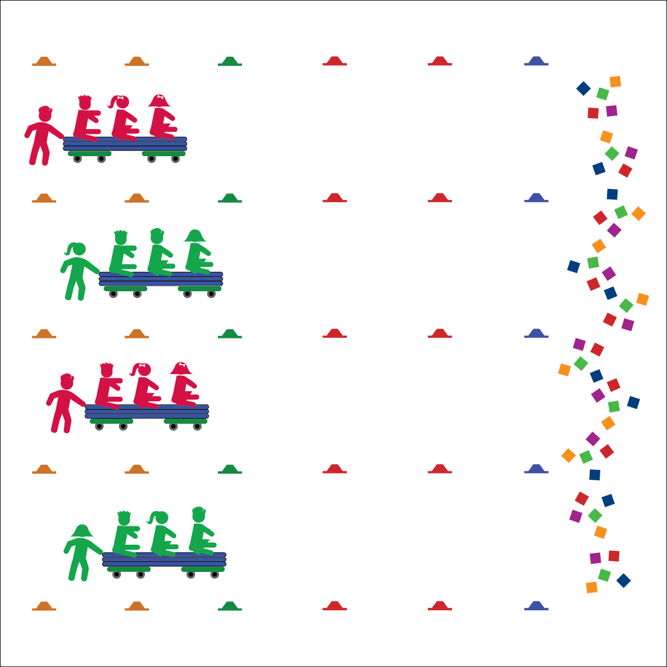

**Equipment:**

* 2 scooters per group of 4 students
* 1 gymnastics mat per group of 4 students
* 12–48 cones
* 24–48 beanbags

**Set-Up:**

1. Use low-profile cones to create a large activity area with start/stop lines and, if desired, course pathways.
2. Place beanbags at the far side of the gym, near the stop line.
3. Place scooter boards under a gymnastics mat to create “bobsleds.”
4. Place students into groups of 4, each group at a bobsled. 3 students from each group sit on their bobsled.

**Activity Procedures:**

1. Today’s activity is called Cooperative Bobsled Driving. The object of the activity is to work together to move the bobsled safely throughout the activity area and collect gold medals (beanbags).
2. You and the 3 other students at your bobsled are a team. The team member standing up is the pusher. The person sitting in the back will be driver, the person in the middle will balance the sled’s weight, and the person in front is the team’s brake person.
3. When I say, “GO!” your team’s pusher will start moving the group around the cones. The driver will communicate with the pusher in order to help them move safely through the gym. If the sled is going too fast, the brake person will put their feet down to brake.
4. Teachers, give teams a few minutes to discuss strategies for success.
5. Teams will drive from one side of the gym to the other in straight pathways or through cone courses designed by the teacher. When they reach the other side, they collect 1 gold medal and then return to the start line. Rotate roles before starting again.

**Grade Level Progression:**

**3rd:** Play the activity as described above.

**4th:** Add different pathways through teacher-designed bobsled courses.

**5th:** Have students design courses for other groups, then take turns driving all the different pathways.

* **Skill:** I will be mindful of others while moving in open space.
* **Cognitive:** I will explain proper technique for pushing and controlling the bobsled safely in open space.
* **Fitness:** I will apply muscular strength and endurance to this activity.
* **Personal & Social Responsibility:** I will work cooperatively with others by taking turns pushing the bobsled.
* Communicate Cooperatively with Friends
* Move Safely with Equipment
* Show Teamwork

**COOPERATIVE BOBSLED**

**COOPERATIVE BOBSLED**



Backward, Communication, Cooperation, Curved, Force, Guide, Left, Pathway, Push, Right, Straight, Teamwork



* **Standard** **2 [E1.3-5]** Recognizes the concept of open spaces in a movement context (3); Applies the concept of open spaces to combination skills involving traveling (e.g., dribbling and traveling) (4a); Applies the concept of closing spaces in small-sided practice tasks (4b); Dribbles in general space with changes in direction and speed (4c); Combines spatial concepts with locomotor and non-locomotor movements for small groups in gymnastics, dance, and games environments (5).
* **Standard 4 [E4.3-5]** Works cooperatively with others (3a); Praises others for their success in movement performance (3b); Praises the movement performance of others both more and less-skilled (4a); Accepts “players” of all skill levels into the physical activity (4b); Accepts, recognizes, and actively involves others with both higher and lower skill abilities into physical activities and group projects (5).
* **Standard 5 [E4.3-5]** Describes the positive social interactions that come when engaged with others in physical activity (3); Describes/compares the positive social interactions when engaged in partner, small-group, and large-group physical activities (4); Describes the social benefits gained from participating in physical activity (e.g., recess, youth sport) (5).



* **DOK** **1:** What is cooperation?
* **DOK 2:** How can group cooperation affect the performance of the sled?
* **DOK 3:** How can negative interactions with others affect the sled’s performance and the performance of athletes at the Olympics?



**Organize students to interact with content.** Group dynamics play a key role in the success of each team. Even though students are required to discuss ideas as a team prior to starting the activity, many students tend to set out on their own—sometimes with limited success—before realizing that they will not be successful until all group members become involved. Move from group to group, offering guidance while also allowing each group to discover their own process to complete the challenge. Monitor student behavior throughout the activity with a careful watch for the unsafe use of equipment and disrespectful language.



* **Adaptation:** Students go 1 at a time through the bobsled course while partners perform fitness activities. Play the activity with locomotor movements instead of scooters.
* **Extension:** Students design courses for homework and use protractors to design different driving angles for the course. Then use painters’ tape to mark the angles on the ground. The other groups drive the courses for points.