­­

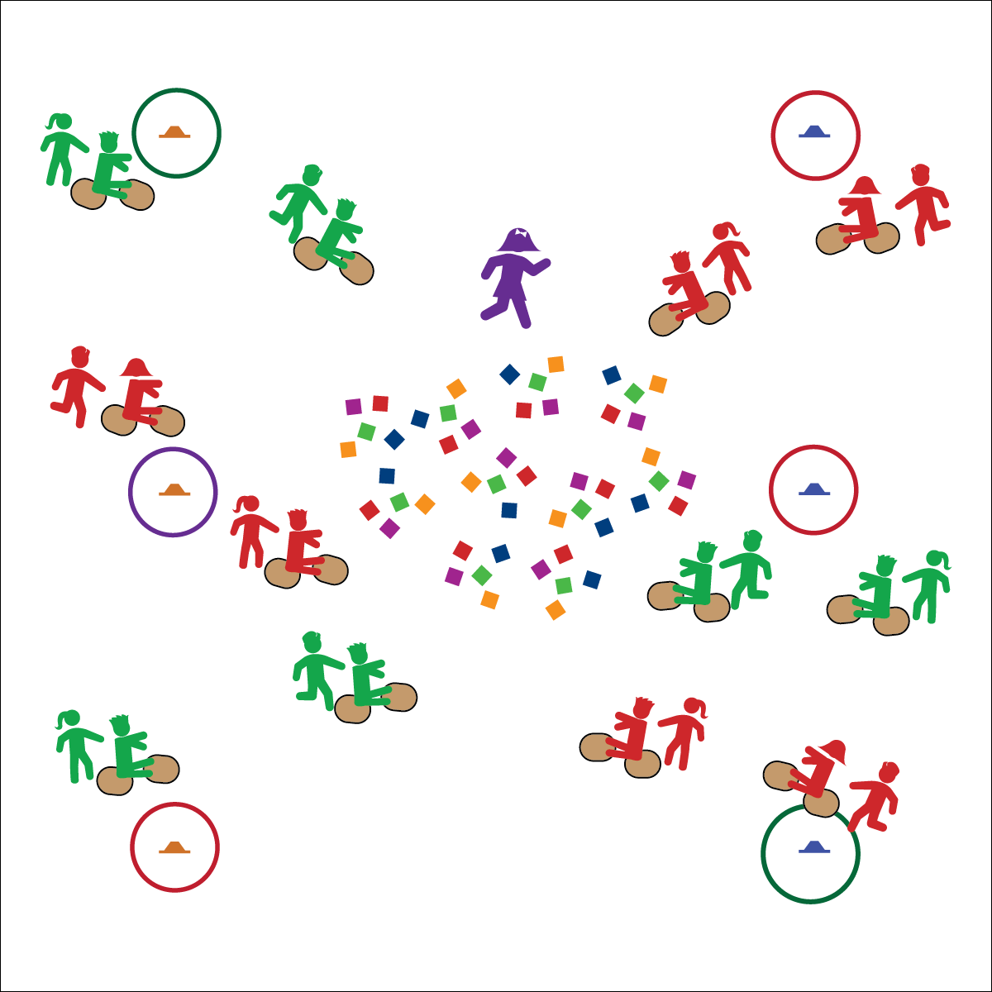

**Equipment:**

* 1 carpet square per student
* 6 cones
* 6 hoops
* 24–64 beanbags or yarn balls
* 1 pinnie

**Set-Up:**

1. Place cones around the perimeter of the activity area with a hoop around each one.
2. Place the beanbags in the center of the area.
3. Using a pinnie, designate 1 students as an “Olympic athlete.”
4. Students in pairs, each pair with 2 carpet squares. Have an equal number of pairs line up behind each cone. This can be played locomotor movements, rather than with carpet squares

**Activity Procedures:**

1. Today’s activity is called Olympic Village Clean-up. The object of the activity is to help clean up the Olympic Village of all the trash (beanbags) left over from the athletes’ daily meals and place them in your waste management center (cone and hoop).
2. 1 person from each pair will be the driver of your clean-up machine. S/he will sit on 1 carpet square with her/his feet on the other (both carpet squares should be face-down). The other person is the “engine,” and s/he will push the driver by the shoulders.
3. When I say, “GO!” the 1st team from each line will attempt to drive to the Olympic Village, pick up 1 piece of trash, and return to their waste management center without being tagged by an athlete.
4. If you are successful, place the trash in the waste management center, high-five the next team in line (who will then attempt to retrieve a piece of trash), and then go to the end of the line. If you are tagged, return the trash to the Olympic Village and go to the end of the line.

**Grade Level Progression:**

**3rd:** Play the activity as described above.

**4th:** Use different colors of beanbags to represent different types of waste. For example, blue=trash, red=recycle, green=compost. Have students sort the trash into the correct piles at the end of the activity.

**5th:** Assign “jobs” to all the groups in the class. Each group will focus on picking up only their type (color) of trash. The class must work together to clean up the Olympic Village.

* Communicate Cooperatively with Friends
* Move Safety with Equipment
* Show Teamwork
* **Skill:** I will be mindful of others while moving in open space.
* **Cognitive:** I will explain proper technique for pushing and controlling the clean-up machine safely.
* **Fitness:** I will apply muscular strength and endurance to this activity.
* **Personal & Social Responsibility:** I will work cooperatively with others by taking turns pushing the clean-up machine.

**OLYMPIC VILLAGE CLEAN-UP**

**OLYMPIC VILLAGE CLEAN-UP**



Compost, Cooperation, Locomotor, Muscular Endurance, Muscular Strength, Recycle, Teamwork, Waste



* **Standard 2 [E5.3-5]** Applies simple strategies/tactics in chasing activities (3a); Applies simple strategies in fleeing activities (3b); Applies simple offensive strategies/tactics in chasing and fleeing activities (4a); Applies simple defensive strategies/tactics in chasing and fleeing activities (4b); Recognizes the type of kicks needed for different games/sports situations (4c); Applies basic offensive and defensive strategies/tactics in invasion small-sided practice tasks (5a); Applies basic offensive and defensive strategies/tactics in net/wall small-sided practice tasks (5b); Recognizes the type of throw, volley, or striking action needed for different games/sports situations (5c).
* **Standard 3 [E2.3-5]** Engages in the activities of physical education class without teacher prompting (3); Actively engages in the activities of physical education class, both teacher-directed and independent (4); Actively engages in all the activities of physical education (5).
* **Standard 4 [E1.3-5]** Exhibits personal responsibility in teacher-directed activities (3); Exhibits responsible behavior in independent group situations (4); Engages in physical activity with responsible interpersonal behavior (e.g., peer to peer, student to teacher, student to referee) (5).



* **DOK 1:** How can you recognize safe behavior during Olympic Village Clean-up?
* **DOK 2:** What did you notice about our game and safety? Can you give examples of safe behaviors and unsafe behaviors?
* **DOK 3:** How is safety related to learning in physical education class?

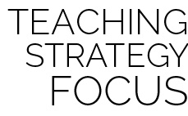

**Help students process content.** Olympic Village is an engaging and vigorous physical activity that students enjoy. Allow students to talk freely about the Olympic experience, transfer their thinking from past physically active events, and process the connection between participation in the Olympic Module and good mental and emotional health.



* **Adaptation:** Use locomotor movements instead of carpet squares.
* **Extension:** Brainstorm ways to implement recycling plans in the cafeteria to reduce school waste and/or start a composting area at school.